

**CLOUD INFRASTRUCTURE AND SERVICES (CT097-3-CSVC)**

GROUP ASSIGNMENT

|  |  |
| --- | --- |
| **TP Number** | **Name** |
| 1. TP064902 | Angelica Kaylee Wiesi |
| 1. TP066172 | Lim Kin Wah |
| 1. TP066234 | Mohammad Jilan Noor Butt |
| 1. TP066789 | Syed Nazrin Bin Syed Nurshadir |

|  |  |
| --- | --- |
| **Lecturer Name** | Nur Azyyati Binti Ahmad |
| **Due Date** | 14 April 2024 |
| **Date of Completion:** | 10 April 2024 |

**__________________________________________________________________________________**

**,**

***This page was intentionally left blank***

# Section A: Project Overview

# Introduction

WingsCafe is a cafe chain which is located in multiple countries across the Globe. Its main offices are in Singapore and Syndney. In addition, its most active operations are in the Asia Pacific Region. Since its establishment back in 2020, the company has carved itself as a relevant brand in the highly competitive food chain scene. To keep up with the huge competition, Wings Cafe must ensure it is constantly digitally transforming. Currently, it carries out its operations physically and virtually, as it gives its customers an option of physically enjoying its services or ordering online through a website. WingsCafe also has a large workforce, totaling around 300 employees.

WingsCafe has received praise from many for its range of menu options, known for combining top notch quality with prices, its dedication to providing top notch service has garnered a customer base from among those who value its expertise and affordable choices. Despite obstacles like the pandemic and changes in the market, WingsCafe has shown resilience by adjusting its tactics to maintain services and keeping customers happy.

However, since WingsCafe has a completely on-premises cloud infrastructure for their virtual/online side of the business, they have been complaining of incurring excessive costs associated with operating and maintaining the networking hardware. As such, they have decided to appoint our team to assist the business to migrate its current on-premises architecture to Amazon Web Services (AWS) cloud.

In this report, the entire process of the migration will be documented and justified. It will divide the entire process based on services and components.

# Cloud Architecture Solution

The changing world of information technology (IT) requires expandable solutions. In this scenario cloud computing has become a game changer allowing companies to utilize computing resources as needed, via the internet (Mell & Grance 2011). Amazon Web Services (AWS) is renowned among service providers for its range of on-demand cloud computing services, covering compute, storage, databases, networking, analytics, and more (Amazon.com Inc., n.d.). This extensive selection of services enables businesses to foster innovation. Grow their IT infrastructure in a cost flexible manner.

WingsCafe deciding to migrate to AWS’s cloud infrastructure will not only save them the cost of purchasing, operating, and maintaining their own networking hardware and software but will also additionally give them access to a huge variety of provides services that will open a whole new world for them. These services cover aspects like security, automation, flexibility and much more.

To establish WingCafes presence, the strategy involves utilizing the infrastructure offered by Amazon Web Services (AWS). Amazon Simple Storage Service (S3) will be used for cost effective scalable storage of website assets like images, videos, and code. This method eliminates the need for servers and simplifies website maintenance. For the website launch, the team will make use of Amazon Elastic Compute Cloud (EC2). EC2 provides virtual machines (VMs) based on different Linux distributions (and other operating systems) removing the need for manual server setup and streamlining website deployment. This enables the team to focus on customization.

In addition to that, AWS also offers a variety of service options to deal with different scenarios. For example, the CloudFront service can be used if one requires to reduce website latency for users globally. Moreover, for elements on the website that require databases a managed relational database service like Amazon Relational Database Service (RDS) can be utilized. RDS simplifies the database and ensures availability, which is crucial for a dynamic website.

AWS also provides a huge range of tools for the convenience of both users and network architecture, such as the AWS Cost explorer service which allows a user to estimate the infrastructure cost.

In this project, the team will consider and utilize the relevant inventory of tools to assist WingsCafe in migrating their website.

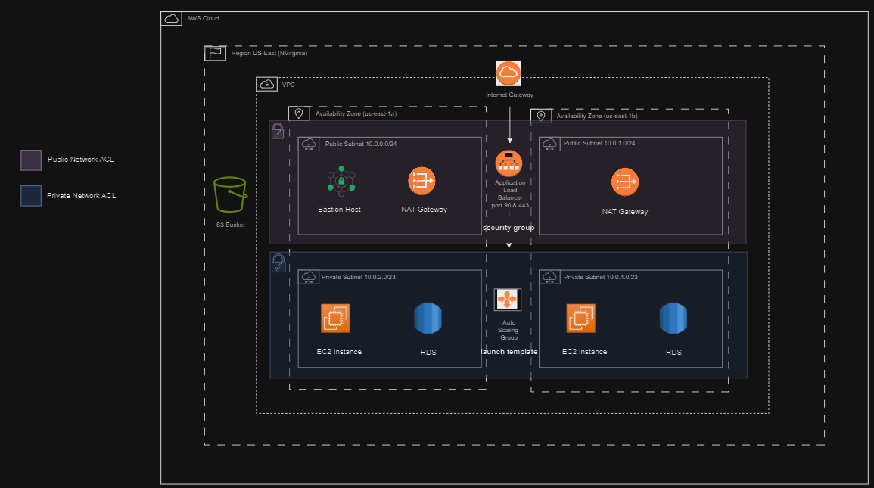

The team will assist WingsCafe in migrating their website from the physical servers, owned by the company, to a flexible infrastructure hosted on Amazon Web Services (AWS). This AWS setup will be tailored specifically for WingsCafe’s presence.

As can be seen above, an network architecture diagram is shown. At the core of the infrastructure is the Virtual Cloud (VPC), a protected network with an address range. The VPC can be thought of as a gated community offering an added layer of control over who and what can reach WingsCafe’s resources. Inside the VPC the team will establish subnets. Public subnets will be open to internet access ideal for a bastion host that serves as an entry point for accessing the virtual devices located within the private subnet. A NAT Gateway will also be present, enabling resources to connect to the internet for updates, while restricting internet traffic for increased security.

The essence of WingsCafe’s architecture resides in the subnets. Here the team position the resources, unseen from outside, but easily accessible within the VPC. This is where one can find WingsCafe’s application database, housed on an RDS (Relational Database Service) instance. Additionally, the team will set up EC2 instances/servers that serve as the hub, for WingsCafes website code.

To make sure WingsCafes website can handle levels of customer traffic, the team plans to use an Application Load Balancer (ALB). This functions as a traffic manager, intelligently spreading out website visitors among EC2 instances to ensure acceptable performance even during peak times. Additionally, the team will set up an Auto Scaling Group that will automatically adjust the number of EC2 instances based on demand, so WingsCafe only pays for the resources depending on the traffic their website receives.

Security is a priority and Security Groups within the VPC will act as barriers carefully managing incoming and outgoing traffic for each resource. Any website assets, backups, or the application code itself will be securely stored in an S3 bucket, which provides storage space in the cloud. Furthermore, the team will enhance security by configuring Access Control Lists (ACLs) to further control traffic flow within the subnets.

By utilizing these interconnected AWS elements, the team aims to establish a scalable and secure infrastructure for WingsCafe’s website. This digital environment will ensure availability and resilience to faults maintaining WingsCafe’s presence as accessible as well as reliable for their online customer base.

# Pricing Cost

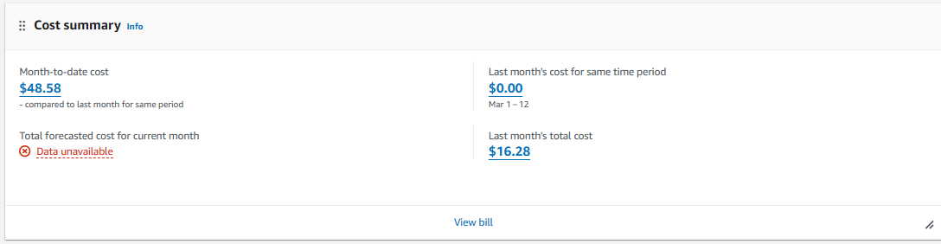

As can be seen above, currently AWS has incurred **$48.58** as the total overall cost for the setup and testing since the architecture is yet to be deployed. Services, such as the EC2, RDS, S3, etc. have contributed to the cost. It can also be seen in the snapshot that more costs were incurred last month relative to the current month, spanning in the ratio of almost 2:1. This is because most of the set up and testing was carried out the previous month.

It can also be noticed that the AWS Cost explorer has failed to generate a forecasted amount for the current month. The reason seems to be due to shortage of data. This is because the website is still in the development phase and has not collected enough data. In addition, the website hasn’t been visited enough to make a notable mark in monetary terms.

# Cloud Environment

## Project Plan

Despite having just one device available for configuration due to private account limitations, the four-member team successfully built WingsCafe's cloud infrastructure through a combination of coordinated efforts and individual contributions. Several meetings were held to accommodate everyone's schedules, and even when only two or three members were available (often during debugging phases), progress continued.

The initial phase focused on configuring fundamental components. All four members participated, taking turns on a device, where the screen was projected on a large LED screen to configure the Virtual Private Cloud (VPC), subnets, internet gateways, route tables, security groups, and the S3 service. This collaborative approach ensured everyone remained on the same page and contributed to the initial setup.

The second phase involved launching and running the website environment. Here, the work was divided. Sometimes, all members worked together on the large screen, while other times, the tasks were split up individually. This phase included:

* **Autoscaling**: Configuring automatic scaling to handle fluctuating traffic.
* **Load** **balancers**: Distributing incoming traffic across multiple servers for optimal performance.
* **Database (RDS)**: Setting up a managed database service using Amazon Relational Database Service (RDS).
* **Parameter Store**: Securely storing application configuration data.
* **Additional Configurations**: Fine-tuning the basic components to ensure compatibility and overall system functionality.

The team also collectively reviewed, updated, and corrected the website code. Once finalized, the code was uploaded to the server and thoroughly tested to ensure proper functionality within the newly built cloud infrastructure. Finally, the documentation was split evenly between the team members.

By leveraging a combination of collaborative work sessions and individual contributions, the team successfully overcame the limitations of a single device. This project exemplifies the importance of effective communication, teamwork, and adaptability in achieving technological goals.

## Web Services Deployed

The initial step in getting Wingcafe’s website up and running on Amazon Web Services (AWS) infrastructure is to grasp the concept of web services. A web service serves as a means of communication between a server and a client system following protocols for data exchange (Clegg et al., 2023). In this scenario, AWS offers a range of services for constructing and launching Wingcafe’s website.

One of these services is AWS EC2 (Elastic Compute Cloud) which enables the creation of servers in the cloud. These virtual servers, also referred to as instances, can be tailored with operating systems and hardware specifications to cater to the requirements of business (Amazon Web Services, n.d.). The EC2 instances will serve as the **backbone** for Wingcafe’s web application.

However, prior to deploying EC2 instances, it is essential to establish the infrastructure. This includes setting up a cloud (VPC) that acts as the fundamental base for all other AWS resources. The VPC will set up a network that isolates Wingcafe’s resources, such as EC2 instances, storage buckets in S3 (Simple Storage Service) and other necessary services. When these elements are configured collectively, one can create an expandable setting, for launching Wingcafe’s website.

## Team Members

|  |  |  |
| --- | --- | --- |
| ***Name*** | ***TP Number*** | ***Specialization*** |
| Angelica Kaylee Wiesi* | TP 064902 | Cloud Engineering |
| Lim Kin Wah | TP 066172 | Cloud Engineering |
| Mohammad Jilan Noor Butt | TP 066234 | Digital Transformation |
| Syed Nazrin Bin Syed Nurshadir | TP 066789 | Fintech |

Table 1: team members

There are four members within the team, however, only two specialize in networking and are experienced with using the AWS platform. However, all the members have a background in Information Technology as well as networking theory and Linux and were able to decently contribute within the project.

## Project Challenges and Limitation

|  |  |  |
| --- | --- | --- |
| ***Challenges*** | ***Explanation*** | ***Mitigations*** |
| **Knowledge Gap in Network Specialization** | Only two team members had network specialization, creating a knowledge and experience gap within the team. | The two network specialists tackled critical tasks while providing initial briefings to the non-networking students, ensuring everyone was on the same page. |
| **Limited Device Usage Due to Private Accounts** | The lack of a shared account restricted device usage to only one device. | The team addressed this by holding physical and online meetings to collaborate effectively despite the limited devices. |
| **Outdated PHP Files and Testing Challenges** | WingsCafe provided outdated PHP files using a direct database connection (rather than a PDO connection). Extensive syntax and code structure changes were made and tested locally. Migrating and testing these changes in the network environment presented another hurdle. | The team tackled the outdated code by refactoring it to use PDO connections. They made the changes and tested them locally before migrating and testing them again in the network environment. |
| **Tight Budget Constraint** | The project had a strict budget of only $100. | To avoid exceeding the budget, the team worked diligently within a tight timeframe, minimizing breaks to optimize their time and resource usage. |
| **Repetitive Uploads and Transfers for Code Updates** | Uploading website files to the S3 server and transferring them to the Linux environment for every code update was a tedious and time-consuming process. | The team streamlined the process by directly editing the code files within the Linux environment, eliminating the need for repetitive uploads and transfers. |

# Cloud Infrastructure

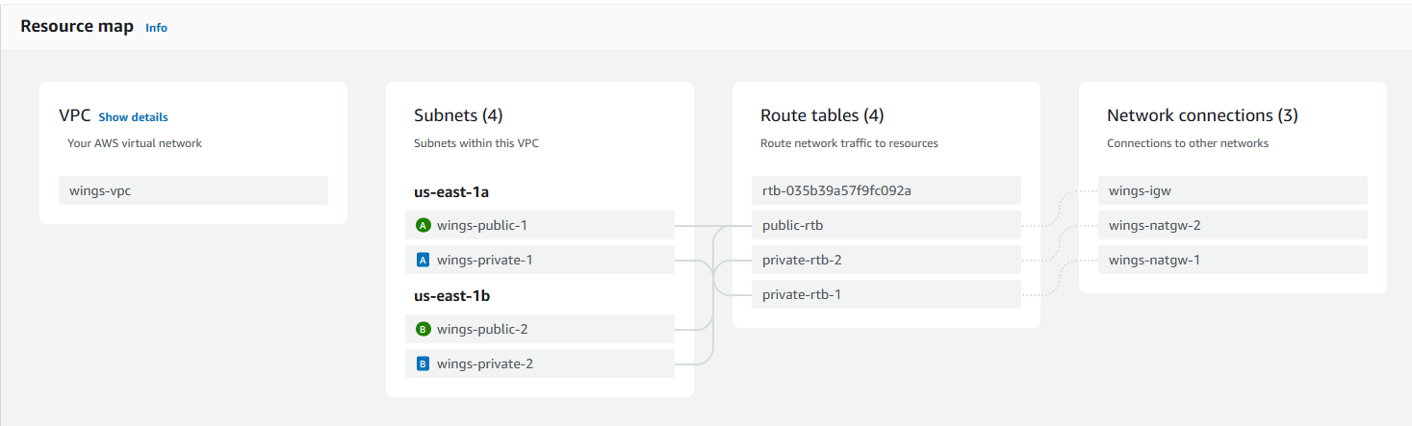

The figure above shows the overview of the project’s infrastructure. The foundation of this infrastructure is the Virtual Private Cloud (VPC) that is assigned to the IP address of 10.0.0.0/16. The subnets in the VPC can use IP addresses that range from /16 to /24. The VPC is situated in the region of North Virginia and spans across two availability zones, US-East-1a and US-East-1b. Each of the availability zones consists of 2 subnets which comprises of I public subnet and 1 private subnet. Therefore, the VPC has a total of 4 subnets to locate the resources. The subnets will be connected to the route tables. In this infrastructure, the team created 3 route tables, which are composed of 1 public route table and 2 private route tables. Furthermore, the route tables will be routed to either the Internet Gateway or NAT Gateway to connect the subnets and allow communication to and from the VPC. Further explanation of the infrastructure will be clarified in the subtopics below.

## Virtual Private Cloud (VPC)



Figure 1: wings-vpc: VPC of Wingscafe

As the project starts off by establishing its foundational infrastructure, the team’s focus settles on setting up a Virtual Private Cloud (VPC). VPC is a secure isolated virtual network that mimics the structure of a traditional on-premises network that enables the users to deploy AWS resources securely (AWS, 2024). Aside from providing the familiar features of network setup in data centers, VPC also provides flexibility and scalability that comes from virtualization in cloud environment (AWS, 2024). Then scalability of VPC is shown by the ability to create subnets and deploy various services within multiple availability zones without the need to expand any physical networking features. Thus, by starting with VPC, the team provides security from unauthorized data and offers flexibility that is tailored to the use case of the project to create a resilient infrastructure.

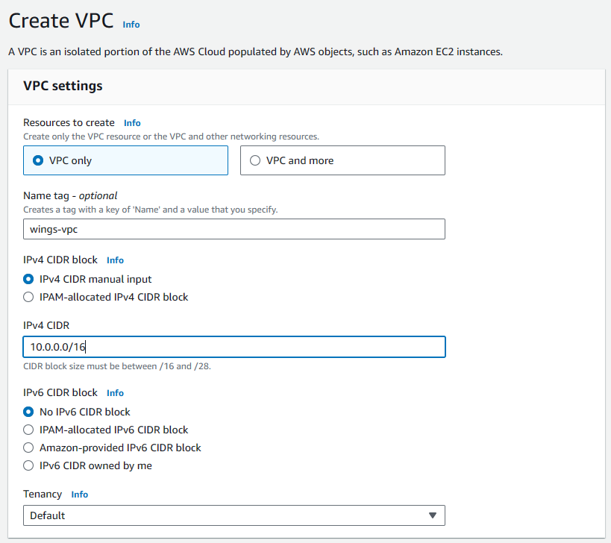

Figure 2: wings-vpc configuration

To create the VPC, search for "VPC” on the search bar of the AWS Management Console and click “Create VPC”. Clicking the button will lead to a template to specify the resources allocated for the VPC. In the VPC setting, choose VPC only” to exclusively address the VPC configurations. Next, to provide an identifiable label for the VPC, the team assigns the name “wings-vpc”. This naming convention is chosen to differentiate the VPC for Wings Café, which is the current project, and future projects’ VPCs. A descriptive name will minimize human error and streamline resource management. Furthermore, the team manually inputs the Ipv4 Classless Inter-Domain Routing (CIDR) block. The range selected is “10.0.0.0/16”, which provides 65.536 addresses, which is deemed enough for the current usage of the VPC. Manually specifying the range of CIDR block allows the team to control it to the use case of the project. Since the usage of Ipv6 is still unfamiliar and the is not necessary for the project’s scope, the team opted to not allocate any Ipv6 CIDR block. Then, the tenancy for the VPC is set to default, which is shared tenancy. This setting ensures better resource utilization on the instances launched in the VPC. Keep the rest of the settings as default and click “Create VPC” to launch the new VPC.

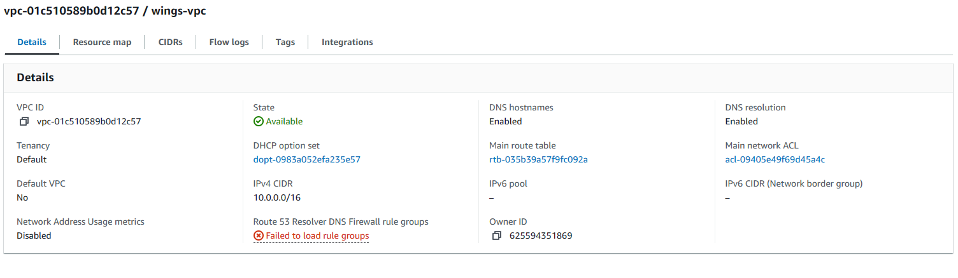

Figure 3: wing-vpc details

The configuration of the VPC is shown in the figure above, specifically the details. It shows the VPC ID, the defined CIDR block, and other configurations.

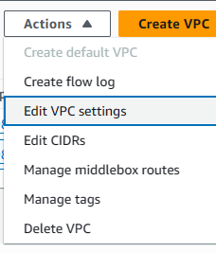

Figure 4: Edit VPC settings

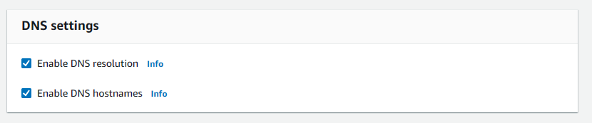

Figure 5: Enable DNS hostnames

The final step in creating the VPC is to choose the “wings-vpc” by clicking the check box and choosing the Action tab. In the VPC setting, ensure that the Enable DNS Resolution and Enable DNS Hostnames are on by checking the check boxes. Checking the DNS resolution allows EC2 instances to translate domain names into IP addresses. Meanwhile, checking the DNS hostnames allows instances to have DNS hostnames assigned to them. These features provide a user-friendly way for users to access and manage the instances. With this configuration, the VPC are setup and can be used to host the instances.

## Subnets

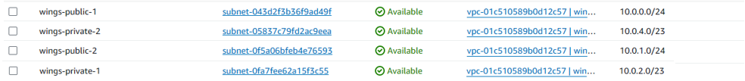

Figure 6: subnets in wings-vpc

Following the creation of the VPC, the subnets within the VPC are defined. Similar to a VPC, which is a defined range of addresses to be utilised in a particular network, subnets are smaller ranges of IP addresses that help break down large networks into smaller segments to serve different purposes. An excellent example of subnet usage is seen in large corporations, in which various departments are placed in different subnets, increasing network efficiency and security.

In this case, subnets are created for the deployment of AWS resources for WingsCafe, such as Amazon Elastic Compute Cloud (EC2) instances, Amazon Relational Database Service (RDS), and more (AWS, 2024). These subnets will then be attached to the VPC created as mentioned above. The requirements given by WingsCafe outline the migration of existing infrastructure to a secure and highly available cloud environment, which will entail deploying the application in multiple availability zones within the Asia Pacific region. As for the security requirements, the application will be deployed in private subnets, of which a bastion instance and redundant NAT gateways will serve as the intermediary point for access (AWS, 2024). In a nutshell, each availability zone will contain a set of one public subnet and one private subnet.

### Public Subnets

Wings-public-1

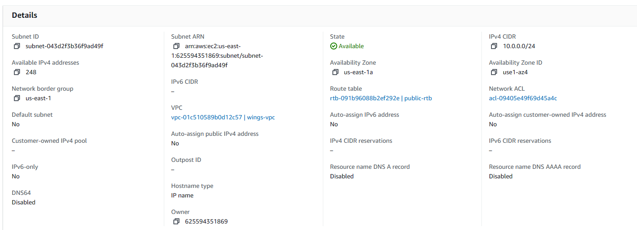

Figure 7: details of wings-public-1

Wings-public-2

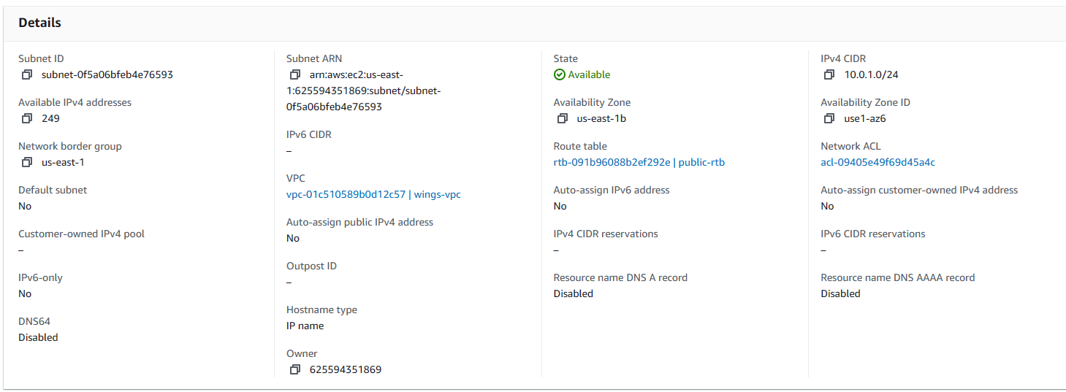

Figure 8: details of wings-public-2

The figures above represent the configurations of the public subnets, which are named wings-public-1 and wings-public-2. The address range assigned to said subnets is 10.0.0.0/24 and 10.0.1.0/24, and they represent the availability zones us-east-1a and us-east-1b, respectively. They are also associated with the wings-vpc and are grouped together in the public route table named public-rtb, which will be explained in further detail in *Section 4.3.1*. The resources of WingsCafe that require direct internet access are placed in these subnets such as the NAT gateways and load balancers (IY, 2023). Further explanations about load balancers and NAT gateways will be provided in *Section A: 4.5* and *Section B: 3.3* respectively.

### Private Subnets

Wings-private-1

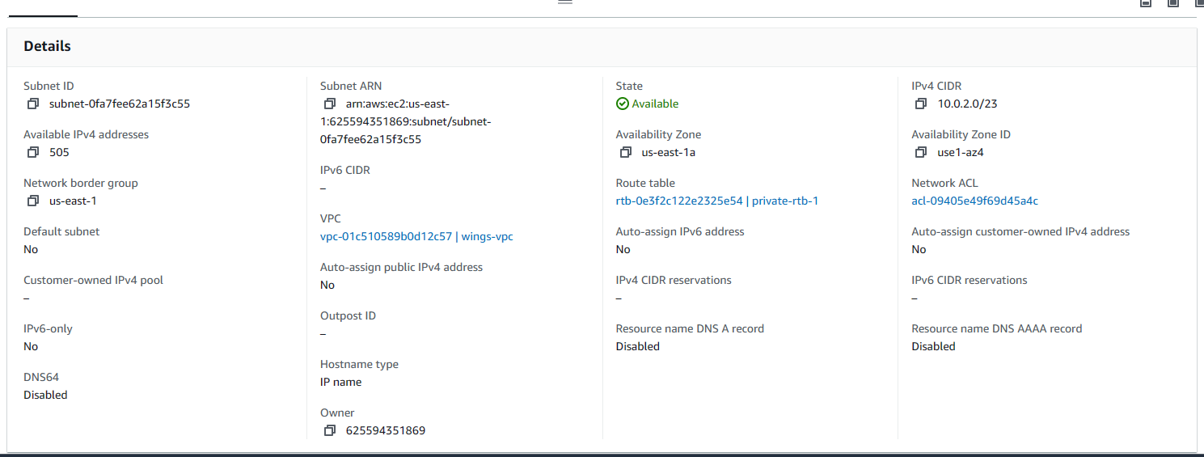

Figure 9: details of wings-private-1

Wings-private-2

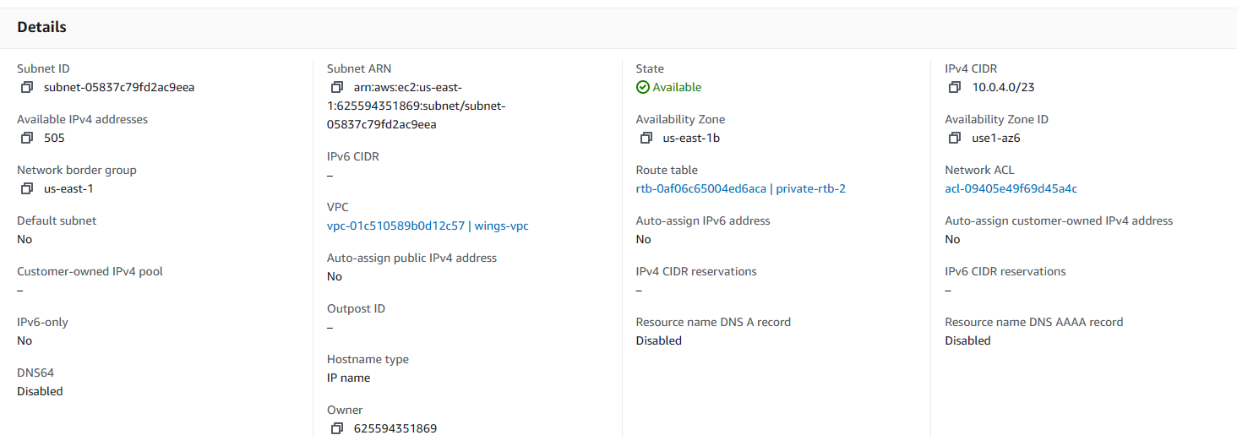

Figure 10: details of wings-private-2

Similar to public subnets, private subnets with the same naming conventions as the public subnets have also been created, namely *wings-private-1* and *wings-private-2*. The assigned IP address ranges for the private subnets are *10.0.2.0/23* and *10.0.4.0/23*, which also represents the availability zones *us-east-1a* and *us-east-1b* respectively. Associations with the *wings-vpc* have been configured as well.

Unlike public subnets, the private subnets are not grouped together in one private route table, but separate route tables instead. This allows for granularity in defining security measures, such as access control rules, that vary between different private subnets and creates high-availability by removing single-points-of-failure, meaning the faults in one availability zone will not affect the functionalities of others (Agarwal, 2024). The configurations for the private route tables are documented in *Section A: 4.3.2*.

## Route Tables



Figure 11: route tables in wings-vpc

A route table in AWS is a set of rules that regulates the path of network traffic (Book, 2023). It is one of the features in VPC that is connected to each subnet, controlling the traffic flow between them. A route table will direct network traffic based on the destination IP addresses. Each route consists of a destination and a target, with the destination being the possible destination of the network traffic and the target being the resource where the traffic will be routed, such as the internet gateway or NAT gateway (Book, 2023). The team has created 1 route table connected to the public subnet and 2 route tables that are connected to each of the private subnets. A further explanation of the created route tables will be shown below.

### Public Route Table

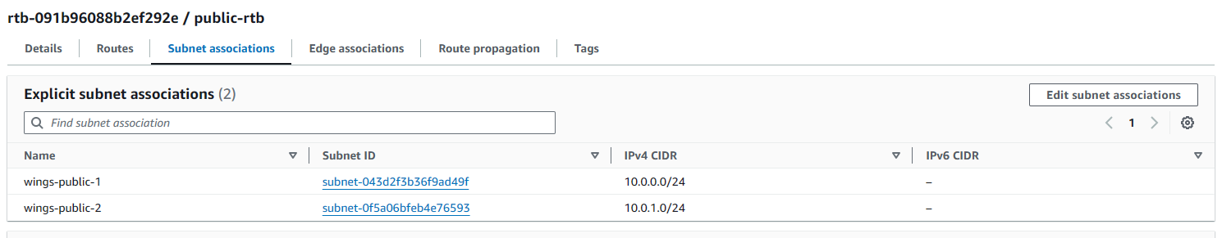

Figure 12: public route table's subnet associations

The public route table is defined as (name) in this VPC. In the Subnet Association tab, the public subnets are attached to this public route table. These public subnets use the same route table as the use case allows both subnets to be routed to the same resources.

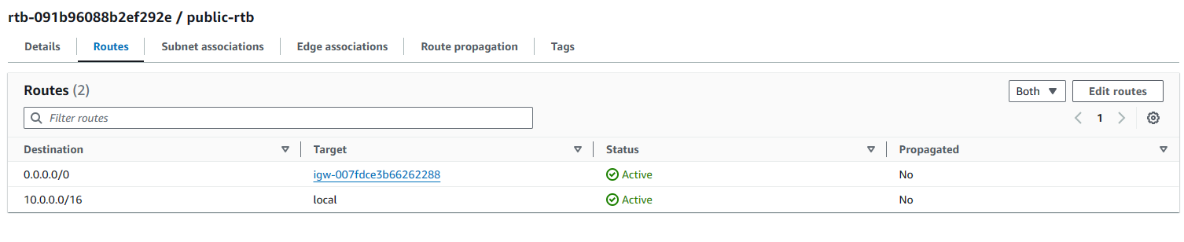

Figure 13: public route table's routes

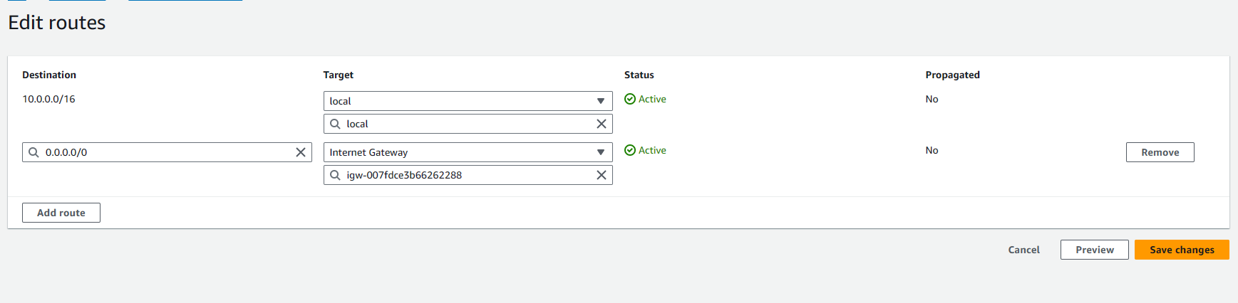

Figure 14: public route table's routes

The route tables consist of several labels that need to be specified to create a route, some of it are the destination and target. The destination is the destination IP address of the network traffic, while the target is the resource where the traffic will be directed to, which is essentially the nest hop of the traffic.

To edit the route table, go to the Routes tab and click “Edit routes”. In the Routes tab, there are two routes that are specified for the public subnets in US-East-1a and US-East-1b. The first route is created by default in the route table, and it comprises of “10.0.0.0/16” as the destination and “local” as the target. The implementation of “10.0.0.0/16”, which is the range of IP addresses of the VPC, as the destination means that the route applies to all traffic routing within the VPC, as opposed to traffic with external destination. The “local” in allows the traffic to be routed to different resources within the VPC.

The second route consists of “0.0.0.0/0” as the destination and “<internet gateway ID>” as the target. The destination of “0.0.0.0/0” means all possible IP addresses, thus any traffic without specific routes will be boxed under this route. This is usually for any traffic that is destined for external networking. The “<internet gateway ID>” is the internet gateway that the team has created. Choosing the internet gateway as the target means that any traffic that matches the destination of “0.0.0.0/0” will be routed to the internet gateway which will route it to the internet.

In conclusion, the two routes are used to allow internal routing and external routing. The external routing is sent to the internet gateway as the next hop to the internet as shown in the architecture is through the internet gateway. Furthermore, the usage of one route table for two public subnets in different availability zones is implemented as the resources in the two subnets will be routed using the same routes. It allows better management of routes and minimize errors that could occur during modification of any of the route tables.

### Private Route Table

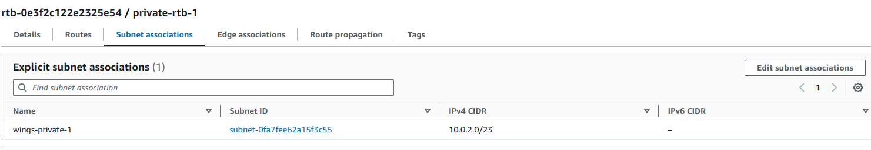

Figure 15: subnet association of private route table in US-East-1a

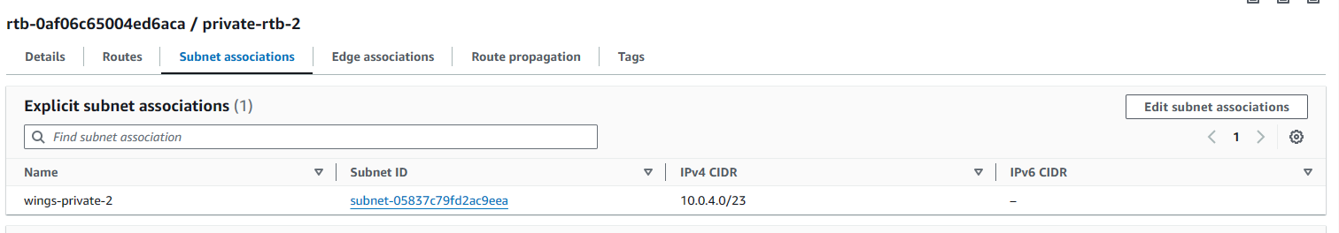

Figure 16: subnet association of private route table in US-East-1b

The private route tables are named as (name) and (name) in this VPC. There are two private route tables, with (name) associated to the private subnet in US-East-1a and (name) associated to the private subnet in US-East-1b. The private subnets are not routed in the same private route table unlike the public subnets, because some routes are different for each of the private subnets. The private subnets of US-East-1a will have external traffic sent to the available NAT Gateway in the public subnet of US-East-1a, while the private subnet in US-East-1b sent the traffic to NAT Gateway situated in the public subnet of US-East-1b. Therefore, two private route tables, each associated with different private subnets, are created.

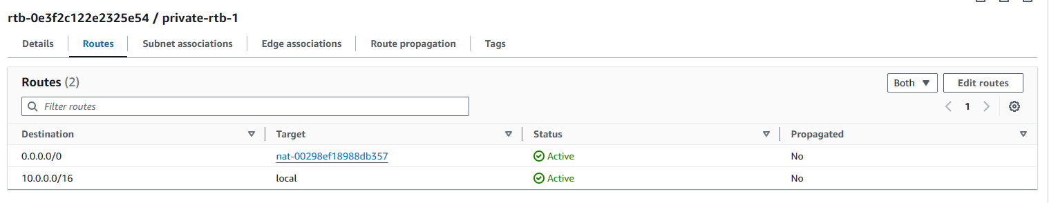



Figure 17: local route in private route table 1

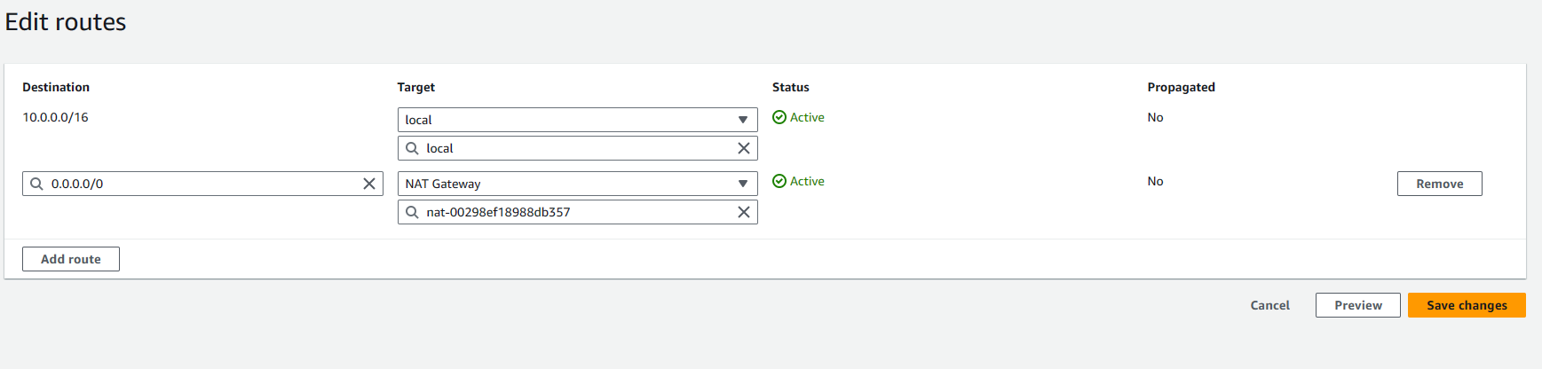

Figure 18: local route in private route table 1

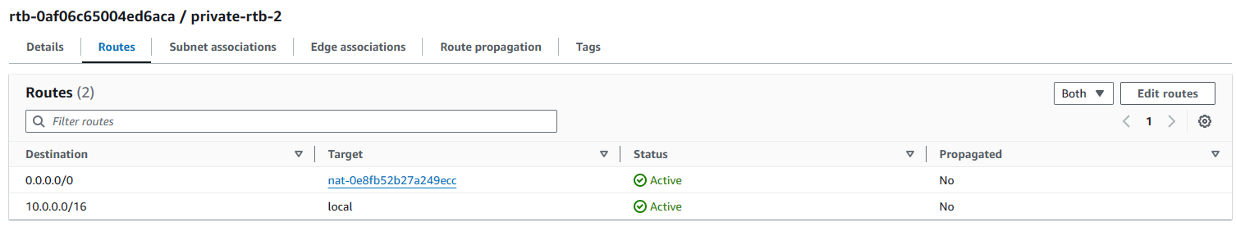



Figure 19: local route in private route table 2

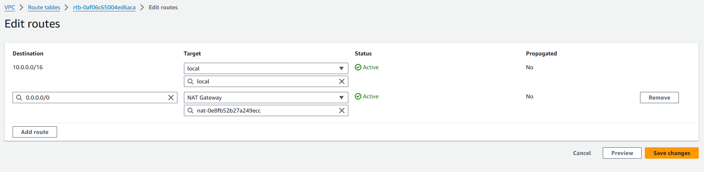

Figure 20: local route in private route table 2

The figures above show that there are two routes for both private route tables. In both route tables, there is the default route, which has the destination of “10.0.0.0/16” and target of “local”. This allows both route tables to have routes that can lead network traffic to resource within the VPC.





Figure 21: external route in private route table 1



Figure 22: external route in private route table 1





Figure 23: external route in private route table 2



Figure 24: external route in private route table 2

The figures above show the routes that led to the team’s decision to create two different route tables for each of the private subnets. The two route tables show that the network traffic destined for “0.0.0.0/0” is sent to the NAT Gateway. However, the NAT Gateway specified in the two route tables are different as different NAT Gateway are created on each of the public subnets that exist in different availability zones. Thus, the private subnets in availability zones 1a and 1b will be routed to the NAT Gateways in their own respective availability zones. To allow granularity and minimize errors in routing, two private route tables are created.

## Internet Gateway



Figure 25: wings-vpc's internet gateway: wings-igw

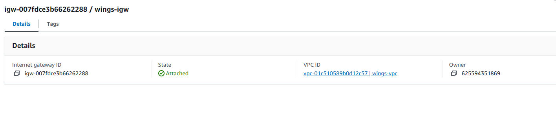

Figure 26: wings-igw configuration's details

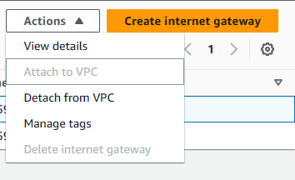

Figure 27: attach wings-igw to wings-vpc

An internet gateway is a scalable feature in AWS that allows communication between VPC and the internet (AWS, 2024). It is the bridge that connected resources in public subnets, such as EC2 instances, to access the internet using a public Ipv4 or Ipv6 address (AWS, 2024). Additionally, it allows connection from the internet to the resources in the subnet. The team created an internet gateway for the project and named it “wing-igw”. After the internet gateway is created, click on the Action button, and choose to attach the internet gateway to the VPC that houses the resources for the café website hosting. Once the internet gateway is attached to the VPC, access to and from the internet is available.

## NAT Gateway

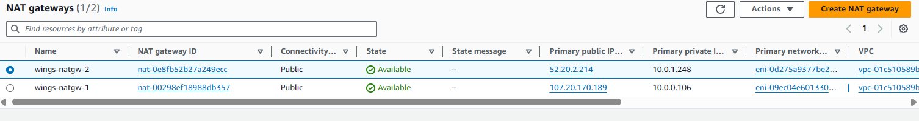

Figure 28: NAT gateways in wings-vpc

A NAT gateway, or Network Address Translation in full, can be defined as a service that allows private networks access to the internet without having to configure public IP addresses, meaning hosts in said network can establish connection to the internet and receive requests and transmit responses, but block connections established by the internet (Oracle Cloud, 2024). Hosts in private networks establish outbound internet connections by transmitting a packet that contains the source (private) and destination (public) IP addresses and route it to the NAT gateway, which translates the private source IP address into a public IP address, and then continues to transfer said packet to the intended recipient. As for the response, the NAT gateway recognises packets that contain the translated public IP address and performs reverse translations to enable routing within private networks. In short, utilising NAT gateways adds a layer of security for private cloud resources by serving as an intermediary platform for network-internet connections.

As mentioned above, the WingsCafe application is hosted on two availability zones, each equipped with a private subnet. Therefore, a NAT gateway is configured for each of said availability zones, which can be seen in the figure above. The names *wings-natgw-1 (us-east-1)* and *wings-natgw-2 (us-east-2)* were chosen. The rationale behind implementing distinct NAT gateways for outbound internet connection from the private networks is akin to the implementation of separate route tables. By defining different NAT gateways for each private network, which are also designed with redundancy in mind, high-availability and fault-tolerance is achieved by eliminating single-points-of failure (AWS, 2024). For instance, when a NAT gateway is faulty, the private network that it is associated with loses outbound internet connection but does not compromise internet connectivity for other private networks. This, in turn, provides the WingsCafe application with highly available and fault-tolerant internet connectivity.

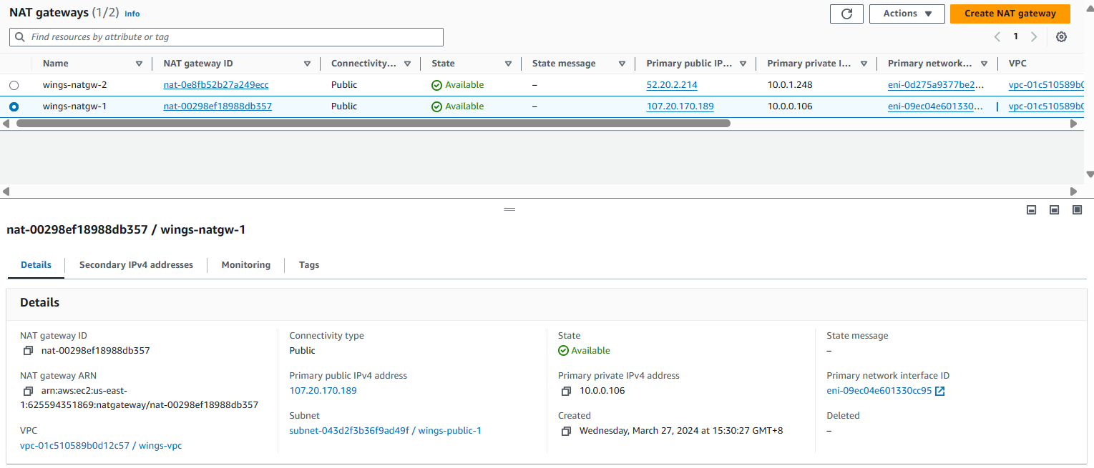

Figure 29: details of wings-natgw-1

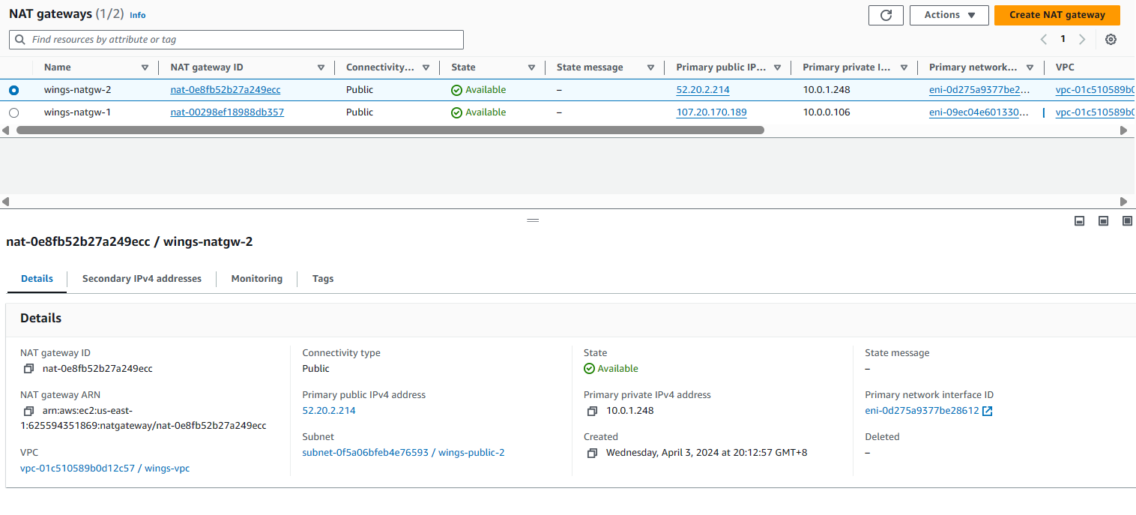

Figure 30: details of wings-natgw-2

The figures above represent the completed configuration for the NAT gateways *wings-natgw-1* and *wings-natgw-2*, which are both associated with the public subnets of each availability zone, namely the *wings-public-1* and *wings-public-2* subnets. The private IP addresses assigned to said gateways that serve as the default gateway for their private hosts are *10.0.0.106* and *10.0.1.248* respectively, whereas the public addresses 107.20.170.189 and *52.20.2.214* were also assigned to the gateways respectively.

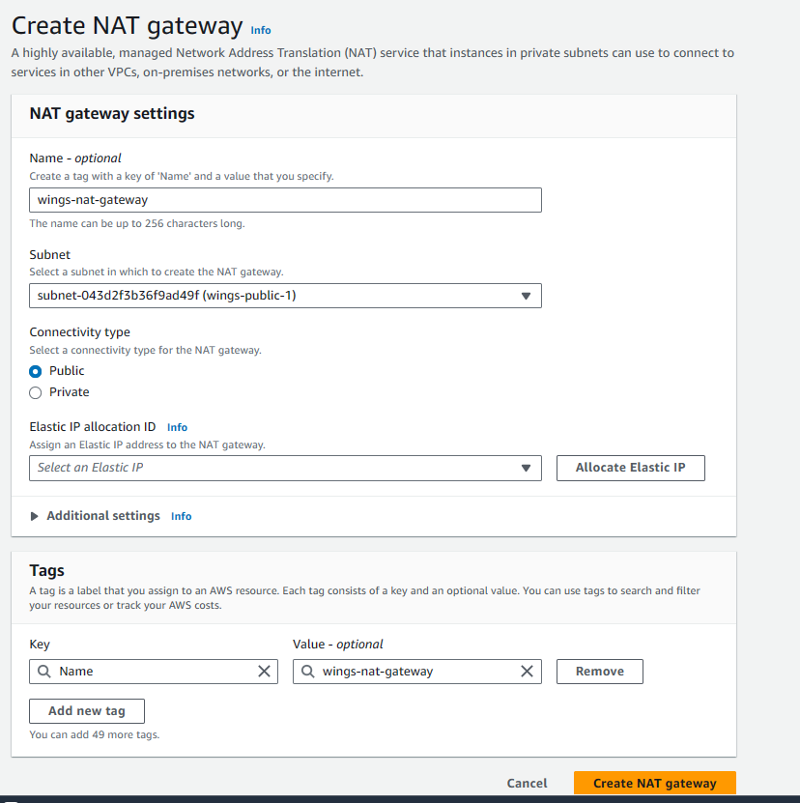

Figure 31: NAT gateway's configuration.

The figure above represents a sample configuration process of the NAT gateways. First the title of the NAT gateway is defined, which in this case is *wings-natgw-1* and *wings-natgw-2*. Then the subnet in which said gateways are created are chosen, which are the public subnets for each availability zone, namely *wings-public-1 (us-east-1)* and *wings-public-2 (us-east-2)*. The public connectivity type has been chosen to allow outbound internet traffic from private hosts while restricting inbound traffic to the private hosts from the internet. Lastly, the elastic IP address is also selected, which in this case is the *wings-eip* elastic IP that the team has configured. The specifications and configuration process is documented in *Section A: 4.6*.

This concludes the NAT gateway configuration process, and the *Create NAT gateway* button is then clicked to start the creation process.

## Elastic IP Address

Another staple feature in cloud computing environments is elastic IP addressing. Elastic IP addresses can be defined as a fixed static IP address that can be associated with cloud resources, which would otherwise have constantly changed IP addresses due to dynamic assignment (AWS, 2024). Configuring elastic IP addresses and associating them with cloud resources allow consistent connection to said resources to be established regardless of the status of the instance, which provides fixed endpoints for communication. Furthermore, its mobility allows associations to be migrated between instances, allowing quick remapping to alternative instances when one is experiencing downtime and providing enhanced flexibility and availability (AWS, 2024). Allocating elastic IP addresses comes with no additional charge as long as they are associated with a functioning cloud instance (Stack Overflow, 2017).

Implementing elastic IP addresses would be beneficial for the deployment of the WingsCafe web application on the cloud. In this case, the elastic IP address is associated with the public NAT gateway that allows for the assignment of a static and consistent public IP address for outbound internet traffic from hosts in private networks, enhancing efficiency of outbound internet traffic from private hosts.

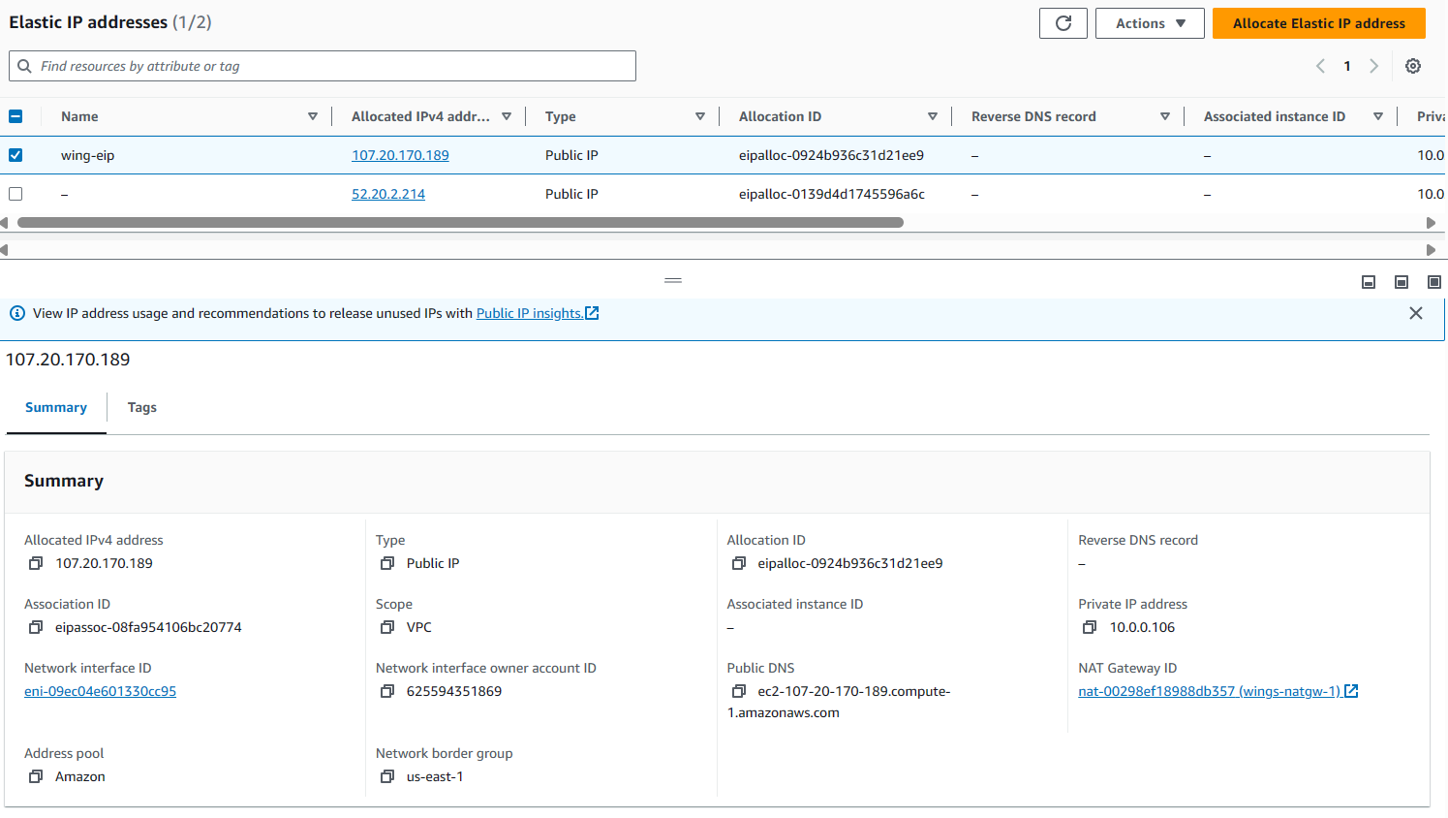

Figure 32: elastic ip used in wings-vpc for NAT gateways

The figure above illustrates the completed configuration of the elastic IP address utilised for the WingsCafe cloud implementation, named as *wings-eip* with the public IP address *107.20.170.189*, which is chosen from the pool of available IPv4 addresses from Amazon themselves. The availability zone in which the elastic IP address will be utilised is in *us-east-1*.

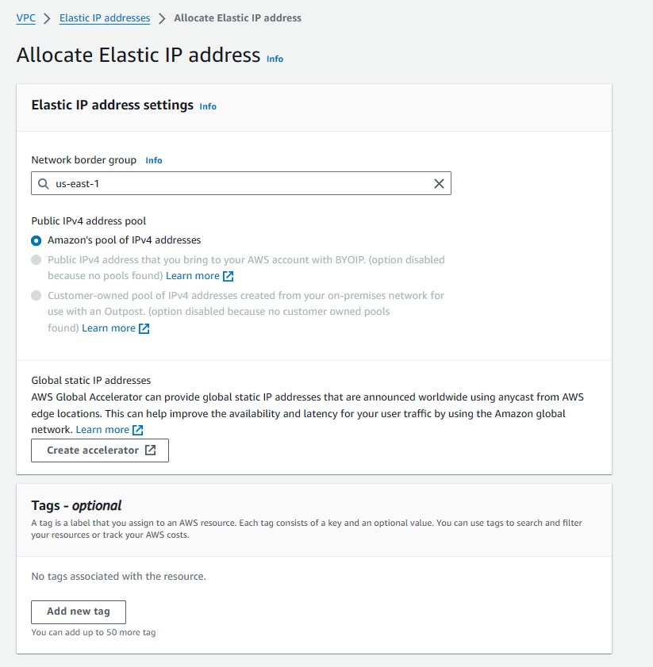

Figure 33: elastic ip's configuration

The configuration process for the elastic IP addresses are fairly simple as well, of which the interface is shown in the figure above. Allocating elastic IP addresses mainly entails defining the availability zone of which the address will be utilized, which in this case is the *us-east-1* availability zone. The IP address pool of which the elastic IP address will be taken from is also defined during configuration, which is the Amazon public Ipv4 address pool. Resource tags are also available but optional for configuration. After clicking on the *Allocate Elastic IP Address* button at the bottom, the elastic IP address is finally assigned according to the criteria defined during configuration.

# Disaster Recovery Plan (D.R.P)

Disaster recovery is the proactive activities and measures taken by an organization to prepare and respond to technology-related disasters that may be faced in the future. These disasters can range from situations such as power outages to natural calamities occurring and security breaches, where the impact of these events could hinder the systems from meeting their business objectives at their primary location. In assessing the effectiveness of the disaster recovery solutions applied key metrics are used such as Recovery Point Objectives (RPO) and Recovery Time Objectives (RTO) where these metrics focus on ensuring quick restoration after rare but impactful events. This process encompasses the establishment of protocols and policies aimed at swift recuperation from such incidents (Disaster Recovery Options in the Cloud - Disaster Recovery of Workloads on AWS: Recovery in the Cloud, n.d.).

The significance of why disaster recovery is so important to an organization and is a practice that must be adhered to, is due its ability to mitigate the adverse effects of unexpected disruptions towards a organization's IT systems and infrastructure, which could have been a result of a variety of occurrences such as natural disasters, technical failures, human error, or cyberattacks. These disruptions are extremely harmful as they not only disrupt daily business operations but also affect the revenue streams and customer satisfaction. Being able to promptly respond to these disruptive events will allow the facilitation of uninterrupted business continuity and minimized downtime thus cutting down on any significant financial losses that the organization might face potentially (Disaster Recovery Options in the Cloud - Disaster Recovery of Workloads on AWS: Recovery in the Cloud, n.d.).

Moreover, integrating data protection, backup, and restoration processes into disaster recovery strategies bolsters system security, reducing vulnerabilities to ransomware, malware, or other cyber threats. This proactive approach not only protects sensitive data but also fosters customer trust by demonstrating the organization's commitment to safeguarding their information. Additionally, well-prepared disaster recovery plans contribute to enhanced customer retention by minimizing service interruptions and swiftly addressing customer inquiries during crisis situations (Disaster Recovery Options in the Cloud - Disaster Recovery of Workloads on AWS: Recovery in the Cloud, n.d.).

Furthermore, on the justification for organizations to implement their own DR, effective disaster recovery planning can yield cost-saving benefits by minimizing recovery costs associated with downtime and productivity loss. For instance, leveraging cloud storage solutions for data backup offers a cost-effective means of maintaining operations while mitigating financial losses. By investing in robust disaster recovery measures, organizations can not only mitigate the risks posed by unforeseen disasters but also bolster their resilience and competitiveness in an increasingly volatile business environment (Disaster Recovery Options in the Cloud - Disaster Recovery of Workloads on AWS: Recovery in the Cloud, n.d.).

## Type of D.R.P

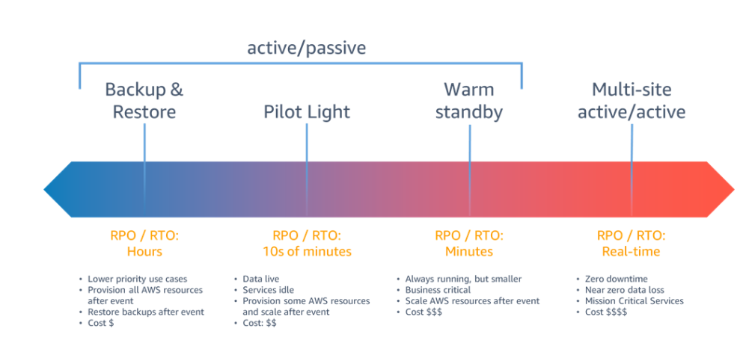

Image _: Types of Disaster Recovery Infographic (*Disaster Recovery Options in the Cloud - Disaster Recovery of Workloads on AWS: Recovery in the Cloud*, n.d.)

AWS allows its clients to set up disaster recovery alongside its other services to ensure the business continuity of its clients. AWS offers 4 disaster recovery strategies being Backup and Restore, Pilot Light, Warm Standby and Multi-site Active. This section will discuss in depth the 4 strategies and finally decide on which strategy will be implemented alongside its justification for selection.

### 5.1.1 Backup and Restore Strategy

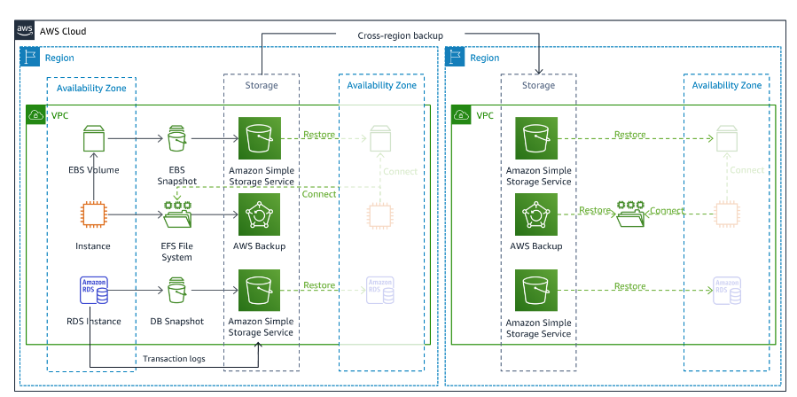

Image _: Illustration of Backup and Restore Strategy (*Disaster Recovery Options in the Cloud - Disaster Recovery of Workloads on AWS: Recovery in the Cloud*, n.d.)

The Backup and restore strategy are seen as the simplest and most straightforward approach suitable for mitigating data loss or corruption. This strategy mitigates the looming threat of disaster by periodically or constantly backing up data from the client’s primary site, as well as redeploying infrastructure, configurations, and application code in a recovery region. Backup with point-in-time recovery is available for various AWS services such as Amazon EBS, Amazon DynamoDB, Amazon RDS, and others. Continuous data replication, particularly with Amazon S3 Cross-Region Replication, offers near-zero backup times but may not protect against all disaster events. AWS Backup provides centralized management for configuring, scheduling, and monitoring backups across various AWS resources. In general, this strategy is suitable for applying towards non-critical applications, where in nature downtime of these applications are less of a concern and Data recovery can take longer. In general, the strategy's main benefits is it being the most cost effective out of the 4 but provides a recovery time to the client as there are many time consuming processes involved such as as data needs to be restored and applications need to be reconfigured. The key service to employing this strategy is AWS Backup service. The service serves as a unified platform for the purpose of protecting data across several AWS services, enabling regular or continuous backup schedules to satisfy diverse Recovery Point Objectives (RPOs).

### 5.1.2 Pilot Light Strategy

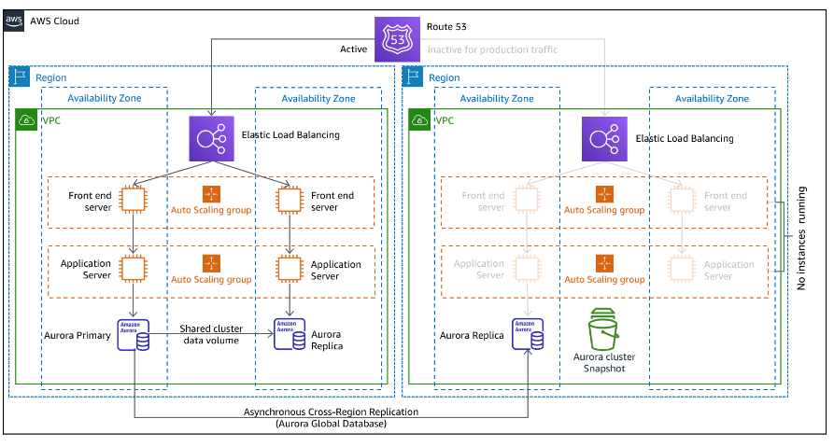

Image _: Illustration of Pilot Light Strategy (*Disaster Recovery Options in the Cloud - Disaster Recovery of Workloads on AWS: Recovery in the Cloud*, n.d.)

The pilot light approaches disaster recovery by replicating data to the recovery region and providing a scaled-down version of the core workload infrastructure. By using this approach, the essential resources for data replication and backup are in constant operation but other elements such as application servers remain "switched off" until required to be used when a disaster happens. This strategy tries to minimize cost by cutting out any ongoing costs that can be incurred by reducing the amount of active resources but remains faster than backup and restore strategy by implementing core infrastructure readily available. In the occurrence of an actual disaster, the backup environment can be scaled from a minimal environment to a full-scale production environment. Continuous data replication is critical for meeting low recovery point objectives (RPO), while point-in-time backups provide further security against data corruption or destruction. In the pilot light strategy, there are multiple services that play pivotal roles, but the key service implemented is usually the database, because it's the most critical component containing stateful data. AWS database services such as Amazon RDS (Relational Database Service) or Amazon DynamoDB are typically used to maintain a live, up-to-date copy of your data. The replication features of these database services are what keep the Pilot Light "lit."

### 5.1.3 Warm Standby Strategy

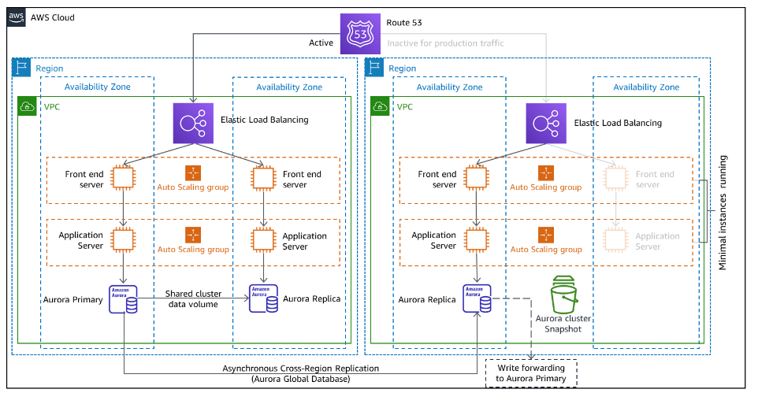

Image _: Illustration of Warm Standby Strategy (*Disaster Recovery Options in the Cloud - Disaster Recovery of Workloads on AWS: Recovery in the Cloud*, n.d.)

The warm standby strategy is a strategy that extends upon the pilot light strategy by which a fully functional copy of the production environment is available in the recovery region. This strategy differs from the former by constantly keeping a standby scaled down environment always-on (warm) in the secondary region, that can be scaled up during disaster thus reducing recovery time. Scaling resources using services like Amazon EC2 Auto Scaling enables quick provisioning of resources to support production traffic. While warm standby offers faster recovery times, it requires more resources and incurs higher costs compared to pilot light. Regular testing and continuous improvements are necessary to maintain confidence in the disaster recovery strategy. The strategy is best implemented when critical applications have minimal recovery time, but continuous full-scale operations are not cost-effective or feasible for a client to take on. This is due to the fact that the standby environment is most usually scaled-down version, employing less instances; like what can be seen in the image above and thus does not allow the environment to host a normal/maximum workload like the main environment (Disaster Recovery Options in the Cloud - Disaster Recovery of Workloads on AWS: Recovery in the Cloud, n.d.).

### 5.1.4 Multi-Site Active

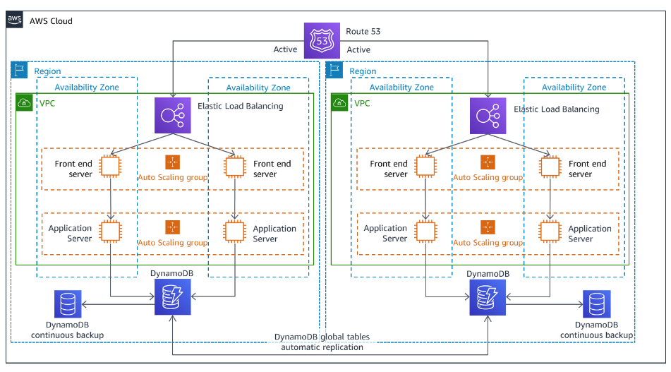

Image _: Illustration of Multi Site Active Strategy(*Disaster Recovery Options in the Cloud - Disaster Recovery of Workloads on AWS: Recovery in the Cloud*, n.d.)

The multi-site active/active strategy involves the method of running the workload of the entire architecture (both in the primary and recovery zone) simultaneously, thus allowing users to access the applications and services from any of the two deployed regions in which the architecture has been fixed to. This strategy provides near-zero recovery times for most disasters, and this is suitable to be employed for use cases where it is essential for mission-critical applications that require an instant failover mechanism to be activated. In this process, there is continuous data replication which helps to ensure data consistency across regions, while active/active traffic routing distributes user requests efficiently. Although very efficient as a DR strategy providing instantaneous recovery, the method is also the most expensive to implement due to it actively full-scale operations and architecture at multiple sites and this causes the client to incur double the cost. Key services in this strategy are primarily Amazon Route 53 whose main function is to manage DNS and traffic routing by intelligently directing user requests to the nearest available region that has the least latency or based on health checks which helps to ensure high availability and fault tolerance. Additionally, other services used to Route 5 are AWS Global Accelerator which complements the service by being able to optimize the user traffic to travel over the AWS global network backbone, reducing jitter and improving performance. Another service that is implemented alongside route 53 is AWS Auto Scaling that automatically adjusts the number of active instances across each active site according to incoming traffic, which ensures that each site can handle its load efficiently and maintain performance during varying demand levels (Disaster Recovery Options in the Cloud - Disaster Recovery of Workloads on AWS: Recovery in the Cloud, n.d.).

### 5.1.5 Comparison of each Strategy

|  |  |  |  |  |
| --- | --- | --- | --- | --- |
| **Characteristic** | **Backup and restore** | **Pilot Light** | **Warm Standby** | **Multi Site Active** |
| **cost-effectiveness** | High | Moderate | High | High |
| **Recovery Time Objective** | Moderate  (<24 hours) | Moderate  (hours) | Low  (minutes) | Near Zero  (seconds) |
| **Recovery Point Objective** | Moderate  (hours) | Low  (minutes) | Low  (seconds) | Near Zero  (none/seconds) |
| **Complexity** | Low | Moderate | Moderate | High |
| **Resource Consumption** | Low | Moderate | High | High |
| **Continuous Data Replication** | Optional | Essential | Essential | Essential |
| **Automation** | Optional | Essential | Essential | Essential |
| **Infrastructure as Code** | Essential | Essential | Essential | Essential |

## Strategy Selection

Through understanding the basic characteristics of each strategy, the wings cafe has decided to proceed on with the restore and backup strategy for their method of disaster recovery. The justification of the decision is based on a few elements. Amazon advices for the best practice in creating a solid disaster recovery strategy is to clearly define the recovery point objective, recovery time objective, the strategy that is able to applied to be able to meet those objectives and finally test and validate the implementation of chosen strategy to ensure the configurations are correct and process can occur smoothly.

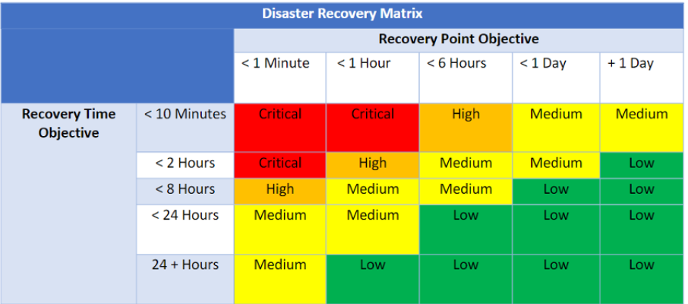

*Image _: Disaster Recovery Matrix (REL13-BP01 Define Recovery Objectives for Downtime and Data Loss - AWS Well-Architected Framework (2023-04-10), 2023)*

With that being said, the primary reason behind the selection is due to the strategy meeting the requirements of the RPO and RTO of the company. Opting for a backup and restore strategy for a cafe's website aligns well with more lenient RPO and RTO parameters, making it an appropriate choice for a business that doesn't heavily depend on online transactions. Assuming the Wings Cafe site does not handle frequent data changes or require instantaneous data replication such as in the situations of high-volume online ordering or real-time inventory management — the appropriate RPO goal that allows for daily backups can suffice. This assumption can be made as Wings Cafe primarily operates as a traditional brick and mortar business and thus might have low transaction volume from this site. Besides that, customers can be redirected to traditional ordering methods as well. With that being said, setting the RPO goal in a day (less than 24 hours) is an acceptable benchmark to be met and also is fulfilled by the suggested strategy. In addition to what's been said about the primary method of business, considering that the cafe’s primary business model might not heavily rely on the website's continuous operation, the RTO can afford to be longer. A temporary website outage would have a minimal impact on the cafe’s walk-in customer base and operations (REL13-BP01 Define Recovery Objectives for Downtime and Data Loss - AWS Well-Architected Framework (2023-04-10), 2023). In this scenario, the priority shifts from rapid recovery to ensuring a reliable and cost-effective method to restore essential functions when needed, a balance that a backup and restore strategy effectively offers.

# Final Outcome

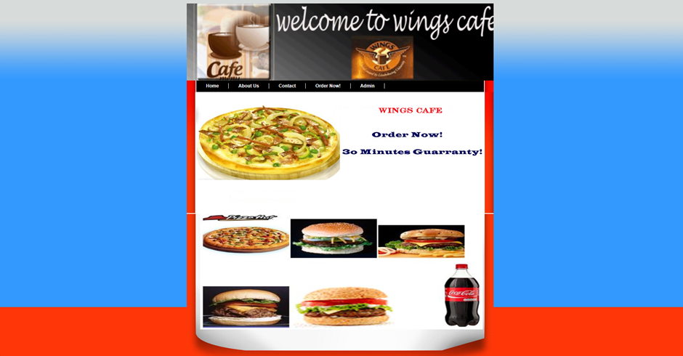

*Image: Final outcome of the configurations 1*

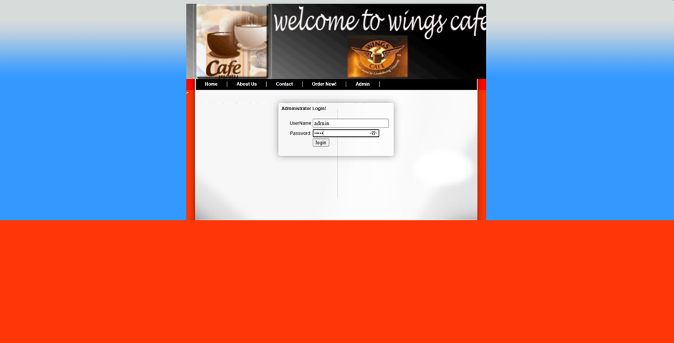

*Image: Final outcome of the configurations 2*

The final result of the project can be seen as the images above which is proof of successfully hosting Wings Cafe Dynamic Website by using AWS and its services. The website has been deployed into the cloud and cloud platform, allowing public users to gain access to the website, and access all its features. The architecture of the project includes the use of an elastic load balancer which will help in overcoming the network traffic, as well as security groups to ensure the security of the site. Adding onto this, the implemented EC2 instances of the site will be automatically replaced by another instance that is running on another availability zone through the auto scaling group implementation. In addition to all of this, a disaster recovery plan (DRP) using the approach of backup and restore was proposed to help as a failover mechanism to ensure business continuity.

# Section B: Individual Work

# Security

## Security Groups

In AWS, a security group acts as a virtual firewall for the services, managing both inbound and outbound traffic (AWS, 2024). It applies to individual instances rather than network interfaces, controlling the network traffic according to predefined rules (AWS, 2024). For example, rules might allow HTTP or HTTPS traffic on a specific port for web servers in private subnet. Unlike subnets, which essentially divide the network, security groups focus more on controlling traffic for instance.

Security groups usage exceed beyond EC2 instances to other AWS services such as RDS, Redshift, and Lambda, improving access control (Book, 2023). Each VPC has its own default security group that is automatically applied if there is no specified security group.

To support security groups, other security components such as NACL and IAM roles are provided to create comprehensive protection against threats and errors (Book, 2023).

### Bastion Security Group



Figure 34: bastion host's security group

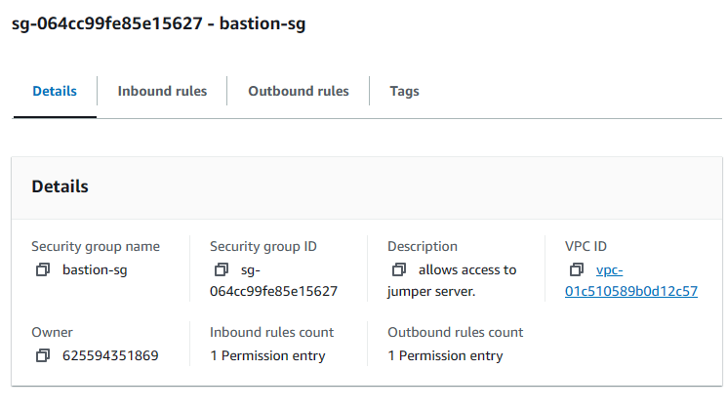

Figure 35: bastion host's security group details

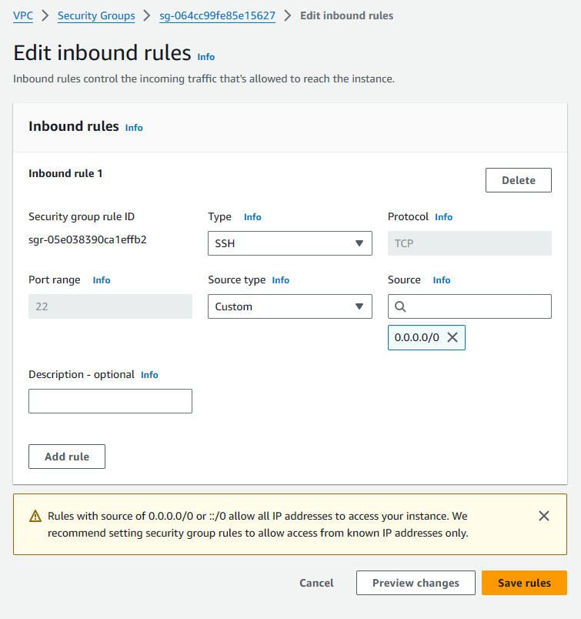

Figure 36: bastion host's security group inbound rules

The figures above show that a security group that will be attached to the bastion host is created. The security group consists of inbound and outbound rules. The outbound rules is the default rules that are applied to other security group which is to allow all traffic. However, the inbound rules will be more restricted to ensure better security. In the inbound rule shown above, the team allowed SSH access on port 22 from anywhere to the bastion host. A bastion host is an intermediary, a secure gateway that allows users to safely access the instances in a private subnet. Therefore, the security should restrict access only for SSH activities in the bastion host.

### Load Balancer Security Group



Figure 37: load balancer's security group

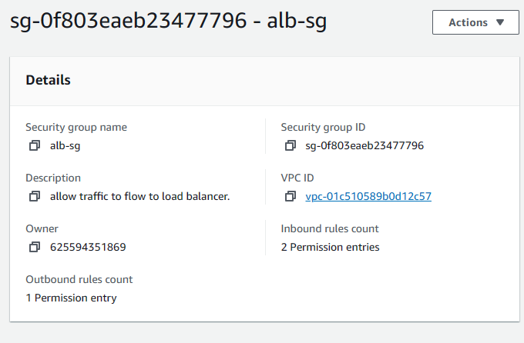

Figure 38: load balancer's security group details

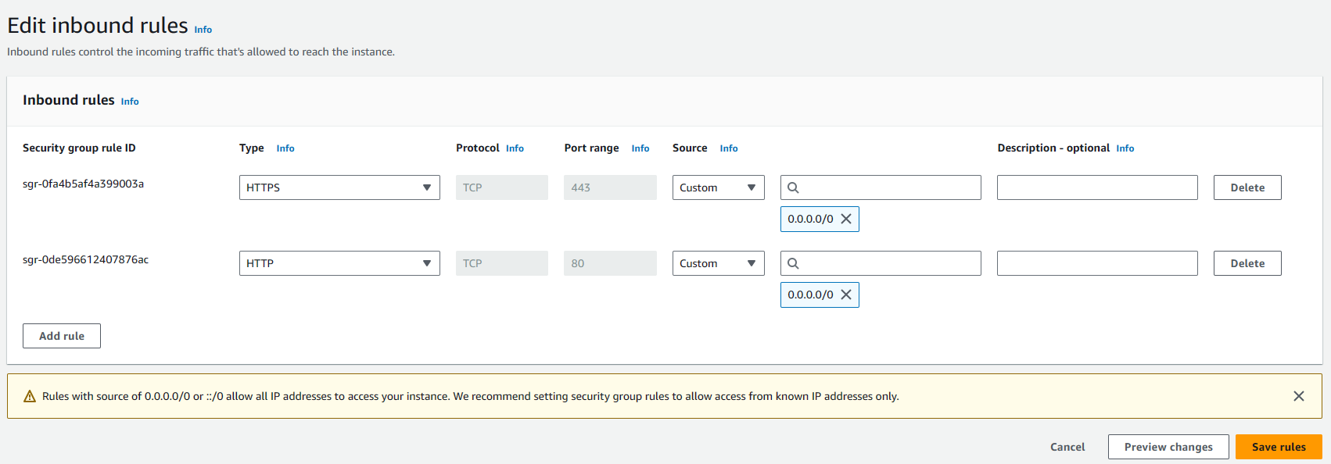

Figure 39: load balancer's security group inbound rules

The figures above showed that a security group was configured to be attached to the load balancer. It shows that the load balancer security group allows inbound for HTTP and HTTPS request, each from its respective ports which are 80 and 443, from anywhere. Load balancer is an internet facing resource. Therefore, it works as a gateway for users’ request to reach the web server or other services. By allowing access from anywhere on ports 80 and 443, the team ensures that anyone can potentially send their HTTP and HTTPS request to the web server.

### Web Server Security Group



Figure 40: web server's security group

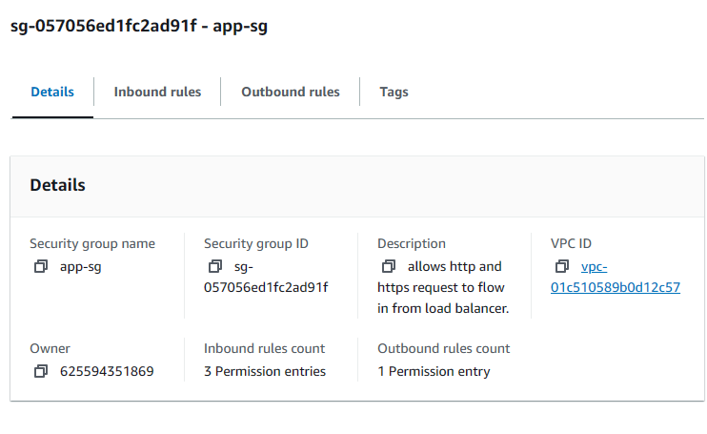

Figure 41: web server's security group details

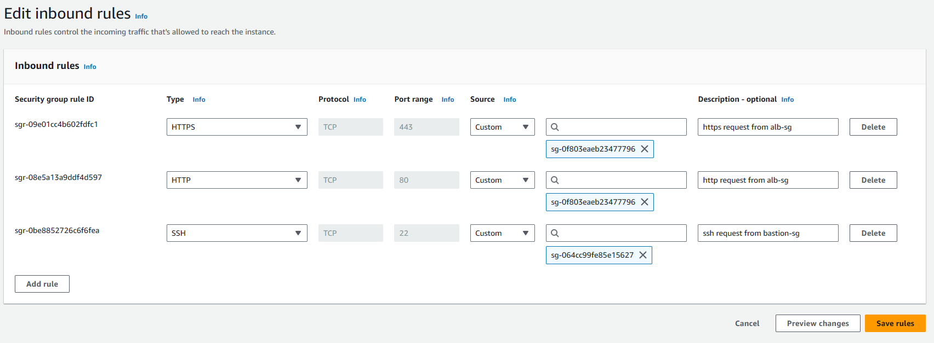

Figure 42: web server's security group inbound rules

The figure above shows the configuration of another security group that is attached to the private ec2 or web server. The inbound rules allow for HTTP and HTTPS access through port 80 and 443 from the load balancer’s security group. Additionally, it also allows SSH request on port 22 from the bastion host security group.

The web server, which is the private ec2, is in the private subnets. Therefore, it doesn’t have a public IP address and can’t be accessed directly from the internet. The security group attached to the server ill allow specific inbound traffic to access the web server, thus restricting access and improving security of the web server. The security group allows for HTTP and HTTPS requests from the security group of the load balancer. This ensures that only traffic that has passed the security group of the load balancer can reach the private ec2. It provides granular security to the web server. It also prevents external users from directly accessing the web server through its private IP address.

The security group also allows for SSH access on port 22 from the security groups of the bastion host. This enables for a secure connection for management purposes. Through restricting SSH access to the bastion host, the web server avoids being directly exposed to the internet for remote access as it needs to pass through the bastion host’ security group.

### Database Security Group



Figure 43: database's security group

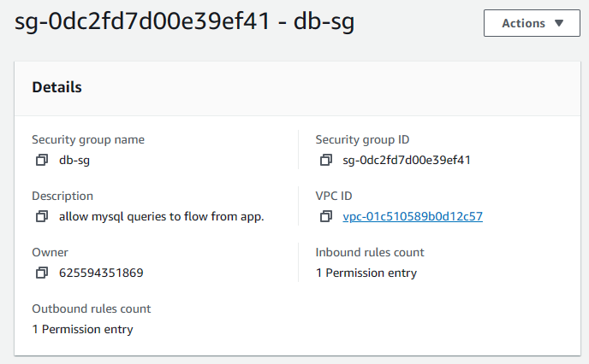

Figure 44: database's security group details

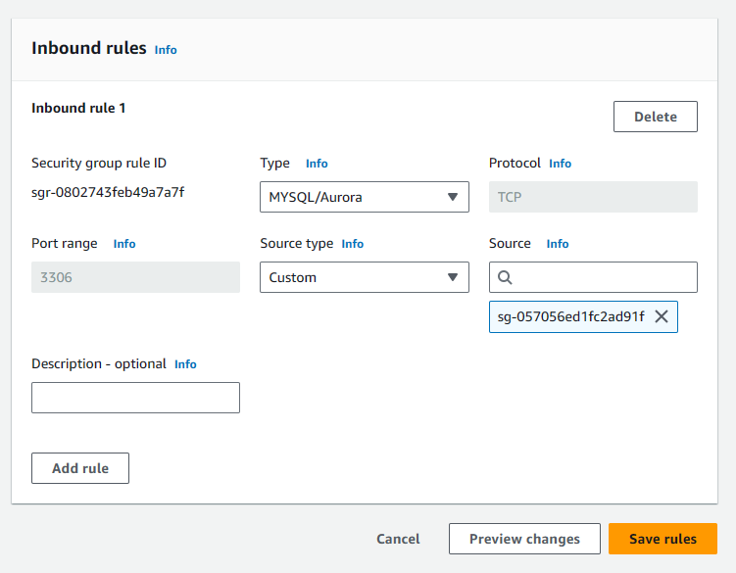

Figure 45: database's security group inbound rules

The database security group is created as shown in the figure above. The inbound rules allow for MYSQL request on 3306 from security group of the web server. The database contains sensitive information about the café’s client, making it a target for attackers. This security group minimizes the possibility of attacks to the database. Specifying the MYSQL protocol ensures that only connections using the right communication format are allowed. Allowing only from the security group of the web server also restricts access to connection coming from the web server instances. Therefore, attempts to access the database from external sources like the internet will be blocked.

## NACL

A Network Access Control List (NACL) is a security feature that is used in AWS’ VPC service. It works using inbound and outbound, thus controlling the traffic going to and from the subnets. It is similar to how security group works and structure itself. However, NACL’s usage is limited in AMS Managed Multi-Account Landing Zone. In this project, the NACL is created automatically by the learner’s lab as the team work on other resources.

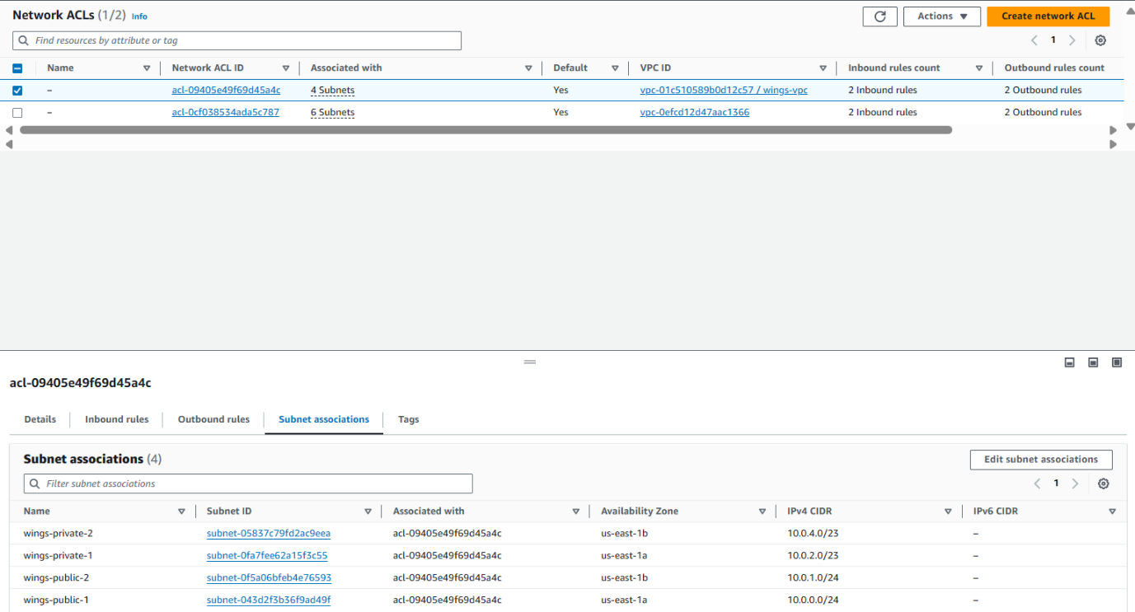

Figure 46: NACL subnet association

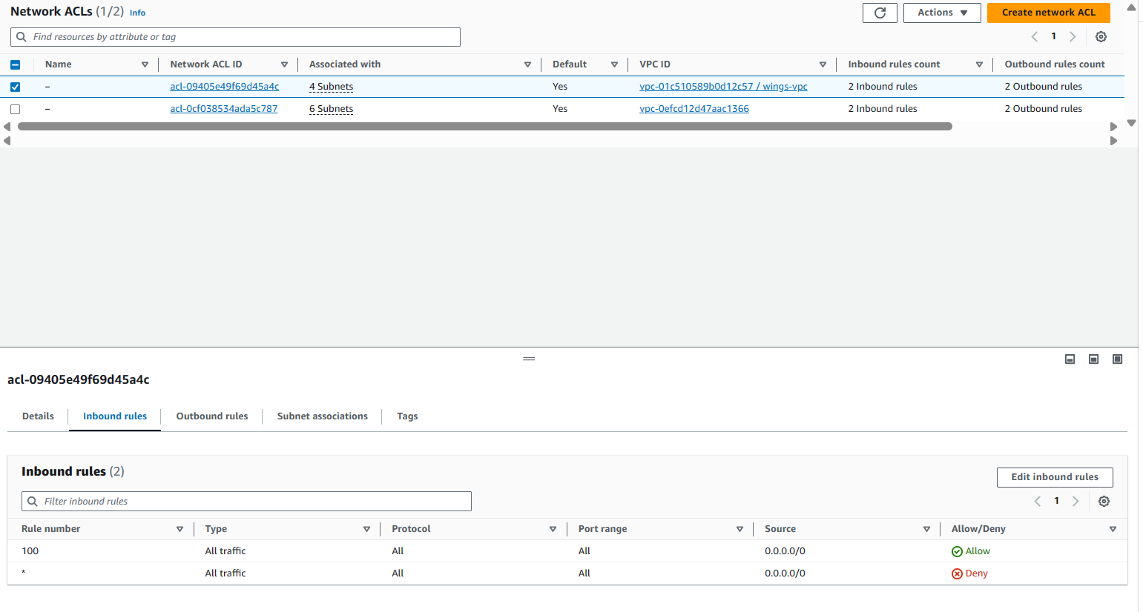

Figure 47: NACL inbound rules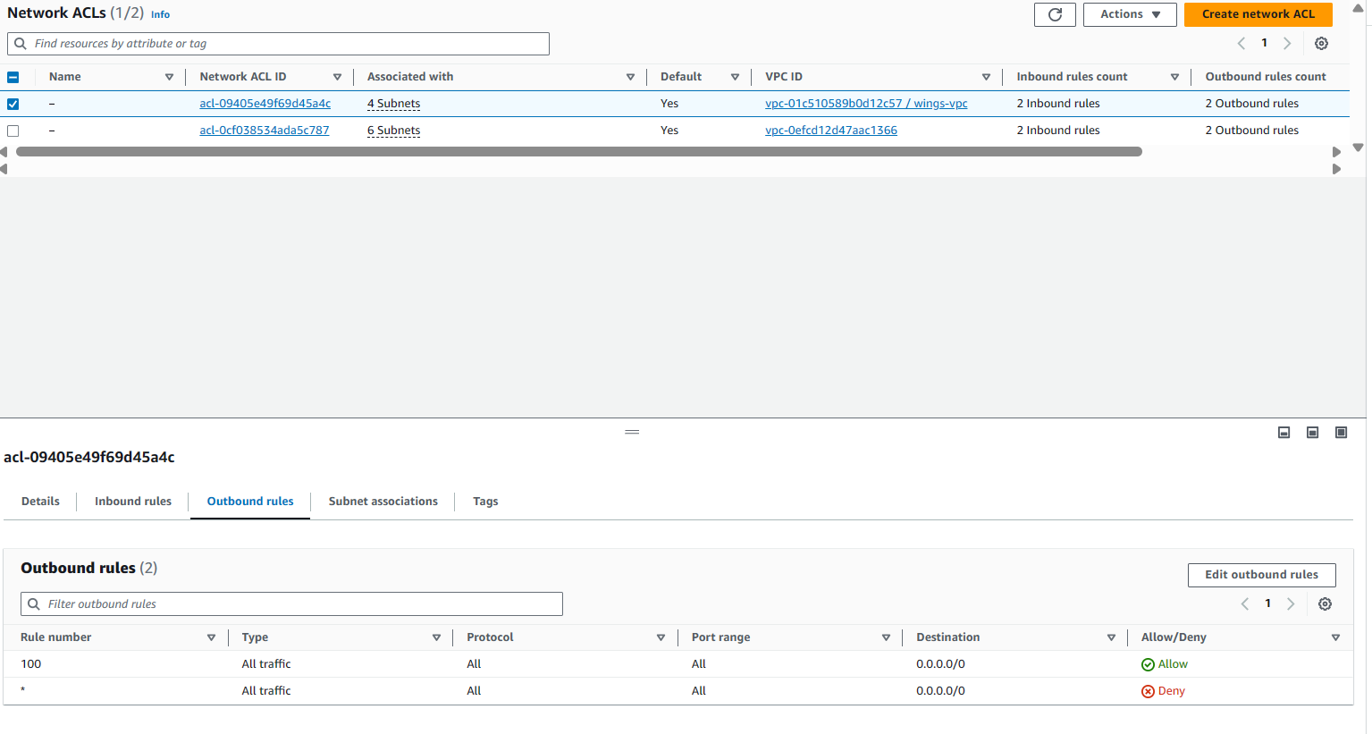

Figure 48: NACL outbound rules

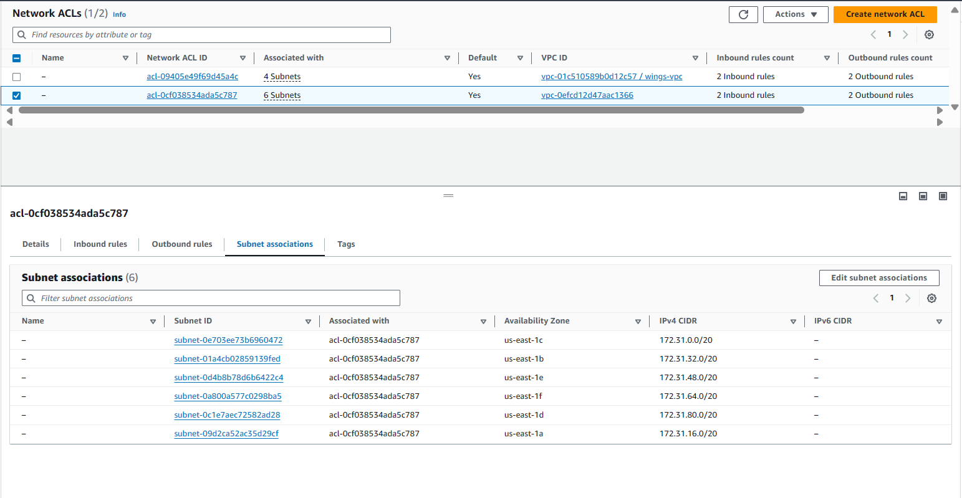

Figure 49: NACL subnet associations

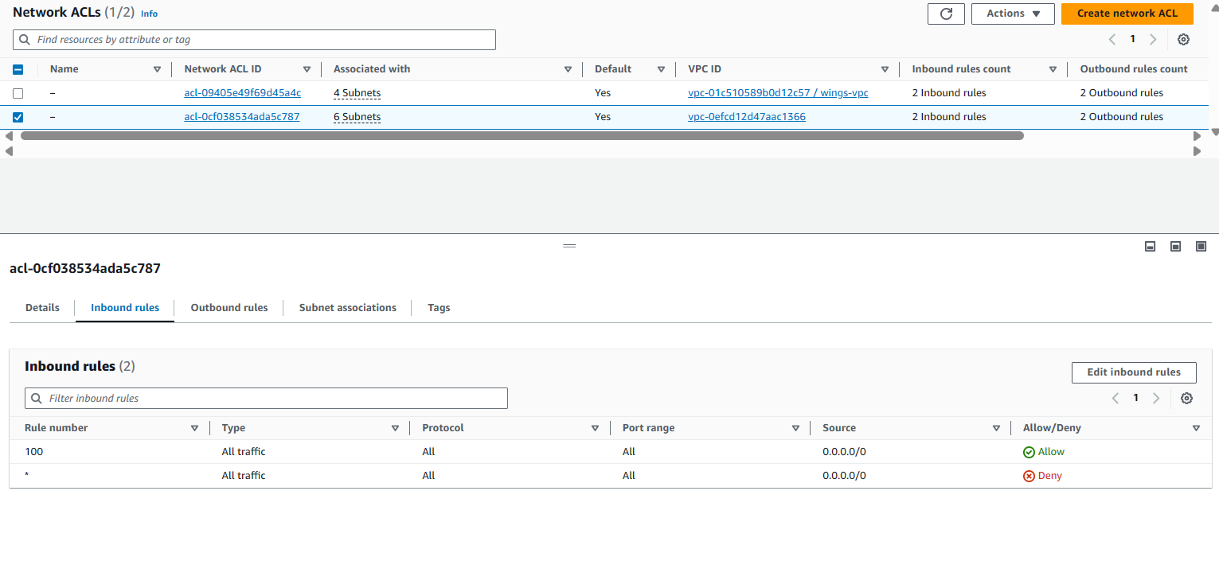

Figure 50: NACL inbound rules

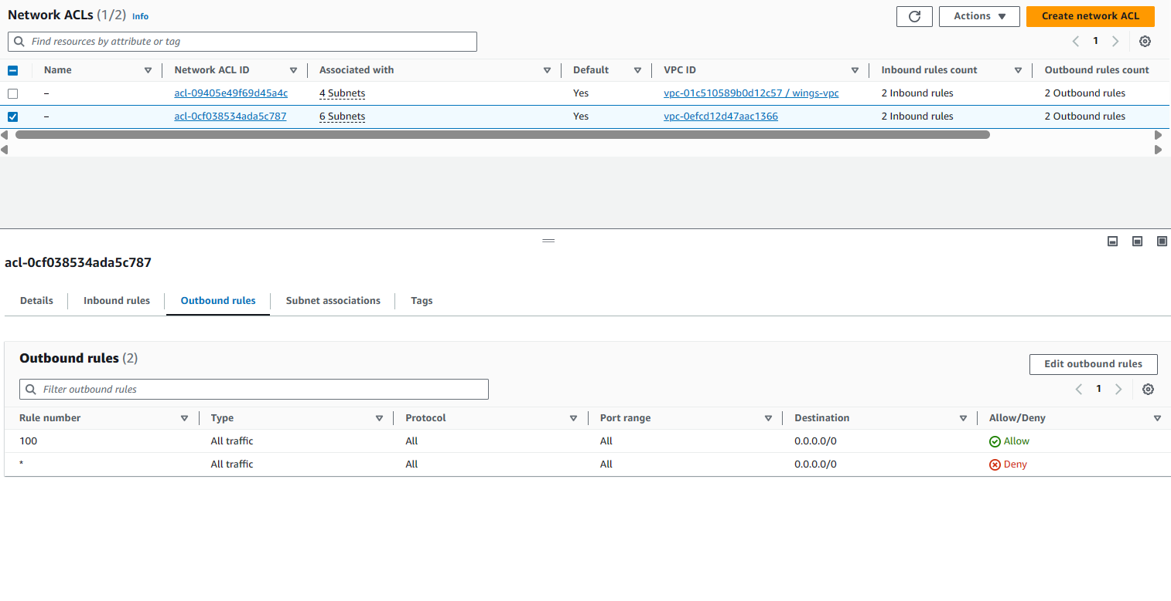

Figure 51: NACL outbound rules

The figures above shows 2 NACL, one with 4 subnets associated and the other with 6 subnets associated. The NACL with 4 subnet associations are the NACL for the subnets created by the team. It explicityly shows the inbounc and outbound rule to allow all traffic. The other NACL with 6 subnet associations are filled with subnets pre-defined by the learner’s lab and also shows the inbound and outbound rule to allow all traffic.

## Bastion Host



Figure 52: bastion host in wings-vpc

A bastion host is a server that enables authorization of users to access resources in private network from an external source like the internet (Risk, 2021). It’s commonly situated in the DMZ zone as it is a resource that intermediates both the external source, such as the internet, and the internal source, like the private subnet. In this case, the team created the bastion host in the public subnet of US-East-1a. This ensures that it’s still accessible to limited external sources but allows private resources to be separated in the private subnet. This method simplifies access control and reduces potential cyber-attacks. Bastion host can be made from a simple, single purpose server that faces the internet and allow access to private resources (Risk, 2021).

Bastion host mainly focuses on controlling accesses of SSH service (Risk, 2021). Users that want to access internal resources can access through the bastion host that has a public IP address and then continue to create an SSH tunnel to any internal resources, in this case, an EC2 instance. Concentrating authorization in one resource allows administrators to provide better security configurations and access control (Risk, 2021). Additionally, the centralized aspects that stores credentials for authorization allows providing and revoking access to resources more effectively as changes in the bastion can cut off or allow access to all the internal resources.

In an operation, which is mimicked by the team, a bastion host will bridge the internet, which is public zone, and the private subnet, which is the private zone. The team’s architecture involves EC2 instances in private subnets throughout the North Virginia region. Rather than showing the accessible port of the instance, which may invite security risks, a server that simply functions as an intermediary is deployed. Users that will enter through the bastion host will need to authenticate themselves through the usage of SSH keys (Risk, 2021).

The figures below will show the process of creating a bastion host. In conclusion, bastion host is just like any simple EC2 server, The only difference is the usage of the instance by users and administrators.

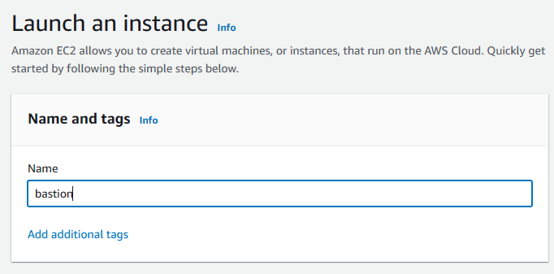

Figure 53: bastion configuration

The figure above shows that the creation of bastion host starts off like any other server, which is by defining the name of the bastion server.

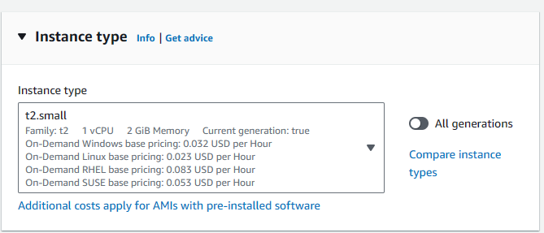

Figure 54: bastion configuration

The instance type is set to t2.small as mentioned in the use case.

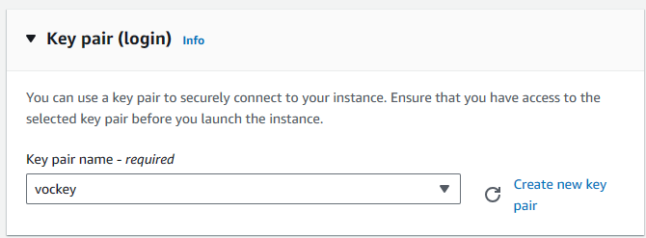

Figure 55: bastion configuration

Next, the key pair is vockey, which is a premade key from AWS Learner’s Lab. This ensures that the key used in the bastion host and the EC2 instance are different. Further explanation of the usage of different SSH keys and how it works in the concept of a jumper server will be explained in *Section B: 1.4 SSH*. The private key that is saved in .pem and .ppk can be downloaded through the Detail tab in AWS Learner’s Launch page.

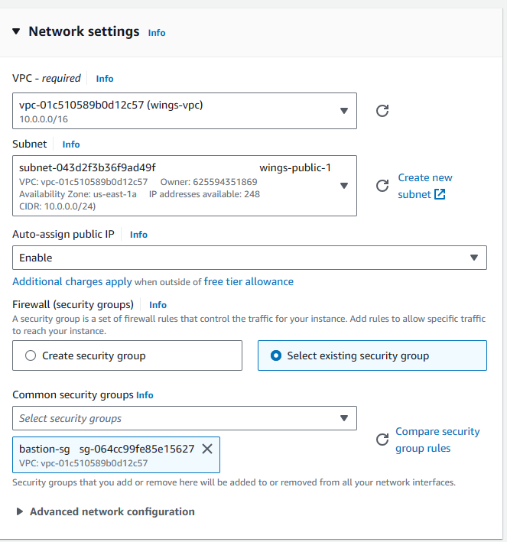

Figure 56: bastion configuration

The team proceeds in specifying the VPC and subnet where the bastion host will reside. The team chose “wing-vpc”, the VPC that the team created to host all the resources of WingsCafe. The bastion host is hosted in “wings-public-1”, which is the public subnet of US-East-1a. Even though the bastion host is specifically hosted in the public subnet of US-East-1a, it can still be used to create an SSH tunnel to the EC2 instance in US-East-1b. Therefore, additional bastion host in US-east-1b public subnet is not required. The reason to this is the nature of VPC that spans across different availability zones, so all resources in the VPC can communicate with each other as long as the security group is configured correctly. Following that, automatic assignment of IP address is also enabled. Furthermore, the bastion host is secured by the security group that specifically allows SSH for inbound rules. 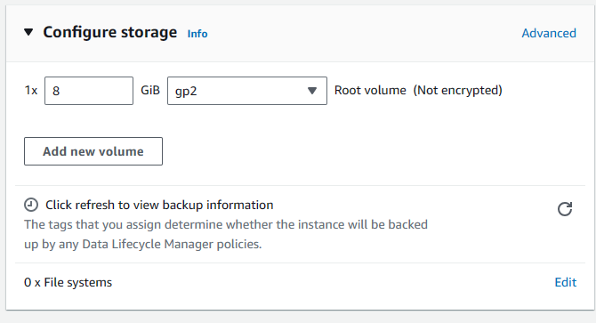

Figure 57: bastion configuration

The figure above shows that the storage volume is configured to 8GiB.

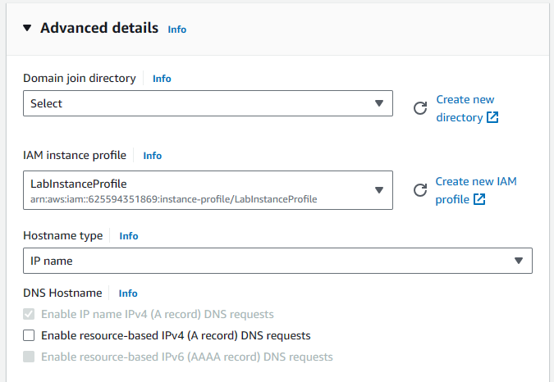

Figure 58: bastion configuration

The figure above shows that an IAM role is attached to the bastion host. The role attached is the “Labrole”, which is an IAM role that is created by default in the Learner’s Lab. This allows for sufficient permissions for the EC2 instance. 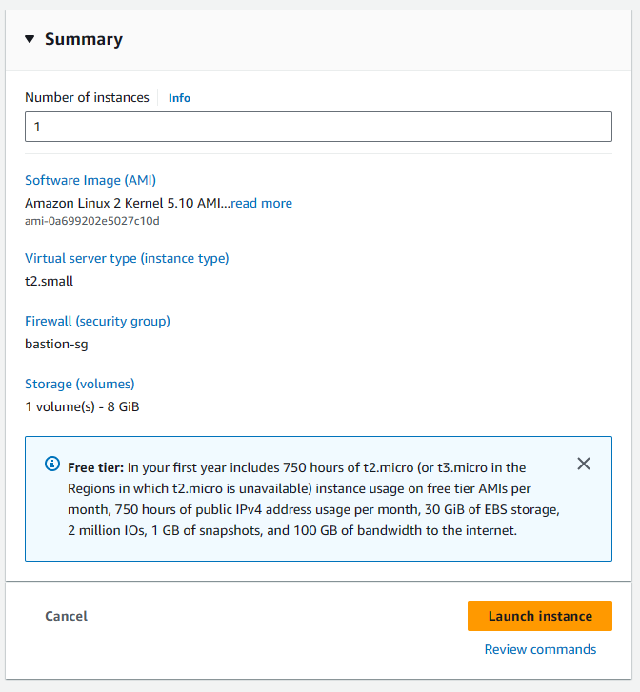

Figure 59: bastion configuration

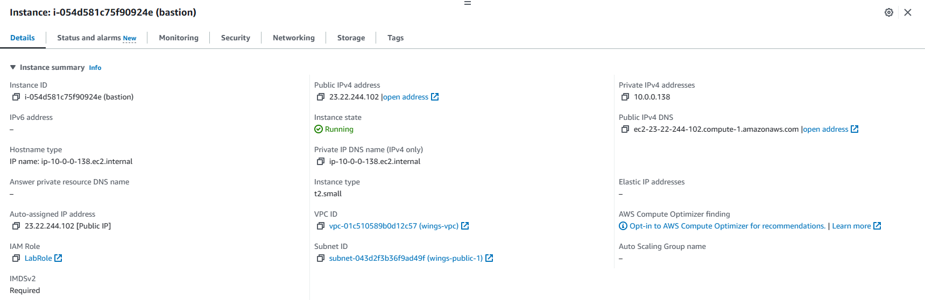

Figure 60: bastion details

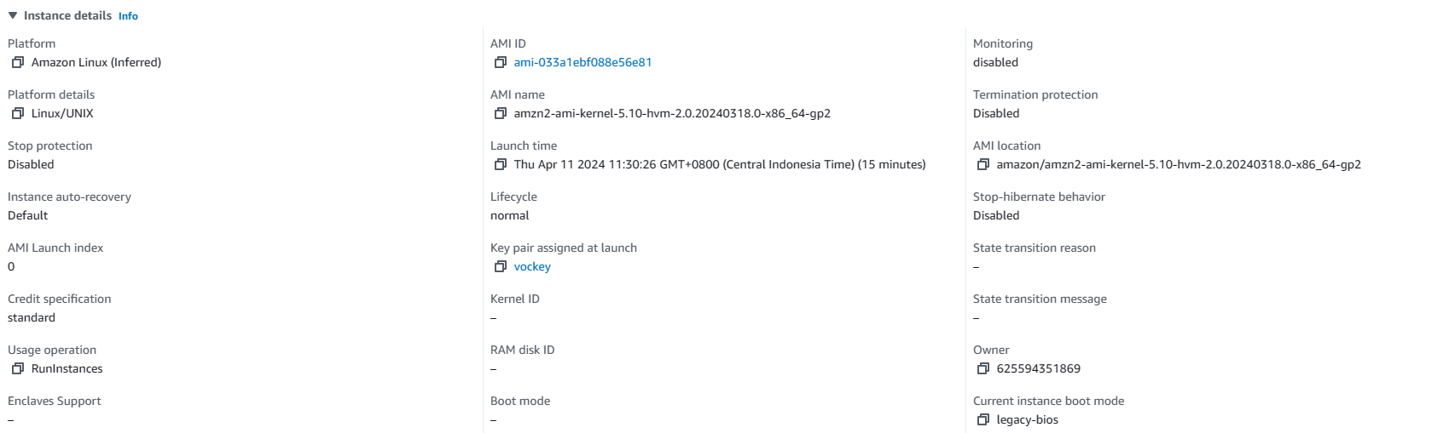

Figure 61: bastion details

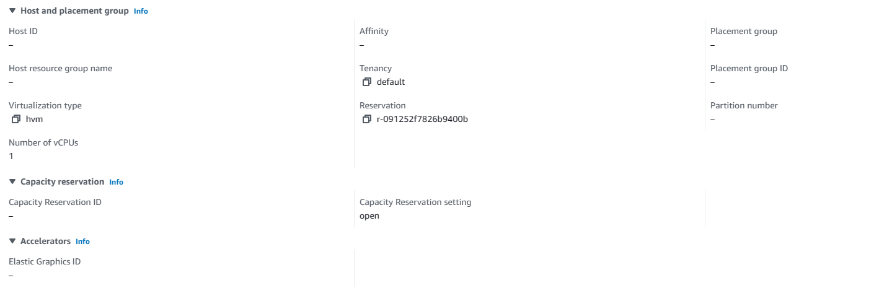

Figure 62: bastion details

The figures above show the details of the bastion host that the team created.

## SSH

SSH, also known as Secure Shell, is a network protocol that allows system administrators to gain safe access to the instances (Loshin, 2024). It encrypts data transfers between two sources that are connected through the internet and enables robust authentication for any users that is accessing it (Loshin, 2024). SSH consists of the protocol itself and the utilities that are needed to implement it (Loshin, 2024).

The usage of SSH makes remote system management easier by allowing authorized users to safely transfer data, login from remote end devices, and run commands according to the right privileges. It connects a Secure Shell client system to an SSH server through the client-server architecture (Loshin, 2024). Typically, SSH uses TCP port 22. SSH is compatible with other protocols, thus making it the preferred protocol compared to less secure protocols like Telnet, rlogin, and rsh (Loshin, 2024).

To use SSH, users can connect to a remote host through the terminal session. If connection is permitted, users will need to verify the remote host’s public key by having the private key. If the user is authenticating, SSH can store the key to streamline future connections (Loshin, 2024). The usage of public key pairs for authentication is one of the most essential features of SSH and is the base of its ability to ensure privacy of terminal connection.

SSH is the protocol that the team use to access the bastion host and the private EC2. The usage of EC2 is also entwined with the way bastion host works to ensure the privacy of private EC2. To bridge the characteristic of bastion host explained in *Section B: 1.3 Bastion Host* and SSH, the concept of public key cryptography needs to be clarified. It is a concept mentioned in the previous paragraph as an important feature of SSH to ensure secure access to all the users. Public key cryptography is also known as asymmetric cryptography (Cloudflare, 2024). It utilizes two keys, which are the public and private key (Cloudflare, 2024). The usage of these two keys makes it different with symmetric cryptography that use the same key for encryption and decryption. In this type of cryptography, the public key can be shared with other users or kept in a public resource like the bastion host. Meanwhile, the other pair, the private key, should only be kept by the key owner, who is the one that generates the key, The public key will encrypt the data, and only the other pair of private keys can decrypt it (Cloudflare, 2024). It ensures that no changes can be made to the data transferred on the internet.

Understanding of how public key cryptography works will help in understanding how SSH works using the bastion host, which will be shown through multiple figures in the next part. To use the bastion host, the user needs to have the private key that is the pair of the public key that is kept in the bastion host. As explained in *1.3 Bastion Host*, the key pair used is the vockey, and users can download the private key file in the Details bar. Next, to connect from the bastion host to another server also uses the same concept of client having the private key and the resource having the public key, just like key and lock situation. In this case, the client will be the bastion host and the resource is the private EC2. This means that the bastion host needs to have the private key of the private EC2 to pair with the public key in the private EC2. Thus, in *1.3 Bastion Host*, the team mentioned that the keypair of the private EC2 and bastion host should be different to ensure people can’t use the bastion host key to enter the private EC2. If the same key is used, it renders the bastion host useless as external source will have easier time in authenticating itself as it has the same keypair.

The figures below will show the step-by-step to SSH to the bastion host and private EC2 securely.

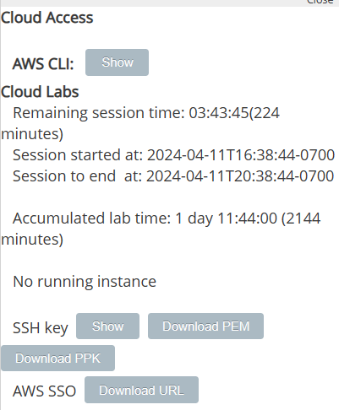

Figure 63: SSH configuration

The figure shows the Detail tab of the Learner’s lab where the team can download the .pem and .ppk file, which are the private key files of vockey. To SSH into bastion host, the team downloaded the .ppk file that is compatible with Putty.

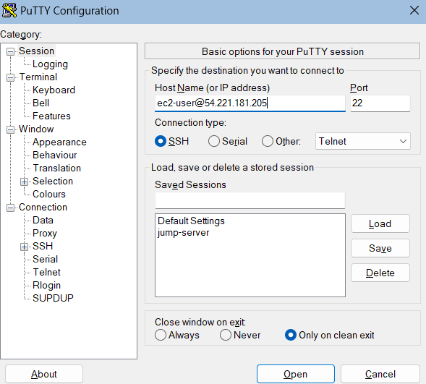

Figure 64: SSH configuration

Next, open Putty and in Session, put the hostname of the instance, then alias (@), and end it with the public IP address of the bastion host. Ensure that the port is at 22 and the connection type is SSH. The team can save the configuration to streamline the process by saving the session by naming it and clicking “Save”.

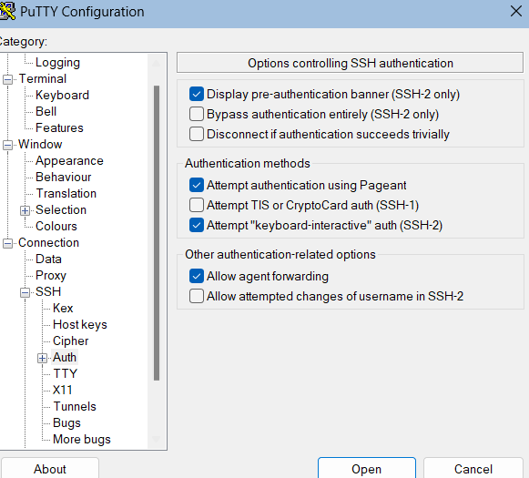

Figure 65: SSH configuration

The team proceeded to go to Auth under Connection and SSH. In Auth, the team ticks the box next to “Allow agent forwarding”. The usage of this feature allows the team to use the private SSH key stored in the local machine to authenticate to a remote server through the usage of bastion host.

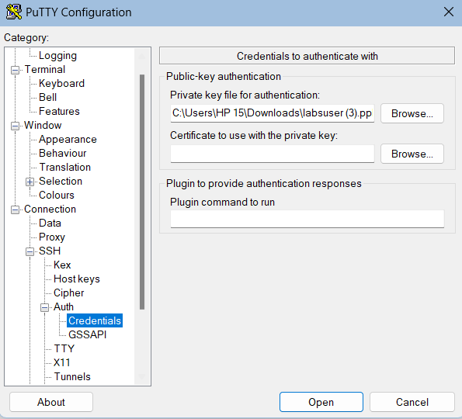

Figure 66: SSH configuration

Under Auth, go to Credentials, where the team can find a place to upload the bastion host’s private key to assist with the authentication process. The downloaded vockey private key was inserted in this part. After these steps, click Open to connect to the bastion host.

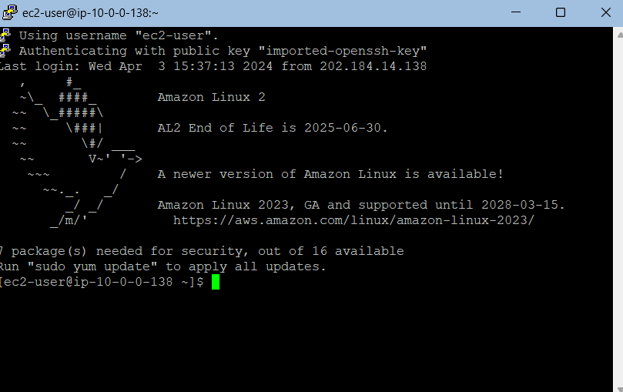

Figure 67: SSH configuration

The team was able to access the bastion host as ec2-user.

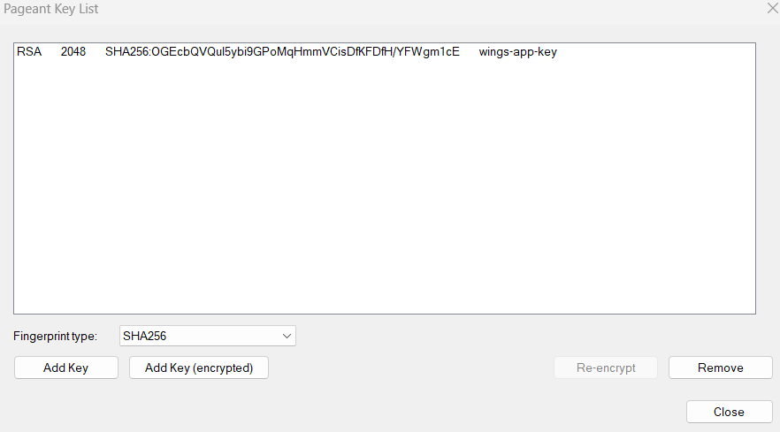

Figure 68: SSH configuration

Next, open Putty’s Pageant, which is another application from Putty that works as an SSH key manager. It is used to store the private SSH keys in the local machine. In this part, the team click Add Key and input the private key of the private EC2 called wings-app-key. As the team has enabled agent forwarding, it allows Pageant that is situated in the local machine to forward the stored private keys securely to the private EC2 that is connected through the bastion host.

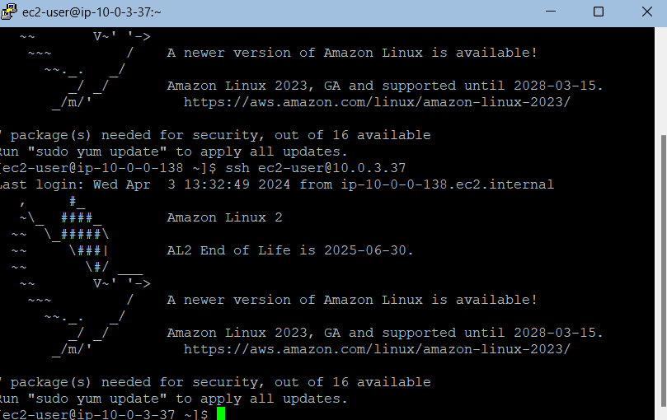

Figure 69: SSH configuration

Using the command of ssh ec2-user@<private ip address of private EC2>, the team was able to enter the private EC2 as ec2-user.

## Identity and Access Management Role (IAM)

AWS Identity and Access Management (IAM) is another security feature in AWS in which roles are created and given permissions (AWS, 2024). These roles provide an identity to trusted users to perform certain operations in the environment according to the given privileges. The usage of IAM roles provides temporary credentials to those who are using the service, making it a robust security practice (AWS, 2024).

IAM roles provide a multitude of functionalities, such as federating workforce identities, accessing workloads in the external and internal environment, cross account access, and granting permission of certain resources (AWS, 2024). Resources in AWS environments can utilize IAM roles for accessing resources using temporary credentials, and simplify the management of these credentials, thus streamlining the management of users’ privileges.

In the learner’s lab, a role is pre-defined by the leaner’s lab called Lab Role. This is a role that can be attached to resources in AWS, It grants variety of access to other resources and has similar permission of console users, thus giving it most of the basic accesses. It can be attached to EC2 instances and allows it to use AWS SSM, S3, and RDS.

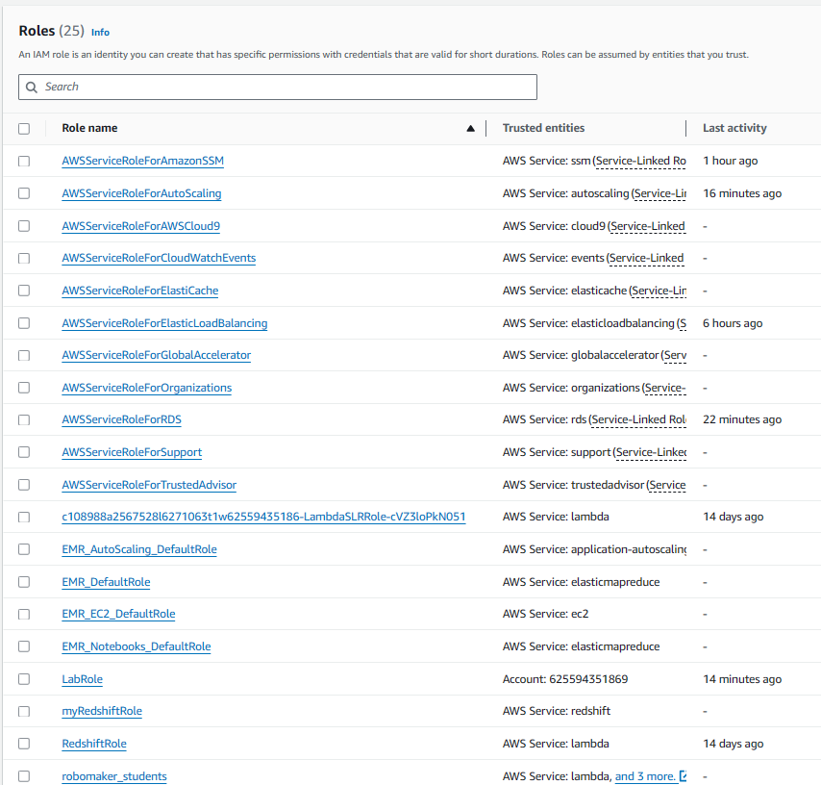

Figure 70: IAM roles



Figure 71: Lab Role

There is a total of 25 IAM roles created throughout the project, and it helps services in AWS work with each other. The team actively attached the LabRole to EC2 instances to give the right permissions.

# Deployment

## AWS Elastic Compute Cloud (EC2)

Before the increased adoption of cloud computing technologies, traditional computing environments consisted of heavy, bare metal servers with limited capacity and limited scalability. This has led to enterprises spending a lot of time and resources calculating and estimating the required compute power to run their technologies, which are often inaccurate and costly. Furthermore, bare metal servers require a spacious environment for storage as well as increased costs due to maintenance and security. Cloud computing has revolutionised the computing industry by introducing virtualisation technology, which implemented virtualised servers instead of bare metal ones. The AWS EC2 service is an example of said virtualised servers.

AWS EC2, which stands for Amazon Elastic Compute Cloud, is a web-based service that addresses the shortcomings of traditional computing environments effectively and efficiently. With the EC2 service, which acts as a virtual machine, enterprises are relieved of the task to conduct tedious estimations on computing power, but instead subscribe to the web service in a pay-as-you-go billing method, meaning they will only be charged based on the consumption of the service (AWS, 2024). This, in turn, allows for high scalability, which can accommodate changes to the cloud computing environment with ease. Its virtualised nature also eliminates the need for the provision of physical spaces to situate bare metal servers, significantly reducing costs and increasing resource efficiency. AWS has also designed the EC2 service to be highly available with 99.99% availability with the redundant deployment of EC2 instances in multiple availability zones (AWS, 2024). Overall, the EC2 service not only resolves the problems encountered with traditional computing environments, but it also offers additional services to foster a fully functional, available and secure cloud-based computing infrastructure.

In conjunction with the requirements defined by WingsCafe, the team has decided to use the AWS EC2 service as the main web service to host its web application. Due to the limitations of the AWS Learner’s Lab account, the region *North Virginia* and the availability zones, *us-east-1* and *us-east-2*, are chosen to represent Singapore and Sydney in the Asia Pacific region. The configuration process is documented as follows:

### 2.1.1 Launch Configurations

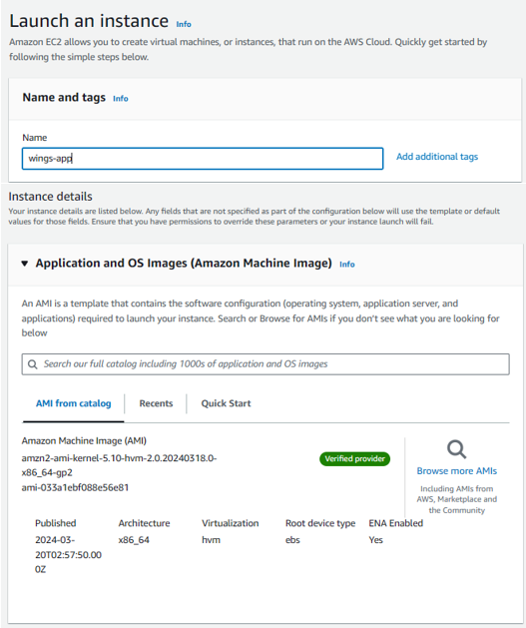

Figure 72: EC2 configuration

After navigating to the EC2 web service in the management console and to the *Instances* page, the button *Launch Instance* is clicked, which leads to the instance configuration interface, as shown in the figure above. The name for the instance is defined, which in this case, the team has chosen the name *wings-app* to represent WingsCafe’s web application. Following that, the Amazon Machine Image (AMI) which contains basic instance configuration information such as the machine’s operating system, application server, and its applications, is chosen. The team has decided to implement the predefined AMI provided by AWS. More information regarding AMIs are documented in *Section B: 2.2*.

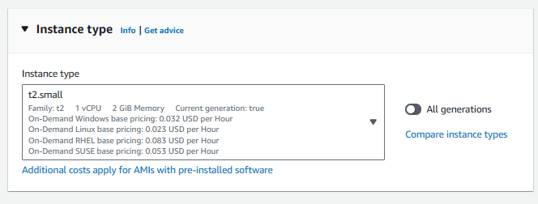

Figure 73: EC2 configuration

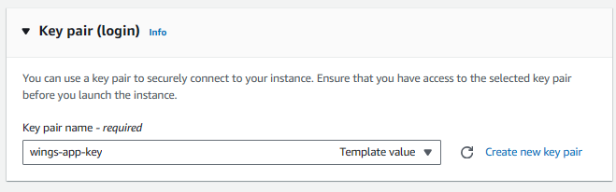

Figure 74: EC2 configuration

Then, the instance type is chosen. As per the requirements of WingsCafe, the type *t2.small* was chosen, which entails one virtual CPU with 2 GiB memory. The key pair that allows access into the private instance is configured here as well. The team has generated a new key pair for WingsCafe’s web server instance instead of using the default *labkey* key pair to prevent unauthorized access. The keys will also be utilized to establish SSH connections to the web instance. Details about SSH connections are documented in *Section B: 1.4*.

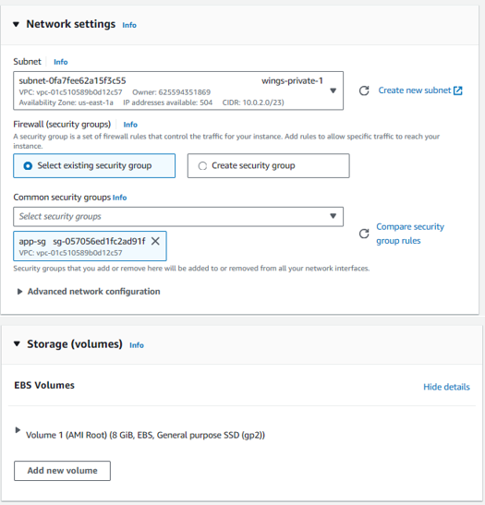

Figure 75: EC2 configuration

After generating the key pair and storing it securely in the team’s local devices, the network settings are configured. Since the web application is to be deployed securely, the subnet chosen of which this instance will be launched is private subnets, which are the *wings-private 1* and *wings-private-2* mentioned earlier in the report *(Section A: 4.2.2)*. The security group chosen for the web instances is chosen from existing security groups, which is the *app-sg* configured earlier in the VPC web service *(Section A: 1.1.x)*.

Following that, the storage configurations for *wings-app* is the 8 GiB, General purpose SSD, which should suffice given the scenario.

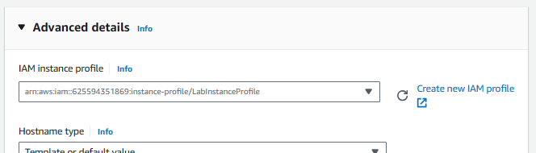

Figure 76: EC2 configuration

The advanced details section for the configuration contains to-be-defined information such as the IAM instance profile, which defines the permissions the *wings-app* instance possesses over the AWS resources. In this case, the IAM instance profile *LabInstanceProfile* was chosen, which allows the necessary access permissions for the *wings-app* instance over AWS resources, such as other web services like Amazon VPCs and Amazon RDS. Selecting this IAM instance profile will ensure a smooth configuration experience later.

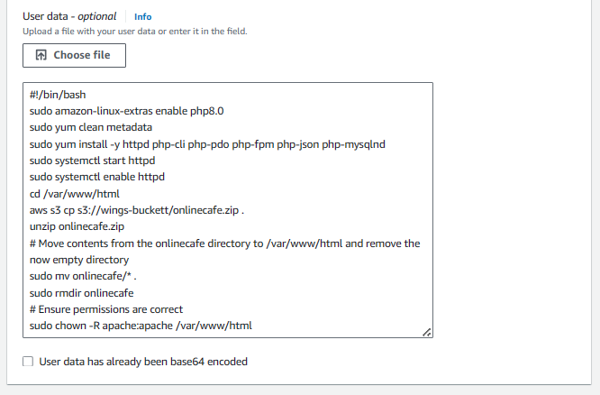

Figure 77: EC2 configuration

At the very bottom of the advanced details section is the user data field, which allows input of scripts that will perform preliminary configurations upon the launching of the instance, increasing workflow efficiency and time-efficiency. A more in-depth explanation of the user script its definitions are documented in *Section B: 2.4*.

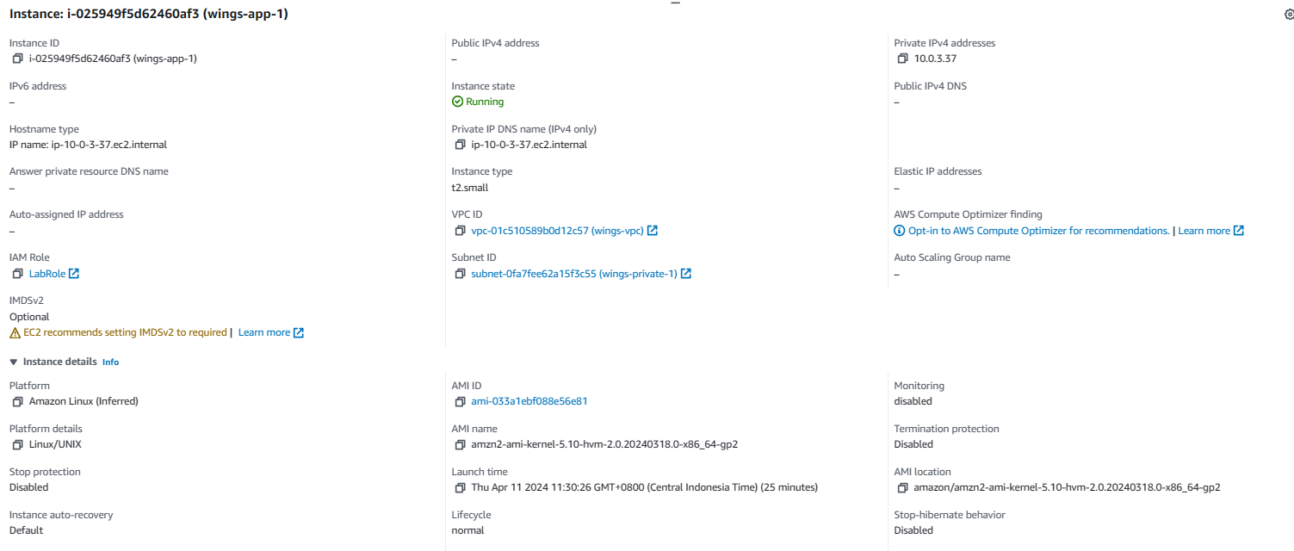

Figure 78: EC2 details

That concludes the configuration process for launching an EC2 instance manually via the management console. The figure above represents the summary of the *wings-app-1* web instance. The steps are repeated to deploy another web instance in the other availability zone and is named *wings-app-2*.

### 2.1.2 Launch Templates

An alternative way to launch instances is by defining launch templates. Launch templates, as the name suggests, refers to a template that contains repetitive information such as the instance types, key pairs, associated security groups, and others for EC2 instance launching (AWS, 2024). These templates work closely with AMIs to streamline the creation of replica instances, significantly reducing configuration time and effort. Launch templates also support versioning, which allows enterprises to update their launch templates into newer versions when changes are made, and set said versions as default so instances that are launched thereafter are of the latest version.

Furthermore, launch templates are usually configured with auto scaling groups, which can help launch instances of different types following the criteria defined during configuration (AWS, 2024). Auto scaling groups are explained in more detail in *Section B: 3.5*. AWS also encourages its customers to utilise launch templates to gain access to the latest updates and improvements, such as Systems Manager parameters (AMI ID), capacity limits, and more.

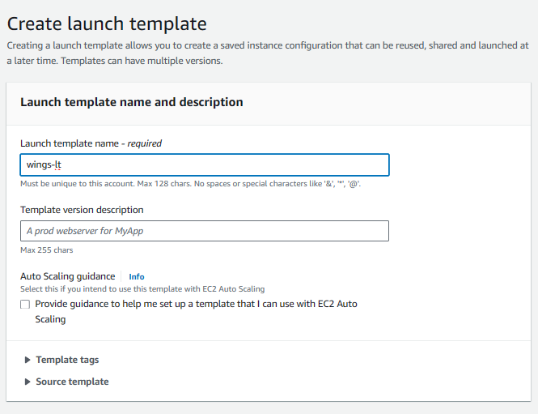

Figure 79: launch template configuration

The configuration for launch templates resembles that of the manual configuration method.

The only difference between the two methods is its naming convention, in which the launch template that the team has configured is named *wings-lt*.

Similarly, user data scripts can also be inserted in launch template configurations. As mentioned above, user data script, though the name may suggest, are not limited to inserting user data, but can also serve as a convenient tool to automate configurations for the instances (Thube, 2023). This includes preliminary configurations such as database and web server setups, importing files from Amazon Simple Storage Service (S3) buckets, parse files, and more. The user data script entered by the team can be seen in *Figure (number)*, of which each line is explained in the table below.

|  |  |
| --- | --- |
| ***Script*** | ***Description*** |
| *sudo amazon-linux-extras enable php8.0* | Installs the latest PHP 8.0 packages for seamless rendering of the WingsCafe web application, which uses the PHP language. |
| *sudo yum clean metadata* | Clears the *yum* package cache to ensure the latest updates are installed. |
| *sudo yum install -y httpd php-cli php-pdo php-fpm php-json php-mysqlnd* | Installs all necessary packages such as the Apache web servers, MySQL drivers, and more that are compatible with the PHP language. |
| *sudo systemctl start httpd* | Starts the Apache web server service |
| *sudo systemctl enable httpd* | Enables the Apache web server service to automatically start when the instance boots up. |
| *cd /var/www/html* | Changes directory to the location of which the S3 bucket information will be stored. |
| *aws s3 cp: s3://wings-buckett/onlinecafe.zip* | Copies the S3 bucket link to fetch said information, such as source code, databases, and more. |
| *unzip onlinecafe.zip* | Unzips the file *onlinecafe.zip* fetched from the bucket. |
| *sudo mv onlincecafe/\** | Moves all content from the file *onlinecafe.zip* to the */var/www/html* directory. |
| *sudo rmdir onlinecafe* | Removes the now empty *onlinecafe* file. |
| *sudo chown -R apache:apache /var/www/html* | Grants necessary permissions of the */var/www/html* directory to the *apache* users. |

Table 2: commands in launch template

In a nutshell, utilising launch templates, with appropriate auto scaling group configurations, can be useful for when replicas of the same instances, or instances of different types are to be launched, therefore significantly reducing configuration time and effort as well as increasing productivity.

## Amazon Machine Image (AMI)

An AMI, or Amazon Machine Image (AMI), is a component within the AWS EC2 service that entails specifications of EC2 instances for launching, ala launch templates, but with different information (AWS, 2024). As mentioned above, launch templates contain information about instances such as instance types and key pair configurations, whereas AMIs contain Amazon Elastic Block Store (EBS) snapshots that capture the state of the EBS volume at certain times, similar to how non-volatile storage operates. Permissions that govern which users can or cannot use certain AMIs are also attached to its configuration. AMIs also contain mapping that controls the volumes attached to newly launched instances (AWS, 2024). Therefore, AMIs and launch templates, alongside auto scaling groups, serve as the foundation for efficient and effective scaling of EC2 instances.

With the implementation of AMIs, cloud administrators can efficiently launch new instances with identical configurations without configuring them one after the other, which promotes consistency between the instances as well (Davis, 2023). This entails that if the AMIs are configured correctly, errors are minimised significantly, reducing the possibility of the instances experiencing downtime, which would have been prevalent with manual configurations. AMIs are also perfect as test grounds for new updates and features without interfering with the current version of the instances, courtesy to the EBS snapshots (AWS, 2024). AMIs also support sharing and collaboration, of which cloud administrators can find ready-made AMIs in AWS Marketplace, similar to the concept of open-source libraries for programming. This provides cloud administrators with head starts that can significantly automate daily tasks and therefore increase productivity (AWS, 2024). Furthermore, implementing AMIs contributes to the enforcement of security best practices by pre-configuring security measures (Pulumi, 2024).

## RDS

Following the configuration of the EC2 environment, a database is to be associated with the EC2 instances to serve as a scalable and secure relational database in the cloud for the WingsCafe web application. A more in-depth explanation of the RDS service is documented in *Section B: 4.1*. The configuration process is as follows:

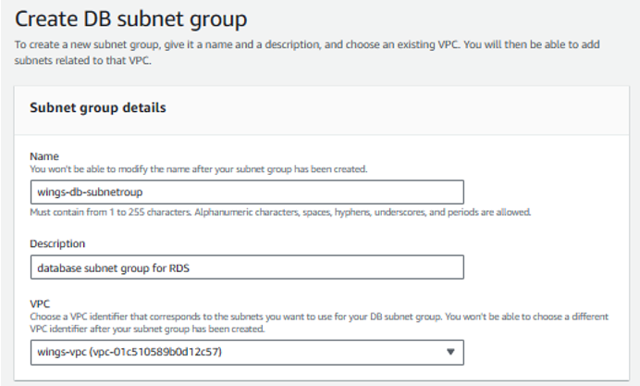

Figure 80: DB Subnet configuration

After navigating to the AWS RDS service in the AWS Management Console and clicking on the *Create DB Subnet Group* button, a configuration interface is shown, as can be seen in the figure above. Firstly, the name of the database subnet group is defined, of which the name *wings-db-subnet-group* was chosen. A brief description has been noted as well for clarity purposes and the subnet group is then also attached to the *wings-vpc*.

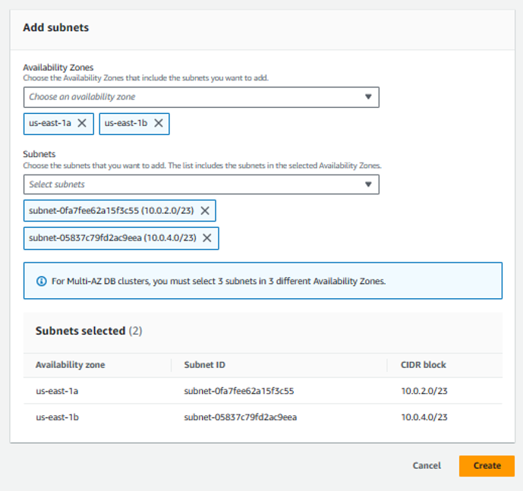

Figure 81: DB Subnet configuration

Following after, the two availability zones of which the WingsCafe web application will be deployed is specified in the RDS configuration as well, followed by associating both the private subnets are chosen. The RDS is placed in the private subnets as the content stored within should not be directly accessible by the public and the internet. After that, the configuration for the database subnet group is complete and the *Create* button is clicked.

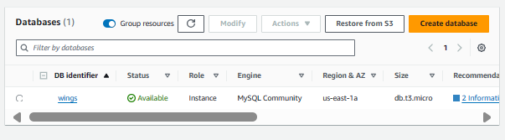

Figure 82: wings database

Following the configuration of the database subnet group, the actual database has to be configured as well. The team navigated the AWS Management Console to the databases dashboard and clicked on the *Create database* button, which leads to the database configuration interface, as can be seen from the figure above *(Figure)*.

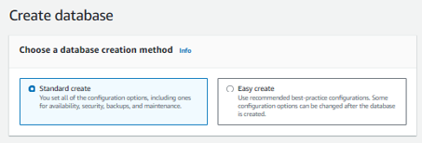

Figure 83: wings database configuration

Firstly, the option *Standard create* has been chosen instead of the alternative option, which provides a higher level of control over the database’s specifications, including its availability, security group associations, and more.

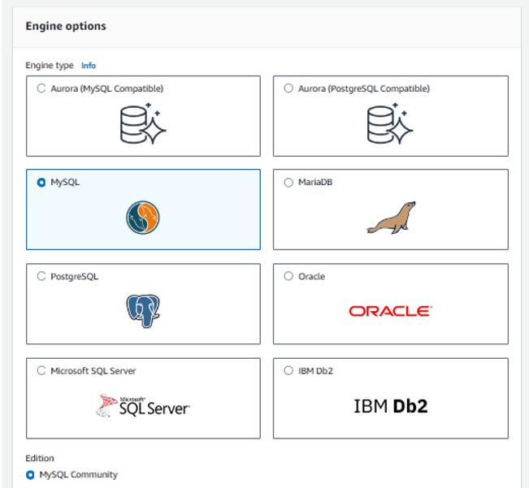

Figure 84: wings database configuration

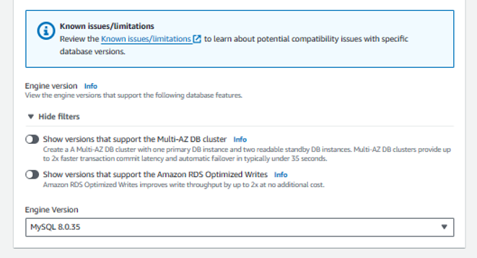

Figure 85: wings database configuration

Then, the specific database engine is chosen as well, which the team has decided to implement the *MySQL* database engine with the version *MySQL 8.0.35*.

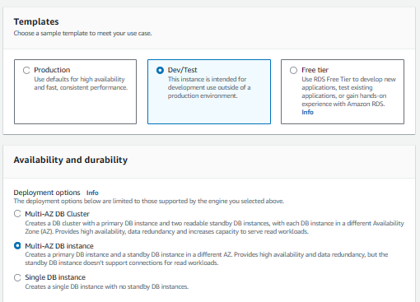

Figure 86: wings database configuration

After that, the *Dev/Test* template is chosen to simulate the cloud environment of which WingsCafe will be implementing, which allows for unit testing and other quality assurance measures to be conducted before pushing towards a production environment. In the next section, the *Multi-AZ DB Instance* option was chosen so that the RDS database can be accessed in both availability zones, which increases availability and data redundancy.

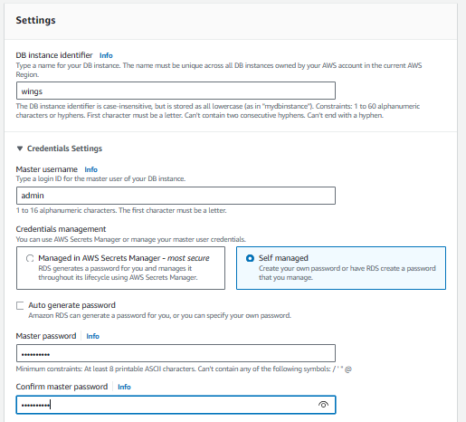

Figure 87: wings database configuration

Under the *settings* section in the configuration, an unique identifier was assigned to the database, which is named *wings*. After that. the credentials for accessing the database are registered. In this case, the team has decided to use the username *admin* and a password that was both complicated but easy to remember. The team has also decided to set credentials management as *Self-managed* which allows for the user’s autonomy over their password, instead of a generated one from AWS Secrets Manager.

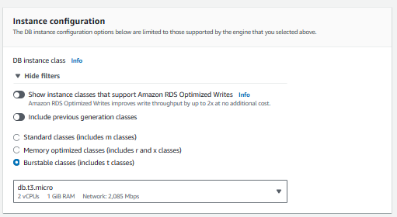

Figure 88: wings database configuration

In the instance configuration section, the database instance classes are defined. The team has chosen *burstable classes (includes t classes)* were chosen, which are the *db.t3.micro* version. Burstable database instances are suitable for deployment in environment in which spikes in resource consumption could occasionally occur, which renders them suitable for implementation in a Food & Beverages (F&B) establishment such as WingsCafe (Rai, 2024).

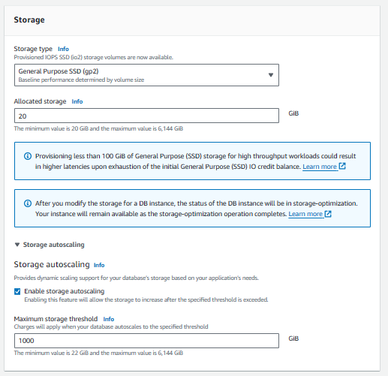

Figure 89: wings database configuration

As for the storage configurations, the storage type *General Purpose SSD (gp2)* has been chosen with an allocated storage of 20 GiB. Autoscaling has also been enabled as well, with a maximum threshold of 1000 GiB, which would have incurred additional costs when the database scales to said threshold.

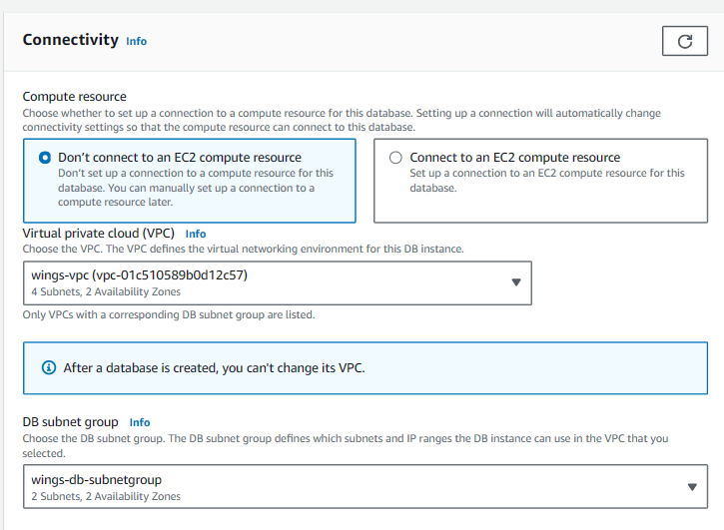

Figure 90: wings database configuration

Under the connectivity section, the team has decided not to connect the database with an EC2 compute resource to allow more control over the connection between the EC2 instances and the database. The team has also attached the *wings-vpc* to the database and associated the database subnet group *wings-db-subnetgroup* as configured earlier.

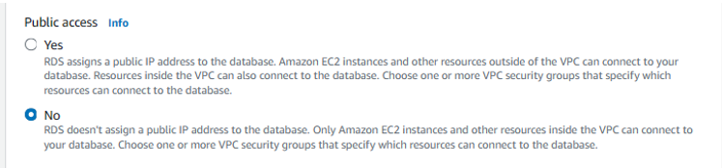

Figure 91: wings database configuration

Since the RDS will be placed in the private subnets of the availability zones, public access is denied and therefore no public IP address will be allocated for the RDS database service.

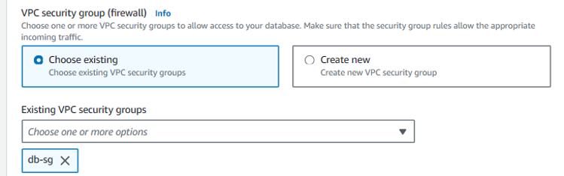

Figure 92: wings database configuration

For added security, the RDS database is also associated with pre-defined VPC security groups as seen in the figure above. The *db-sg* security group that the team has configured earlier in the project will be applied to the RDS database.

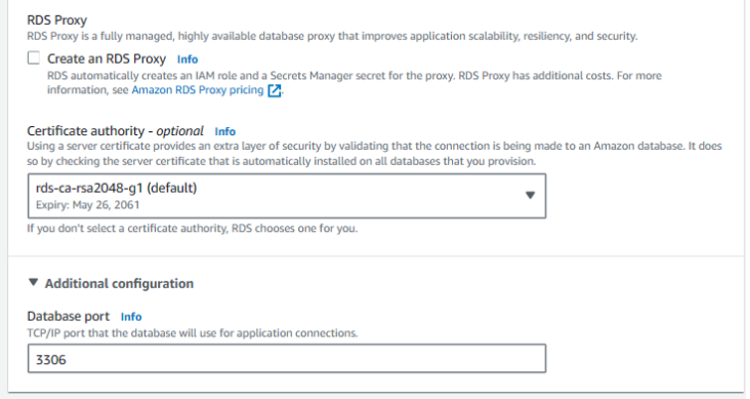

Figure 93: wings database configuration

The team has used the default certificare authority made by AWS which is *rds-ca-rsa2048-g1* with an expiration date at May 26th, in the year 2061. It is compulsory for a certificate authority to be chosen for added security. The port specified for database connections is via *port 3306*.

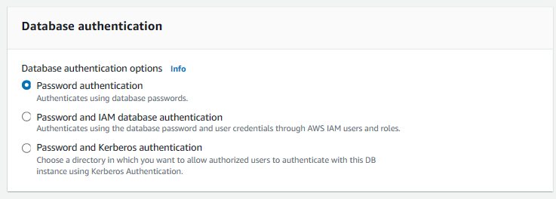

Figure 94: wings database configuration

Moving on, the team has decided to choose *password authentication* as the authentication method when attempting to access the database, which is explained in more detail in *Section B: 4.5*.

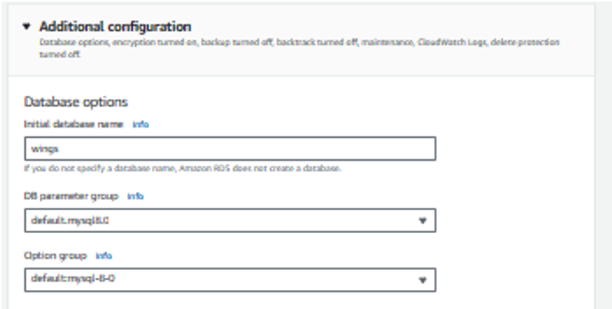

Figure 95: wings database configuration

Under the additional configurations tab, the initial name of the database is defined, to which to team has decided to use the name *wings* for simplicity and clarity. After that, the default settings for the DB parameter group and Options groups were chosen.

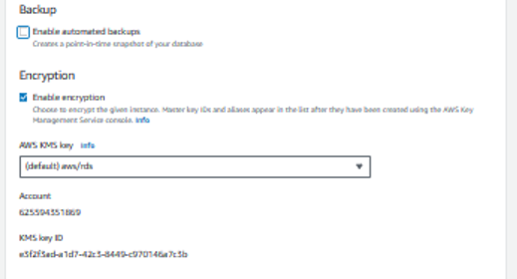

Figure 96: wings database configuration

Encryption is enabled for the database as compliance to user data security policies, mitigating information misusage during unauthorized access or cybersecurity attacks. The default AWS Key Management System (KMS) was chosen, which is *aws/rds*.

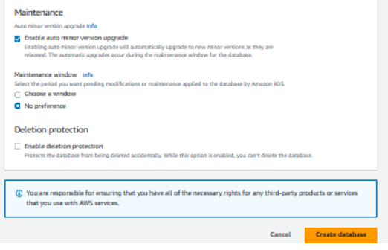

Figure 97: wings database configuration

Lastly, under the maintenance tab, the option for enabling automatic mirror version upgrades was allowed. AWS allows for the creation of read replicas of the database without compromising synchronisation. When ugrades and improvements are implemened, RDS feeds said upgrades to the read replica first, which allows administrators to run unit testing to ensure functionality and compatibility without disconnecting from the current database version, therefore reducing possible downtime (AWS, 2024). Once the tests are completed, RDS performs a failover operation that shifts the primary database to the upgraded one.

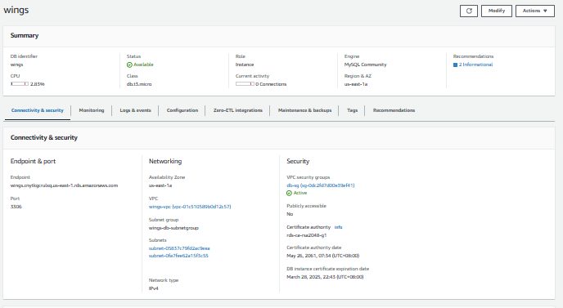

Figure 98: wings database details

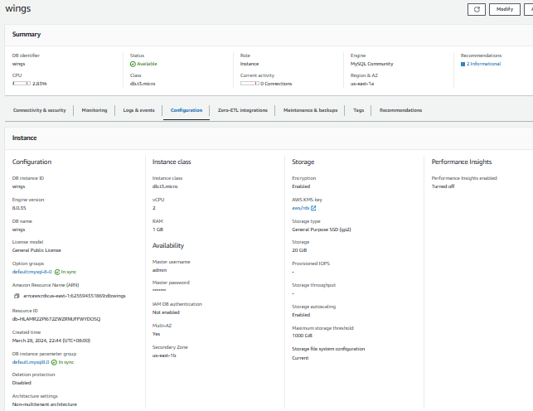

Figure 99: wings database details

That concludes the configuration process for the RDS database. The figures above *(Figure)* illustrate the summaries of said configurations. Now, the WingsCafe web application has a fully functioning database that can be queried and used to store new information from users.

## Parameter Store

The AWS Parameter Store is a service under AWS Systems Manager that offers a secure and stratified method of storing and managing information, such as configuration and secrets management. These parameters can store usernames, passwords, database endpoints, plaintext information, encrypted information, and more. Use cases for the AWS Parameter Store include data validation (AWS, 2024). For instance, administrators can define parameters that point to a user’s permission to an EC2 instance, therefore migrating the validation process away from the backend mechanisms of the application and enforcing more robust security practices.

Implementing AWS Parameter Store would be a serviceable solution to ensure security for the WingsCafe web application, especially since it involves storing and querying databases in real-time. This service not only enforces better security practices, but also provides availability due to its deployment in multiple availability zones within an AWS region (AWS, 2024). Furthermore, versioning and auditing are also supported with the AWS Parameter Store, which produces an audit trail that can aid troubleshooting efforts as well as notify administrators by defining trigger events such as changes made in the parameter values (AWS, 2024).

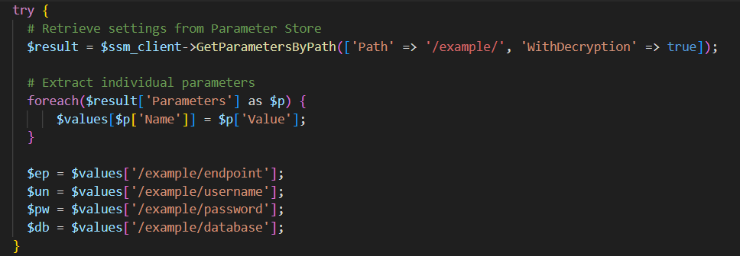

Figure 100: get-parameter.php configuration

The figure above illustrates the code snippet referencing the values stored in AWS Parameter Store from the *get-parameters.php* code file given by WingsCafe, in which the values are stored under the *example* directory. Data validation is then performed that does not rely heavily on backend logic, therefore improving application security. The configurations for each parameter defined for the WingsCafe web application are documented as follows:

There are a total of four parameters defined for the project, namely the *database*, *endpoint*, *username* and *password* parameters.

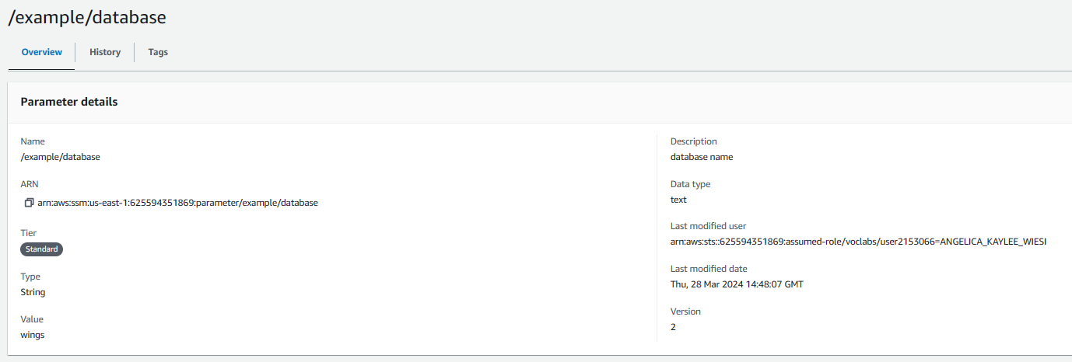

Figure 101: database name parameter

The */example/database* parameter is defined to store the name of the database configured earlier, of which the value is *wings*. The input value from the user, when attempting to access the database, will be cross-checked with the value of this parameter. The connection to the database is documented in *Section B: 4.5*.

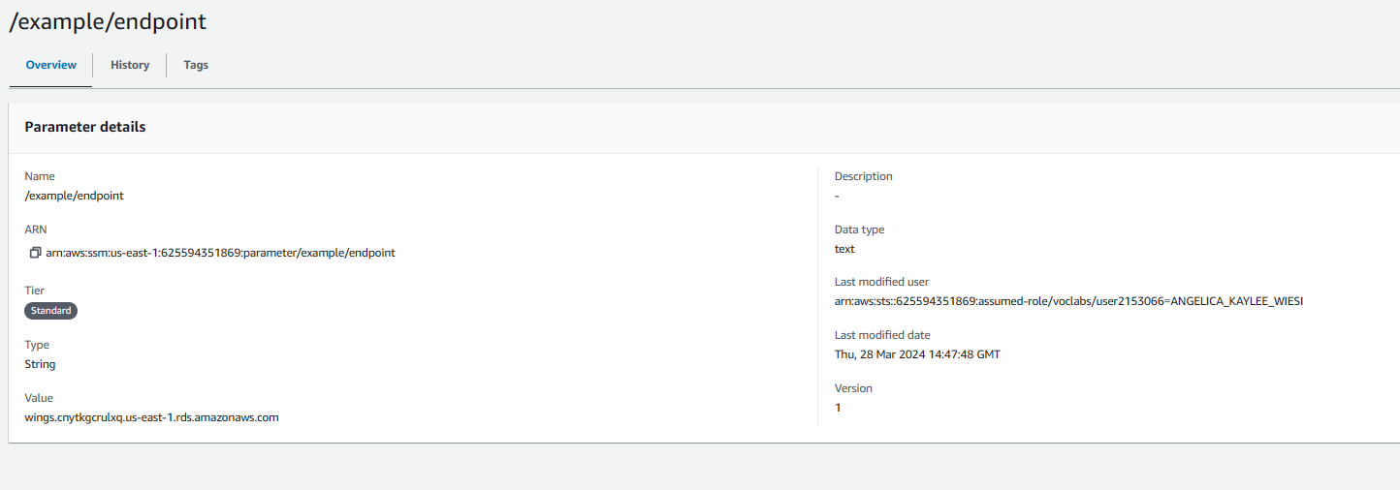

Figure 102: database endpoint parameter

Next, the */example/endpoint* parameter is defined to store the endpoint to the database. The value is copied from the RDS database details and pasted in this parameter as its value. This allows the WingsCafe web application to successfully connect to the database without having to store the endpoint within the code.

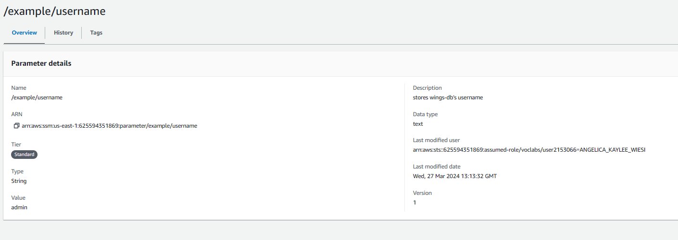

Figure 103: database username parameter

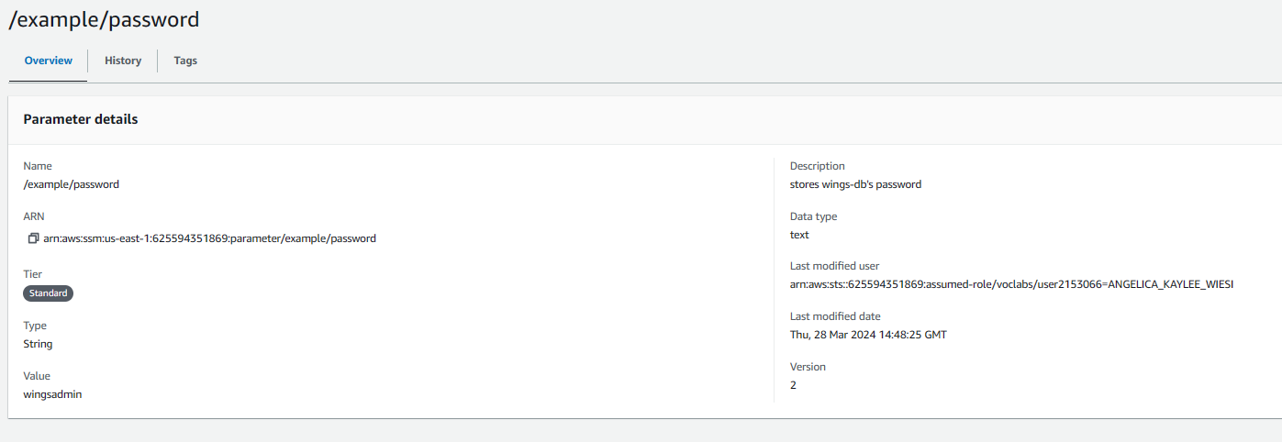

Figure 104: database password parameter

As for the */example/username* and */example/password* parameters *(Figure )*, the values stored are the username and password that were defined during the RDS database configuration. User input from attempting access to the database is then cross-checked with said values as input validation.

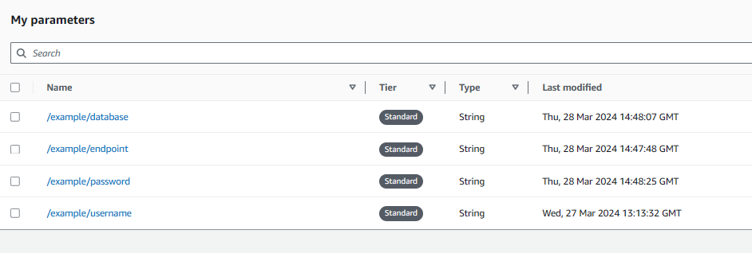

Figure 105: database parameters

That concludes the configuration processes for the AWS Parameter Store. The figure above represents the dashboard for the service upon completing the configurations.

# High Availability/Scalability

In ensure that the element of high availability is present for the setup for the Wings Café website, it is essential to create the architecture of the system that can remain operational during various failures, such as natural disaster, network disruptions or cyberattacks. In achieving the element of High availability, the replication of the Amazon EC2 instances used for the web server can be done across multiple regions. The reason behind distributing the instances geographically will help to prevent a single point of failure from occurringTo provide seamless service continuity if one instance fails, each replicated instance must mimic the original instance's configuration. This configuration reduces the likelihood of extended service disruptions and helps to prevent data loss.

Adding on to the element of high availability, the element of scaling the cloud infrastructure will help to manage the varying levels of traffic or demand the website has to handle, ensuring all users of the sites are able to be catered to. Having this element present in the architecture will allow the system to adjust its computing resources such as CPU power, network capacity, and storage while running. To achieve this concept, the implementation of an auto-scaling group is the configuration service that is required in which this AWS services will automatically adjust the number of EC2 instances across different availability zones that will be dependent on real-time demand. With the ability to create multiple instances to handle workload, the Management and distribution of workload towards these instances will also need to be considered and thus the configuration of an Application Load Balancer has been considered to help distribute incoming network traffic efficiently, thus addressing the network traffic issues previously reported by Wings Café website users. The combination of having elements of high availability and scalability in the site will help to ensure that the website will provide a resilient and responsive user experience, while also being cost-effective towards the client.

## Web Application

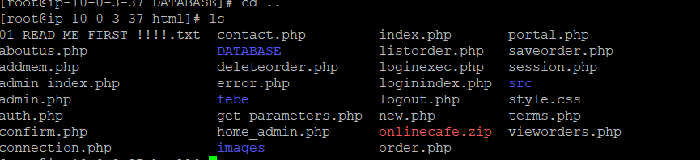

Figure 106: application source code filesk

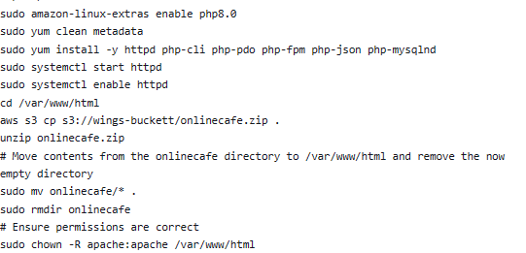

Figure 107: Script to gain files from zip and store into AWS

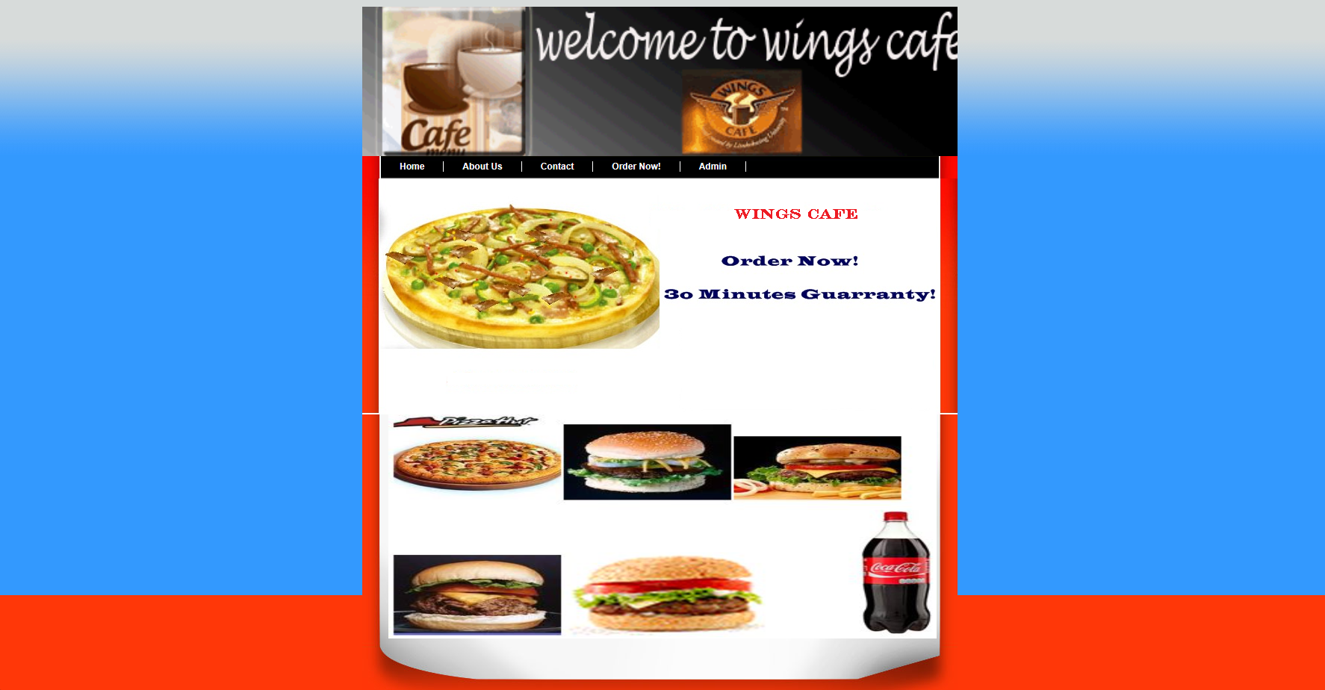

Figure 108:

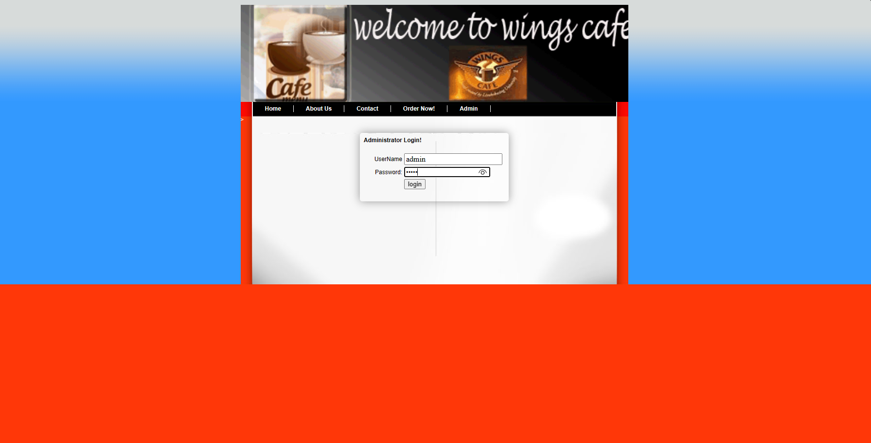

Figure 109: Home page and login page

## High Availability

The author of this section, acting as the cloud architect, would also recommend the implementation of high availability (HA) architecture to be implemented. Due to the constraints on the AWS Learner Lab, the project is only able to run on a single EC2 instance that is located within one availability zone, which is the current Uses 1a or in the region of North Virginia. The reason behind this is that currently the entire system hold a single point of failure which could be at risk and thus if any type of disruptions occur in the region that could affect AWS services, user will have no access to site and the Wings Café website will face downtime if waiting for the issue in the area to be solved. To be able to achieve HA, a failover mechanism should be implemented that acts a mechanism for the system to quickly move its workload to a different instance that has been replicated to take over the workload and run the application there in the recovery zone. In doing this strategy, the EC2 instances can be placed within the same region but different availability zones or the different regions all together.

With that being said, after analyzing the business operations of Wings Café, where it is important to note they operate in two separate regions (Singapore and Australia), the author would recommend optimizing for high availability by deploying the application across both the AWS Sydney and Singapore regions. In doing this, using the AWS Route 53 would need to be able to do geolocation routing for helping to direct users to the nearest region in which the application is running, thus minimizing latency. Thus, if any errors occurs in one region, the failover mechanism would move the workload of the affected region to the other one.

## Elastic Load Balancer

This section talks about the creation of the elastic load balancer for hosting the application. The Elastic Load Balancer (ELB) is a service from AWS that’s main purpose is to be able streamline the distribution of incoming application traffic across multiple backend servers or instances (EC2), which will help to optimize the system speed and overall performance. Aside from helping with the management traffic but the ELB is also able to provide continuous health checks on the back-end targets by which if there is an event that a backend instance has found and deemed to be compromised or underperforming, the ELB will quickly redirect traffic to healthy available instance, which in turn then maintains an uninterrupted and robust service experience for all applications users. AWS offer load balancer options, in which there are three to choose from —the Application Load Balancer, Network Load Balancer, and Gateway Load Balancer— and for the implementation of this project, the has chosen to select the use of an Application Load Balancer has been selected for this project. The creation of this can be seen in the figure below where the instance name is wing-alb(application load balance). The reason behind the selection is due to the facts alb’s have features such as advanced routing capabilities, which are tailored to handle sophisticated and modern application architectures by offering support for HTTP/HTTPS traffic, WebSocket, and HTTP/2. But besides that, the load balance is also able to do host-based and path-based routing, which will enable fine-grained control over the user traffic and providing an infrastructure that is both scalable and secure. With these the justifications being brought up, the Application Load Balancer is the best option for wings café to implement as it is well-equipped to be able to facilitate the high traffic demands and dynamic content delivery required by this project.

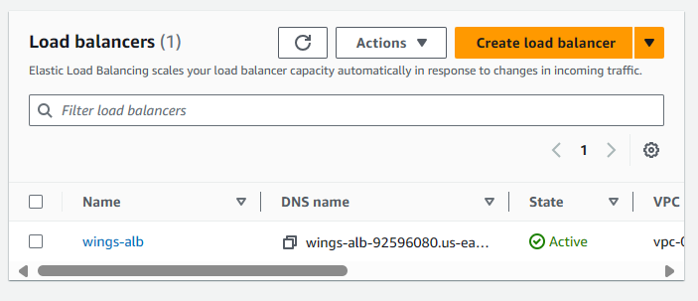

*Figure 110: Proof o ALB creation*

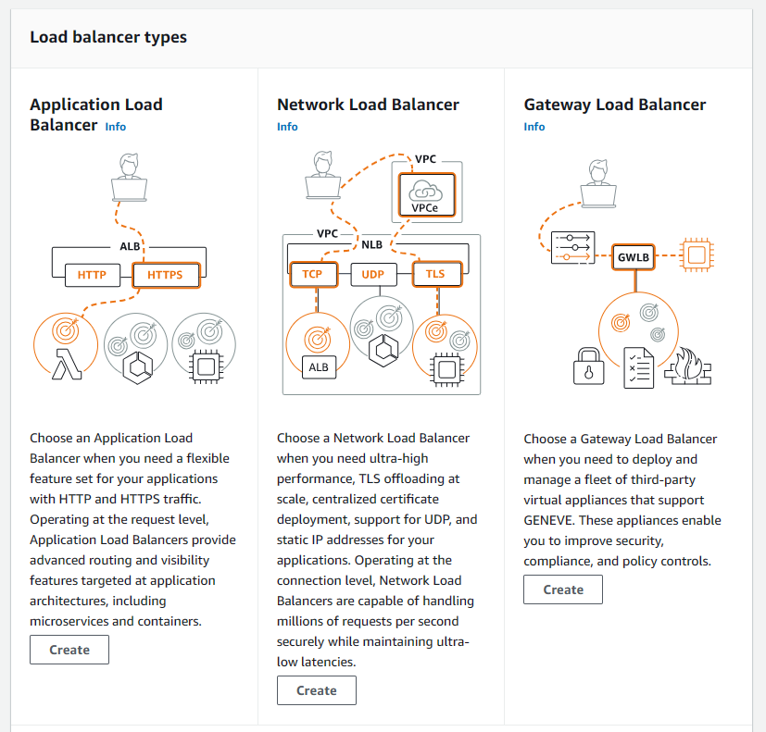

Figure 111: Elastic Application Load Balance Options

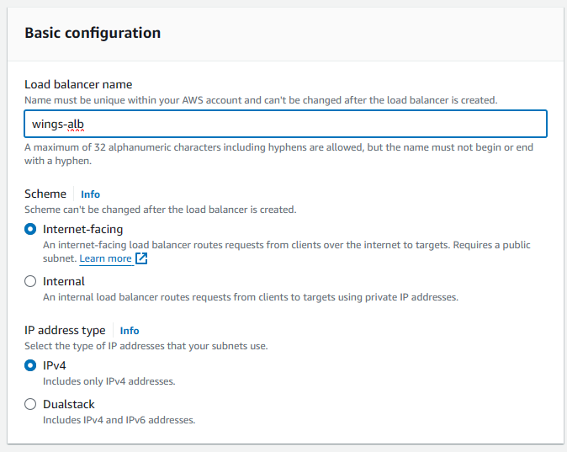

Figure 112: Basic Configuration of Wings Alb

The figure 112 above shows an AWS Management Console interfacethat is used for setting up an Application Load Balancer (ALB) where the author has named "wings-alb". In the creation of the alb, The configuration requires the author to select a scheme where the selectio of 'internet-facing' was done so that the application can process internet traffic coming from the public and necessitate a public subnet. Moving on, the The user must also select an IP address type from which the options were either 'IPv4' or 'Dualstack' for IPv4 and IPv6 support. The selection of IPv4 was done as it is compatible with the vast majority of of internet device. The catering to IPv6 is assumed to not to be needed in this case as well.

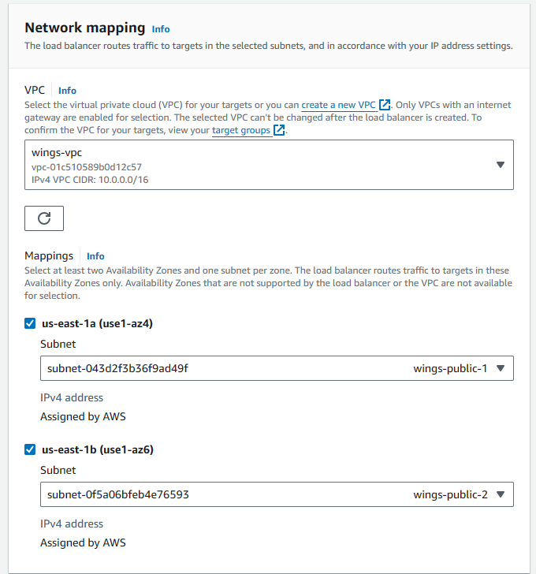

Figure 113: Network Mapping of Wings Alb

FUgure 113 shows configurations done for the section for network mapping for the AWS Elastic Load Balancer setup, in which it shows the virtual private cloud (VPC) and subnet. For the the selected VPC named "wings-vpc" with a CIDR block of 10.0.0.0/16, it is the network where the created application load balancer will operate from and also and route traffic to the specified targets. For the implementation of high availability, the load balancer has been configured to be able to route traffic across multiple subnets which are located two Availability Zones: "us-east-1a" and "us-east-1b" in which the zones are named as "wings-public-1" and "wings-public-2". These two zones are chosen to allow alb to be able to distribute traffic across the distinct locations within the AWS region, providing redundancy and reducing the risk of downtime. Finally, the configurations shows that the IPv4 addresses for these subnets are will be automoatically given by AWS which adhresss to the the IPv4 protocol as previously specified.

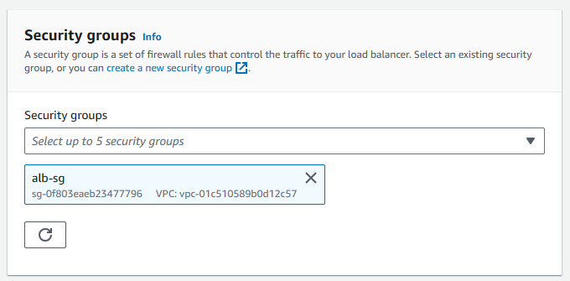

Figure 114: Setting the security group of Wings Alb

In the next configuration step which can be seen above in figure 114, a security group that is named "alb-sg" is being chosen tp pair with application load balancer. The use of a security group will act as a virtual firewall that help to manage the inbound and outbound traffic for the load balancer in the specified VPC.

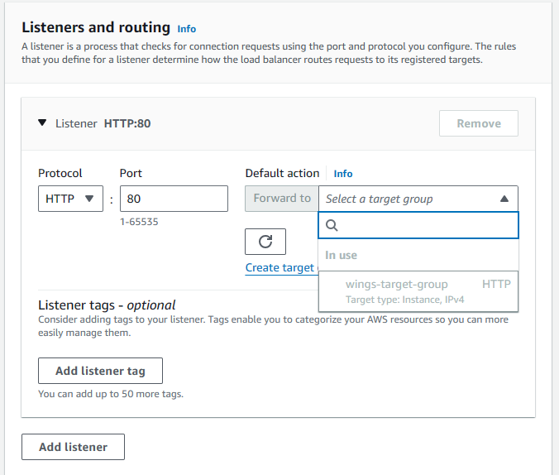

Figure 115: Setting the listening and routing of Wings Alb

The next step in this configuratio is to listener for an AWS Elastic Load Balancer which will listen for any incoming HTTP traffic on port number 80 and then immediately direct the request to the designated target group, which consists of backend servers or instances.

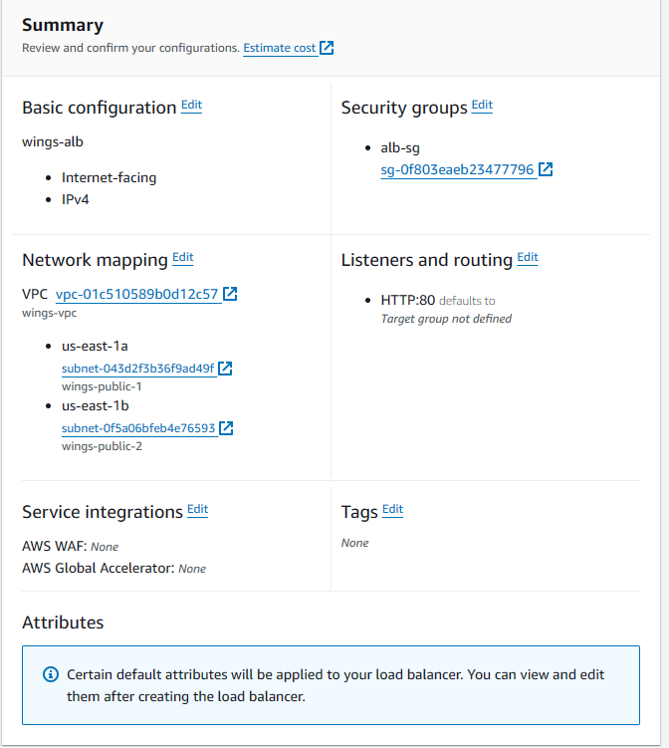

Figure 116: Summary of configuration of Wings Alb

The figure above shows the configurations chosen for the creation of Wings Application load balancer used in the project.

## Target Group

In this section, a discussion of the target group created in AWS will be done. Firstly, a target group is a collection of servers, like EC2 instances or containers, that an elastic load balancer will direct incoming traffic to. The load balancer will perform checks to gauge if these servers are working the right way, then based on rules configured will then decide how to send traffic their way. The amount of traffic in which a target group can handle is based on the load balancer type, for which in this case it is important to note we are using an application load balancer (Target Groups for Your Application Load Balancers - Elastic Load Balancing, n.d.)

.

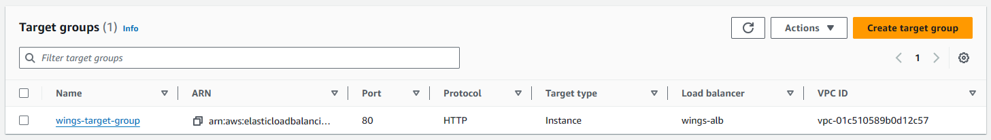

Figure 117: List of Target Group

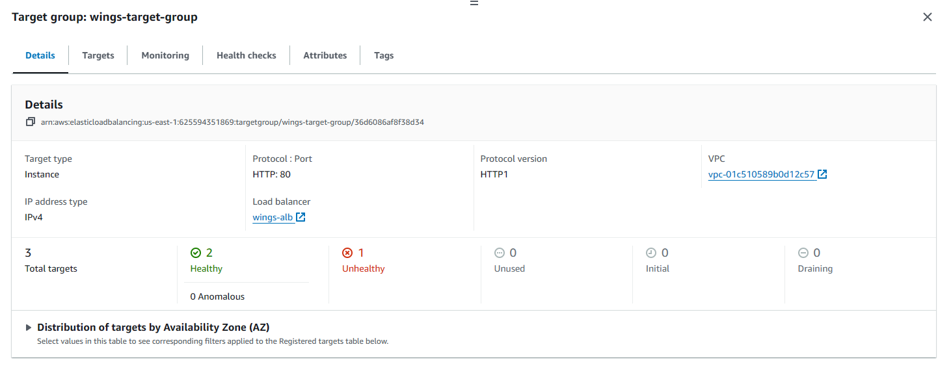 Figure 118: Target Group Details

Based on the figure 117, we can see that there is only one target group created for this project and its named wings-target-group. Below in figure 118, we can see details on the configuration of the target group. The details show that the target group has been configured for instances using that use the IPv4 and the HTTP protocol on port 80. The target group currently three registered targets where at the moment of picture take, two have the status of being healthy and thus are able to handle requests coming from the load balancer, while there is one unhealthy target which cannot receive any traffic. The target group is shown to be associated to a specificeied VPC, and the image shows the that the Load Balancer created beforehand "wings-alb" is routing traffic to it. The display is able to verfiy that that the target group's health checks are fullyoperational.

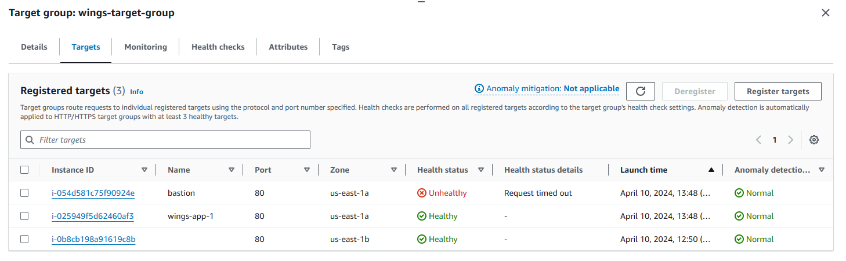

*Figure 119: Target Group target List*

Figure 119 is a snapshot of the targets under the target group created in AWS that is named "wings-target-group," which currently shows that there are 3 registered instances that it routes traffic to. One target instance that has the name"bastion," is at the time marked unhealthy due to a timeout issue occuring within its operating region under 'us-east-1a' zone. Besides tht, there are 2 other instances, named "wings-app-1" and another instance which named has been truncated are shown as having beingb healthy and are distributed across two different zones, 'us-east-1a' and 'us-east-1b'. All the targets created have been configured to handle HTTP traffic on port number 80. The healthy status for each targetr indicated that are able to to receive traffic in which currently the bastion target cannot at the moment.

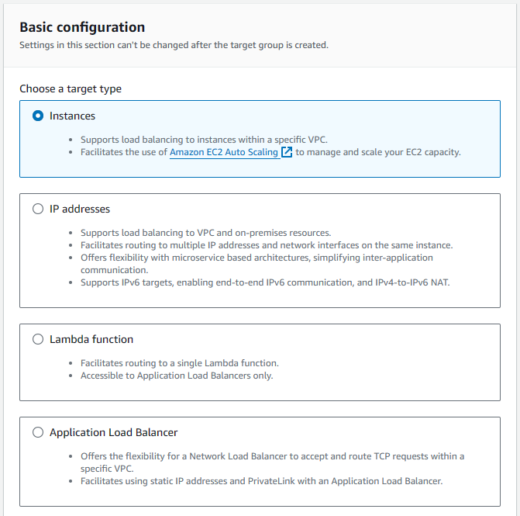

*Figure 120: target type configuration*

The figure 120 shows the AWS target group configuration options that are offered which will allow clients to balance the load between their EC2 instances, IP addresses, a single Lambda function, or use an Application Load Balancer for specific TCP traffic. In this instance were selected.

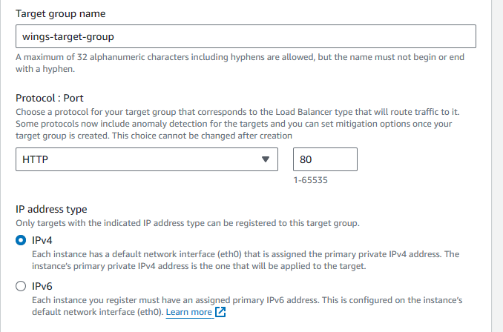 *Figure 121: Port configuration for target group*

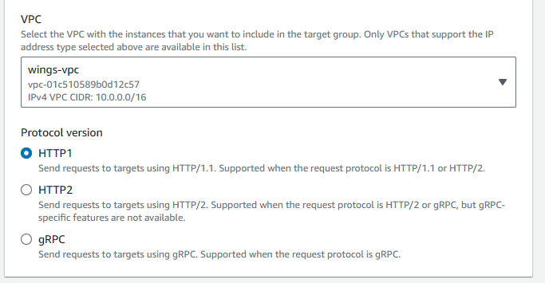

*Figure 122: Additional configuration for target group*

The configuration shows the setup for an AWS target group named "wings-target-group," which based on the configuration in figure 121has chosen to be able to receive the incoming HTTP traffic on port 80 and as well as configure the group to be able to work with IPv4 addresses. In figure 122, it is shown that the target group being created is supposed to be associated with the "wings-vpc" and utilizes the HTTP/1 protocol version, which is to indicate that the target groups are being optimized for traditional web applications that do not need the advanced capabilities of other protocol versions such as HTTP/2 or gRPC.

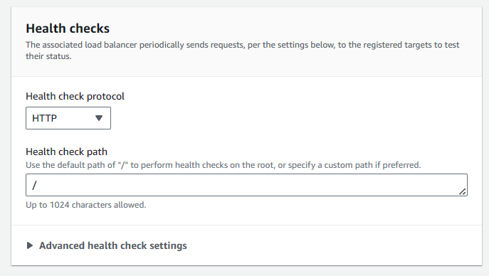

*Figure 123: Health Check configuration for Target Group*

Moving on, the health check protocol that is used as an indicator on how to measure the health status if target is set and will be using HTTP protocols and all the detected results will be forwarded to the root directory.

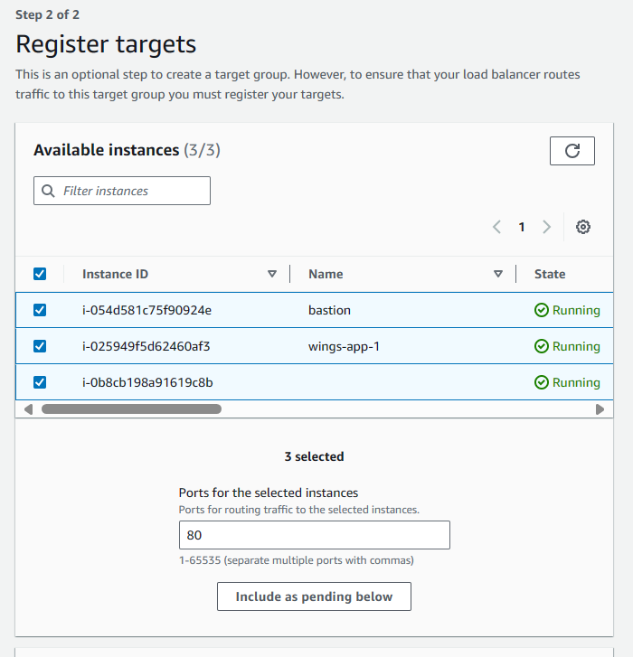 *Figure 124: Registered Target instances results*

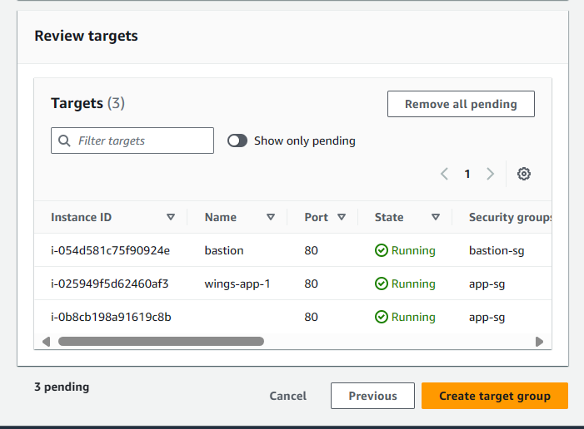

*Figure 125: Results of created targets*

The figures 124 and 125 show the end result of the creating of target group and also validates the creation as all 3 instances show they are in running state as well as the targets.

## Auto Scaling Group

AWS Auto Scaling groups is an AWS systems that helps to ensure our applications are running at optimal performance and availability by being able to automatically scale up or down compute instances needed to handle the traffic where the number of instances are scaled based on specific metrics measured such as CPU usage or network activity (*Auto Scaling Groups - Amazon EC2 Auto Scaling*, n.d.). Below shows the listing of the auto scaling groups created for the project where in this case one was created named ‘wings-auto-scaling’.

.

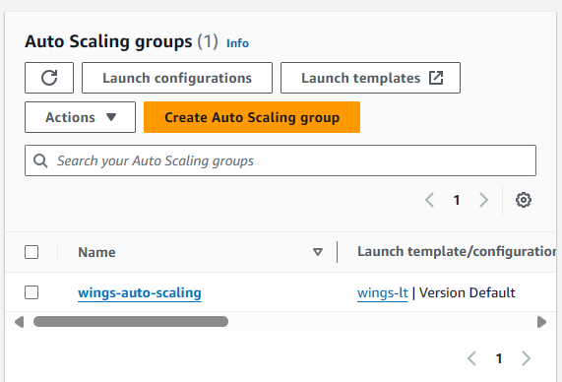

*Figure 126: List of auto scaling groups created*

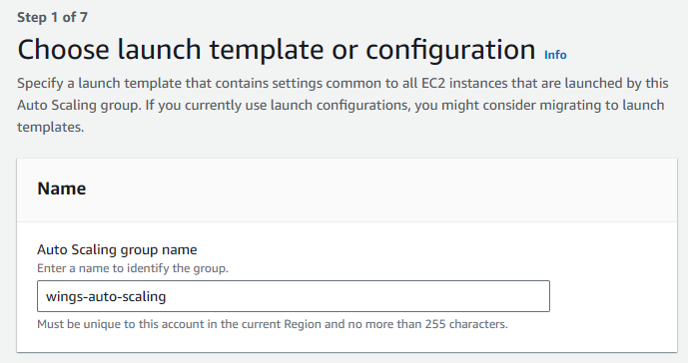

*Figure 127: List of auto scaling groups created*

The figure 127 shows the initial creation of the auto scaling “wings-auto-scaling” is given which follows AWS naming protocol . 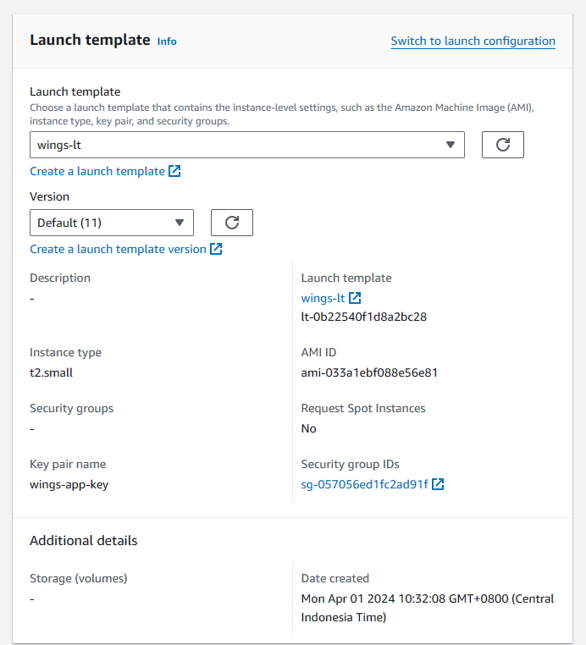 *Figure 129: Selection of template for auto scaling group*

The next step is the configuration of an AWS launch template named "wings-lt," chosen as the template for which is used to specify instance settings for quick and consistent deployment of EC2 instances. The configuration uses the default version (11) of this template which includes setting the details of instance type set to "t2.small," has an Amazon Machine Image (AMI) ID to cater to instance's OS and software configuration, and a key pair named "wings-app-key" for secure SSH access.

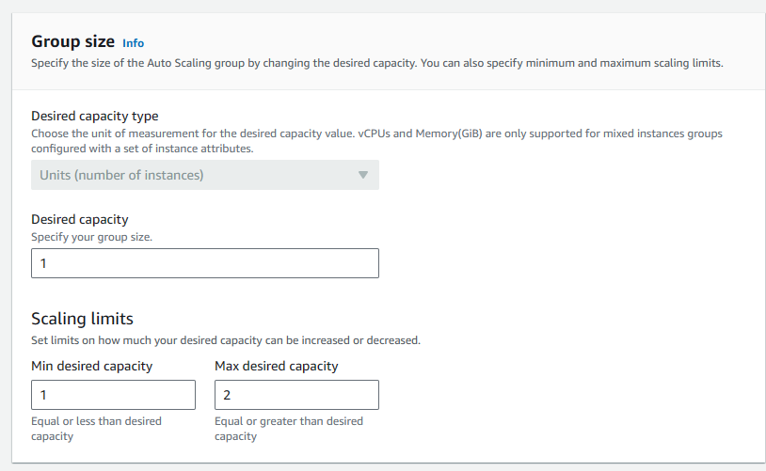*Figure 130: Group size setting for auto scaler*

The figure above can to show settings for an AWS Auto Scaling group, where the author has set it a desired capacity of one instance, which indicates the group will at least maintain a single running instance. Besides that, the Scaling limits are set with a minimum desired capacity of one and a maximum of two which is to establish the boundaries within which the group can automatically adjust the number of instances based on load. The configurations done are to ensure that there is a minimum instance rubbing and, and maximum two to handle increased demand or to maintain efficiency when traffic is at a peak.

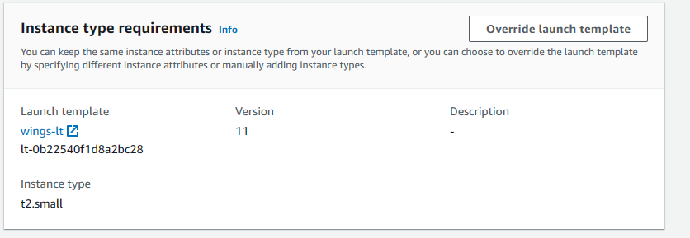 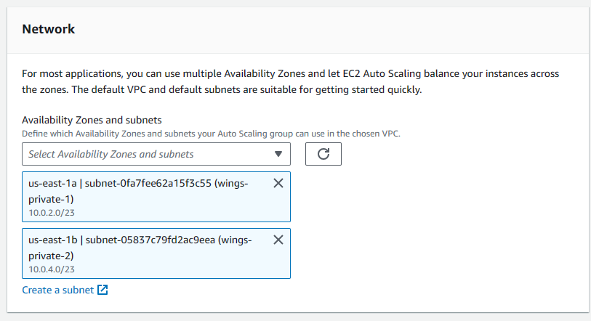

*Figure 131:Instance type requirements*

The figure above shows the configuration of an AWS Auto Scaling group that uses a a specified launch template with the name of “wings-lt" with version 11 which will deploy an instance type of "t2.small" instance types. In addition to this, it's set to distribute the instances across multiple subnets in different Availability Zones that were created beforehand which can be seen as both private subnets were chosen to be used by the auto scaler group.

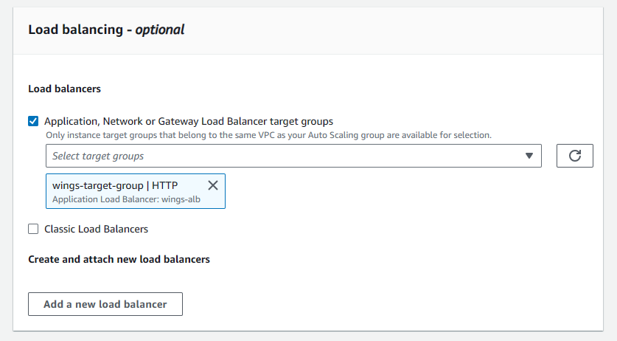 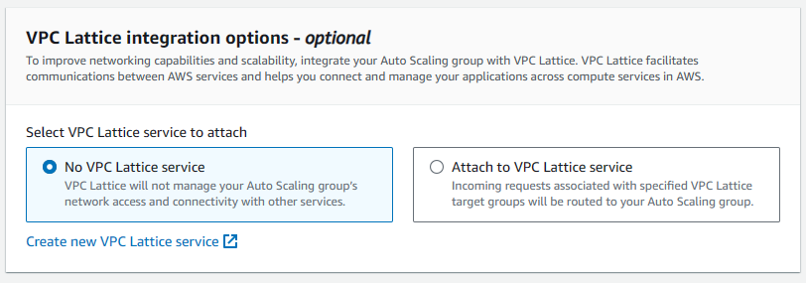

*Figure 132: Optional Load Balancer Configurations*

The figure above shows settings for option configuration for integrating load balancing and VPC Lattice with the created AWS Auto Scaling group. The Auto Scaling group is configured to use the created Application Load Balancer "wings-target-group" for incoming HTTP traffic, in which only instances of within the group will be forwarded request. The Additional option for VPC Lattice integration was not not selected which means that the auto scaling group will not need to use the capabilities and inter-service communications VPC Lattice services.

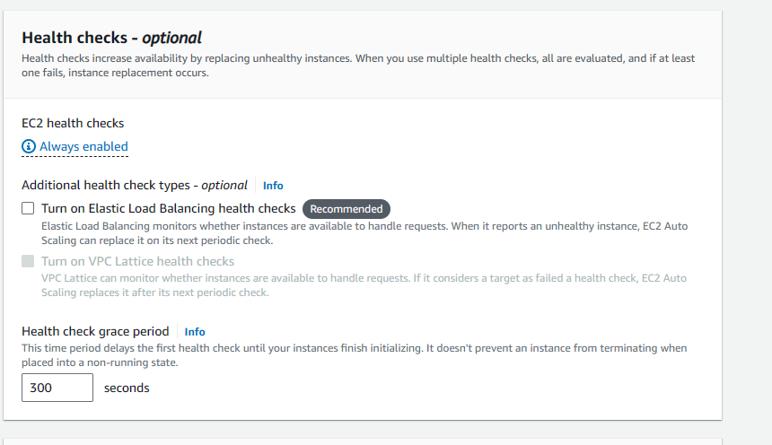 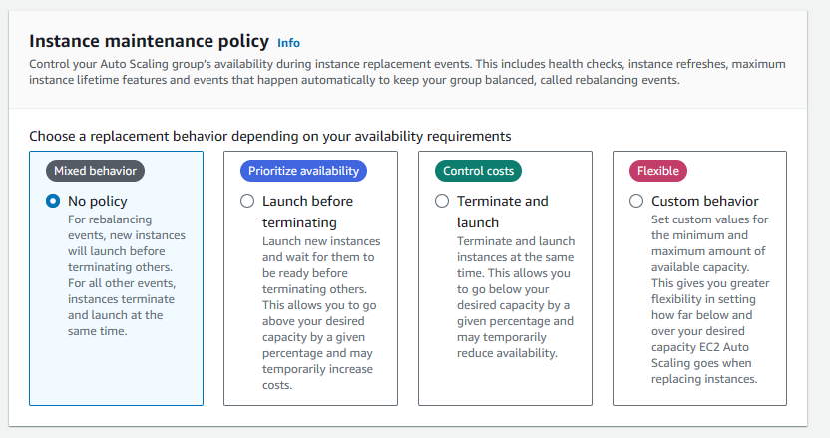

*Figure 133: Health checks and instance maintenance configuration*

The figure of 133 show the health checks and instance maintenance policies for an AWS Auto Scaling group. By default, EC2 health checks are done and allow to add on to doing Elastic Load Balancing health checks for better monitoring but will not be selected by the author. Besides that, the health check grace period set to 300 seconds. Also, AWS offer instance maintenance policy to have rebalancing events for your load balance to ensure the health of the auto scaler. No policy was chosen as he selection.

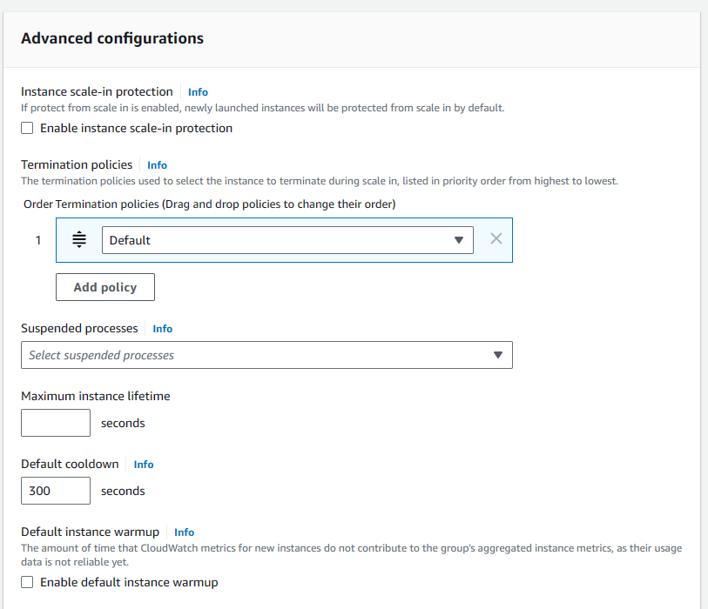

*Figure 134: Advanced Configurations*

Finally, the last section of creating the auto scaling group is the advanced configurations. The advanced configurations includes options such as allowing the instance scale-in protection to will prevent from any newly launched instances from being deleted downscaling activities occur, as well as setting up termination policies to will help for AWS to know which instances to terminate first by, and also change the default cooldown period of 300 seconds when scaling happen. No additional configurations were added by the author.

# 4. Data Migration

Data migration refers to the process of shifting information between storage systems, applications, databases, or computing environments (Cloudfare, n.d.). Within the field of cloud computing, this frequently involves transferring data from servers to cloud-based storage solutions. The importance of data migration, for businesses, lies in the ability to enable them to capitalize on the advantages offered by cloud technology, such as scalability, enhanced security measures, and cost savings.

Cloud computing grants businesses the ability to seamlessly integrate technologies without being held back by the maintenance of the required infrastructure. By migrating their data to the cloud businesses can free up resources enhance data accessibility and access analytics tools ultimately elevating their overall operational efficiency.

In this section, the components configured in AWS cloud in order for data migration are shown.

## 4.1 AWS Regional Database System

Amazon Relational Database Service (RDS) is a cloud service that helps with setting up, managing and expanding databases in the cloud. One big advantage of RDS is that it works well with popular database engines like MySQL, PostgreSQL, Oracle, Aurora, and SQL Server (Amazon Web Services, n.d.). This versatility means it can work smoothly with existing applications when transitioning to the cloud. For WingsCafe, moving their databases to RDS would allow them to make use of the scalability and automation features AWS offers. Moreover, the security measures provided by RDS like encryption for data, can be further strengthened by using Security Groups to manage traffic going in and out of the database instances. Taking this approach could significantly boost WingsCafe’s database security.

## 4.2 SSH Connection

This document will show the SSH connection made to the virtual Linux device in the EC2 instance.



An application called PuTTY is used to make a connection to the Linux device. PuTTY is a free and open-source terminal emulator, serial console, and network file transfer application (Tatham, n.d.). As can be seen in the snapshot, a couple of pieces of information need to be specified for the connection to be made. The first component is the settings or configuration that contains various sorts of information such as the keys, etc. This will be explained more in the next snapshot.

The next piece of information is the IP address which is actually the public address of the Bastion host. Therefore, through this application, the user will be able to gain access to the Bastion host and then finally gain access to the Linux device.



As can be seen in the above two snapshots, the configuration settings are shown for the ***jump-server*** pre-configuration. The first snapshot showcases the SSH settings while the second one shows the private key. Configuring the private key in the settings means the user does not need to enter the private key each time they want to access the virtual device within the private subnet.



Once the jump server or bastion host’s public IP address is used to create an SSH session to the host, the user can further move on and gain access to the private subnet’s ec2 device. This is accomplished through the command: ***SSH ec2-user@[private_ip_address]***. The snapshot above showcases this command.



The above snapshot shows the active private key that has been pre-configured in the settings. Once the connection is built, one can view the specific private key through PuTTY.

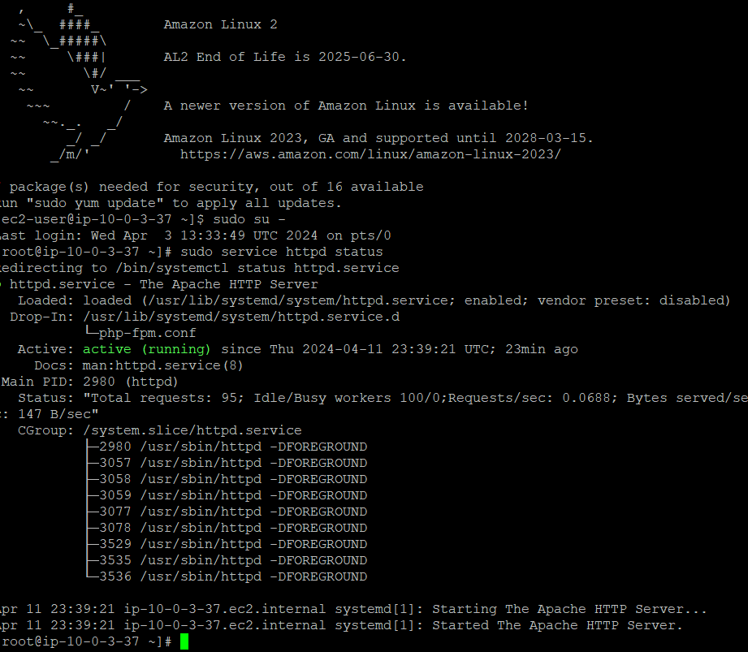

In the above snapshot, a command is run (***sudo service http status***) which checks the status of the Linux webserver and shows that it is successfully running. This implies that the website can run on a browser.

## 4.3 MYSQL

In this section, the MySQL database that has been configured within Linux will be showcased. To gain access to the database, the user has to start a MySQL session using the mysql command. Certain credentials are required to login to the database such as the username and password set in the AWS database instance as well as the RDS endpoint label.

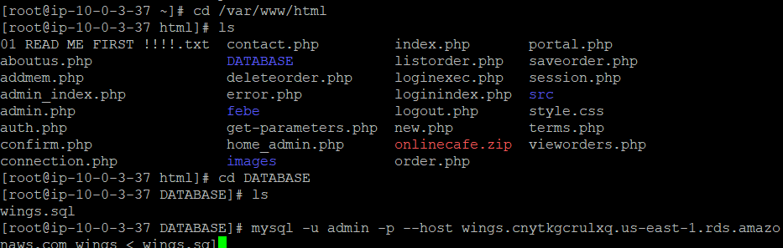

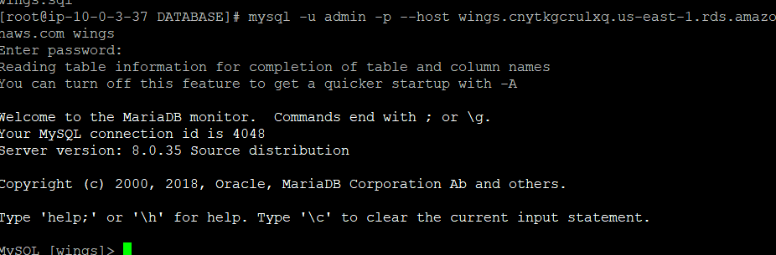

In the above screenshot, the user logs into the database using the mysql command.

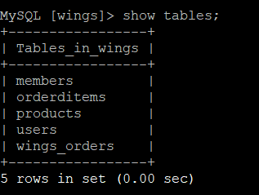

As can be seen in the snapshot, all the tables for WingsCafe are successfully showing within the database.

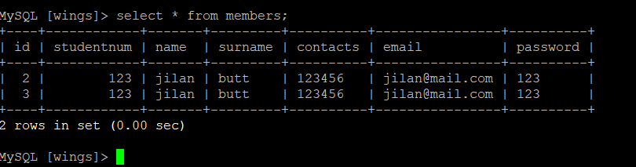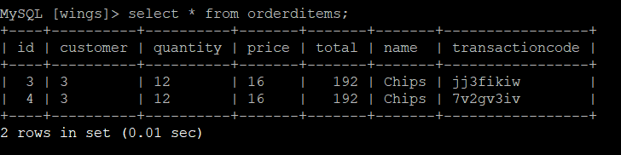

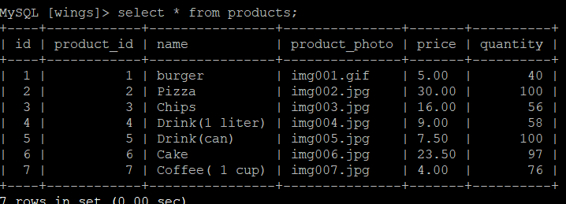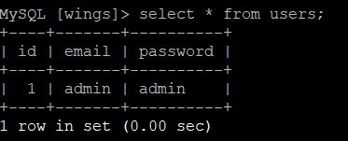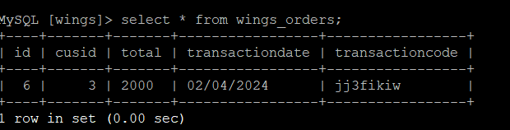

The tables also contain accurate data as can be observed in the screenshots above. This data will remain stored even if one cuts the SSH session made, as it is permanently stored in the database until further changes are made.

## 4.4 S3 (storage)

Amazon Simple Storage Service (S3) is a service for AWS that plays a role by offering object storage, for various types of data (Cloudian, 2023). The S3 service in this case will be used to create a bucket and store WingsCafe’s website. The website is written in PHP. The essential purpose of this phase is to upload the files to the Linux device which has an in-built HTTP server. However, one must note that is not possible to directly upload files from local storage into the virtual device. Therefore, the network architect starts off by uploading to an S3 bucket and then transferring the files to the Linux device’s HTTP server directory.

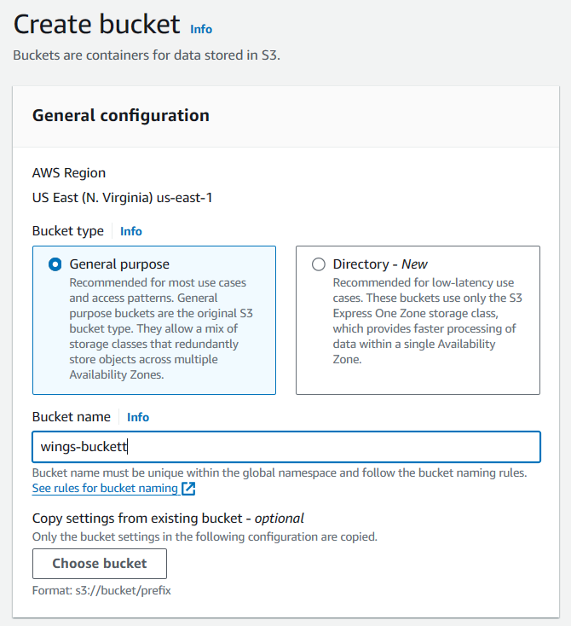

Firstly, the network architect specifies a a relevant name of the bucket, followed by the type of the S3 bucket. In this case, the architect decides to go for the default ***General-purpose*** bucket. Fortunately, AWS allows for the S3 bucket to cater for multiple zones which is suitable in WingsCafe’s scenario.

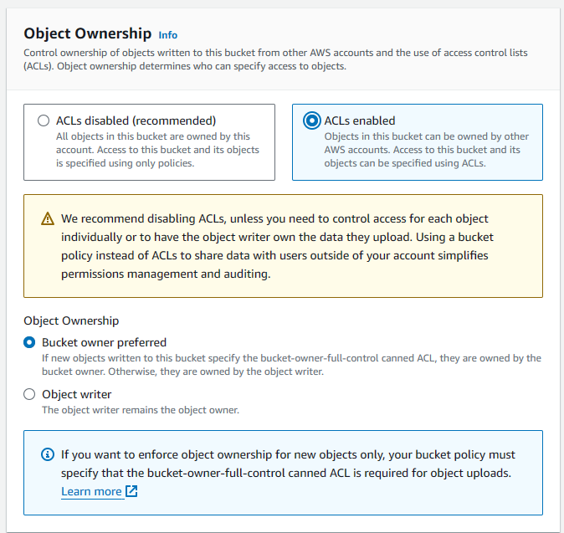

Next, the ACLs is enabled for the sake of security. The bucket owner is also set as the default owner for every material uploaded to the bucket, regardless of who uploads it. These collective settings ensure that the whole bucket is entirely controlled only by the bucket owner. It ensures extra security.

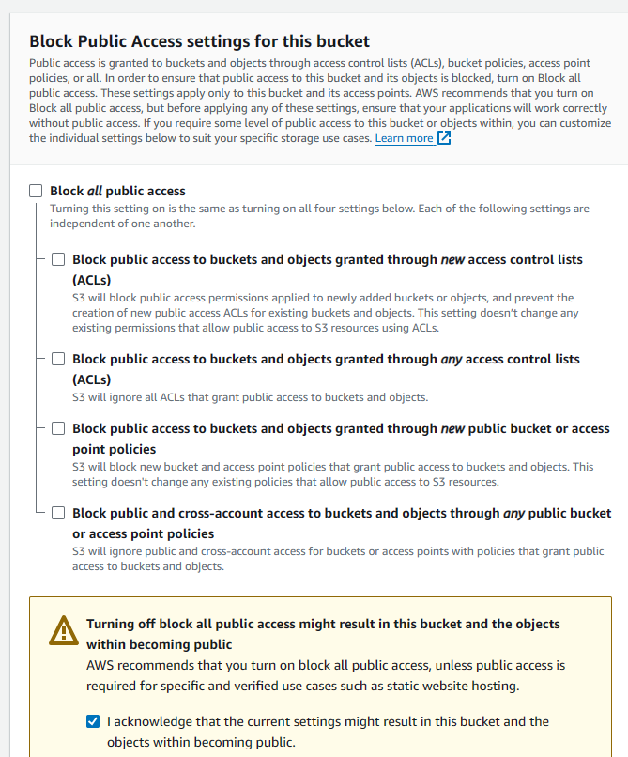

Next, the architect disables any public access as WingsCafe would probably not like its website sources code to be leaked to unauthorized parties. This once again is a safety and security measure.

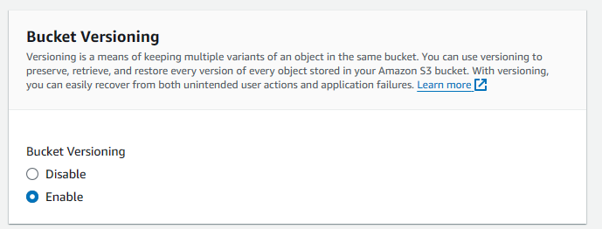 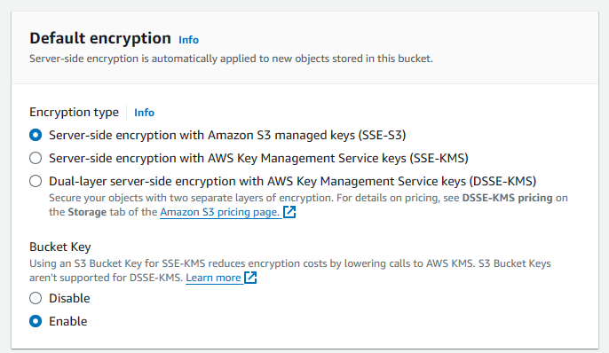

Bucket versioning is enabled, this ensures that everytime a change is made to the contents within a bucket, the older version is archived. It gives one the benefit of downgrading to an older version in the case it is required. However, this means more cost.

For the encryption type, the network architect chooses the default first choice. This is the simplest one and will encrypt the data stored in the S3. This means that a party cannot gain access to the contents held within the bucket if they do not possess the decryption key.

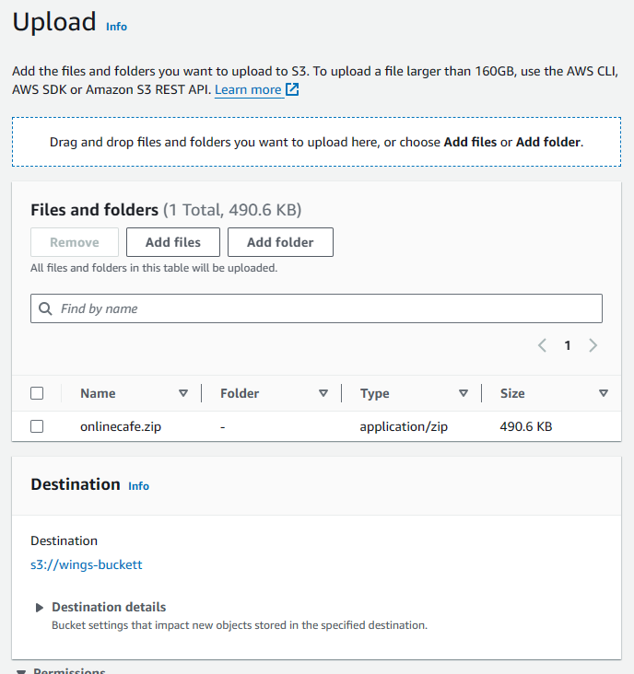

Next, the files are uploaded from the local storage. The files, in this case, is the PHP web folder that was updated by the team. As it can be seen, a ZIP file is uploaded. This file will be unzipped through a script further in the process.

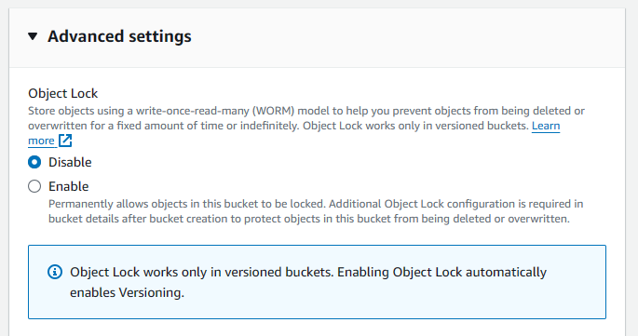 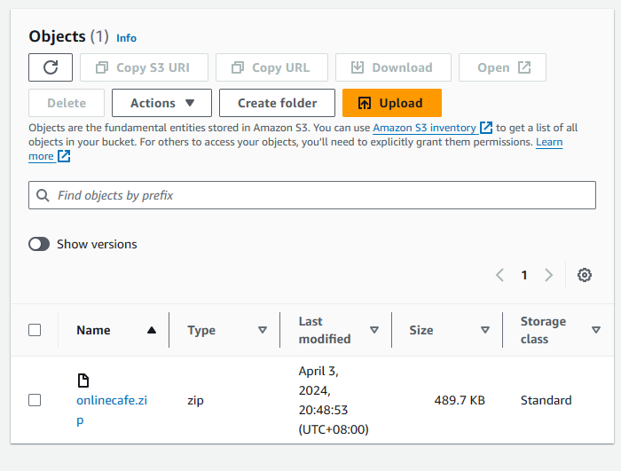

Finally, the object lock is disabled. This means that the architect can change the contents of the bucket by reuploading as many times as they’d like or require.

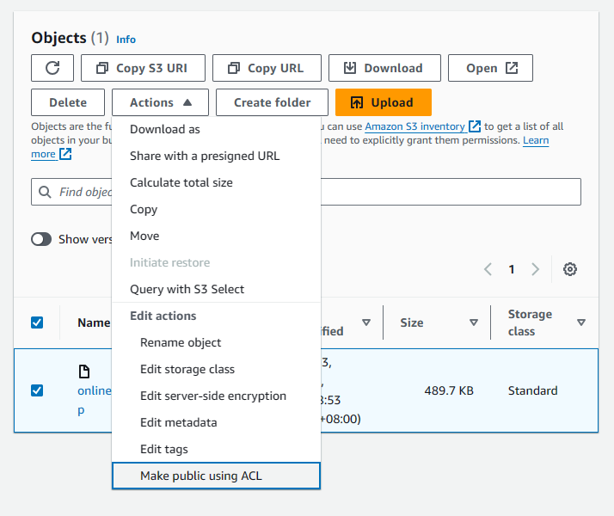

When the bucket is finally created, the network architecture makes the S3 publicly accessible. The reason for this is because the Linux server will later be using the assistance of a script to download website files from the bucket into its webserver directory and therefore will require access.

# Section C: Serverless Architecture

The concept of serverless architecture is a cloud computing execution strategy in which the cloud provider is the entity that dynamically manages the distribution and provisioning of servers for the client. The concept goes against the need of purchasing or renting out servers or virtual machines, where instead the code runs in stateless compute containers that are event-triggered and is fully managed by the cloud provider such as AWS (Serverless Architectures, n.d.).

The reason why serverless architecture is gaining popularity is due to the fact it brings benefits such as reduced operational complexity and cost managing servers or runtime environments has been rendered not needed. But besides those primary reasons, the architecture is also able to offer high scalability as the underlying system within the architecture is able to automatically handle increased loads by instantiating more copies of the function. Adding on to the fact that serverless architecture can be cheaper than a regular architecture approach, as the strategy implements a cost-incurring strategy of only being charged for the precise number of resources consumed by your applications while they are running. Besides that, the method also encourages a microservices-oriented design that allows the development of modular and easy to maintain applications. Finally, the use of this architecture also allows the reduction of time to market and eases the burden of developers by allowing them to primarily focus on the business logic and value creation rather than infrastructure management (Serverless Architectures, n.d.). With that being said, the section will look into the implementation of a serverless architecture approach for Wings Cafe Website.

# 1. Services

This section will discuss the AWS services that are required to be implemented to achieve a serverless architecture for hosting the Wings Cafe Website. The services that will be taken up are described as per below.

## 1.1 AWS Amplify



Figure 106: AWS Amplify (Kirimoto, 2022)

The AWS Amplify Service is a suite of tools and services offered by AWS that allows developers to develop secure, highly scalable web and mobile based applications fast and easily. The service provides a straightforward method of managing backend services as well as integrating with AWS resources for actions such as authentication, APIs, storage, and etc. The Amplify service is able to support many popular development frameworks amongst web developers such as JavaScript, React, Angular, Vue, Next.js, and as well as mobile platforms such as Android, iOS, React Native, Ionic, and Flutter (What Is AWS Amplify, n.d.-b).

The Amplify service is required for the serverless architecture paradigm taken by Wings Cafe by being able to abstract away a majority of the server management tasks. These task include managing the deployment and operation of server-side components required by the application, as well as scaling the underlying infrastructure up and down automatically. With that, developers are than able to put their attention towards writing application code without having to worry about managing servers, thus speeding up development and reducing any potential of human error arising in the deployment and scaling process (What Is AWS Amplify, n.d.-b)..

## 1.2 Amazon S3



Figure 107: AWS S3 (Introduction to Amazon S3, n.d.)

The Amazon S3 is an extremely important service offered amongst other services in its suite as it offers the service of having a robust, scalable cloud storage that can cater to any data of any size that is able to to be accessible from anywhere on the web. In relation to the creation of serverless architecture for this project, the use of S3 will eliminate the use of server management as by being able to integrate with AWS Lambda service will allow the architecture to be able to respond to data driven events like uploads or changes within the clients S3 storage buckets. The pairing of the services allows a seamless interaction that enables automatic data processing, from image resizing to content analysis.

## API Gateway

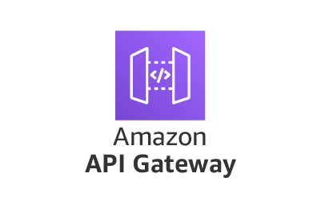

Figure 108: Amazon API Gateway (Samuel, 2022)

Amazon API Gateway service that is fully managed by AWS that eases the role for developers to create, publish, maintain, monitor, and secure their APIs at any scale. In general what APIs are is that they take on the role of being a "front door" for external applications to be able to gain access to data, business logic, or functionality from backend services that are provided from a certain party. The use of this gateway service in the context of serverless architectures is that the gateway will serve as a way to link the client side with serverless backend services such as AWS Lambda. Specifically, the gateway functions to handle all the processes involved that include the accepting and processing of up to hundreds of thousands of concurrent API calls, that include the actions of traffic management, permission and access control, monitoring, and API version management. API Gateway helps to relieve the workload of managing the infrastructure so the developers can focus on writing business logic and application code (Samuel, 2022).

## AWS Lambda

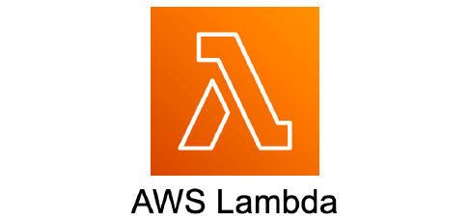

Figure 109: AWS Lambda (Serverless Computing - AWS Lambda Features - Amazon Web

The AWS Lambda service is a serverless computing service that is provided by AWS that runs code in response to events and automatically manages the computer resources needed by that code. It is designed to use functions as a service (FaaS) to run code without provisioning or managing servers. Clients must only upload code to Lambda and the service will be able to handle all tasks and processes that are required to run and scale your code with high availability. The Lambda functions inside the service are able to perform a variety of tasks that range from simple tasks like processing files to organizing complex workflows (Serverless Computing - AWS Lambda Features - Amazon Web Services, n.d.).

The use of the Lambda Service is a primary component towards developing a serverless architecture. In general, a serverless architecture is a strategy of developing and operating applications without the need to manage infrastructure. The service is able to achieve that by making it possible by abstracting the server layer, so developers don't have to worry about server deployment, maintenance, scaling policies, or runtime management. The serverless paradigm enables developers to push code into a production environment, where AWS handles the whole execution, scaling automatically and instantly as needed. Lambda works perfectly with other AWS services such as Amazon S3, Amazon DynamoDB, and Amazon API Gateway, making it an extremely versatile and powerful tool for developing large serverless applications. Using these connectors, developers can create a completely serverless backend for a web application, data processing system, or any other can be triggered by HTTP requests, database changes, file uploads, scheduled events (like cron jobs), and more (Serverless Computing - AWS Lambda Features - Amazon Web Services, n.d.).

## 1.5 DynamoDB

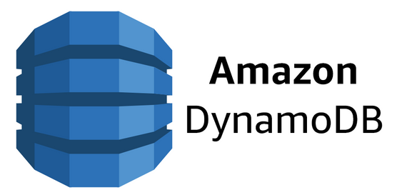

Figure 110: AWS DynamoDB (Get Started With. . . DynamoDB - Serverless, n.d.)

The service of Amazon DynamoDB in general is that it is a fully managed NoSQL database service provided by AWS that is able to provide a single-digit millisecond performance at any scale. The database was developed to be highly available as well as fault-tolerant, with-it having abilities such as built-in replication and backups. The DynamoDB is able to provide its services to both document and key-value data models which in turn makes it a versatile database that can be applied to a wide range of use cases. Towards applying it to create a serverless architecture, the database is perfect for a serverless database solution. The database is able to seamlessly integrate with other AWS services that were previously discussed such as AWS Lambda, Amazon API Gateway, and Amazon S3 to form a comprehensive serverless application stack. By using DynamoDB, it also allows the developers to offload the operational overhead of managing databases, that include tedious activities such as provisioning hardware, configuring the required servers, and handling the architecture to scaling, to AWS. This allows developers to focus on building their applications without worrying about managing infrastructure. Finally, DynamoDB uses a pay-as-you-go pricing model that bodes well with the serverless direction as a user is only charged for the resources they consume which makes it a great cost-effective choice for serverless applications (Get Started With. . . DynamoDB - Serverless, n.d.).

# 2. The Infrastructure

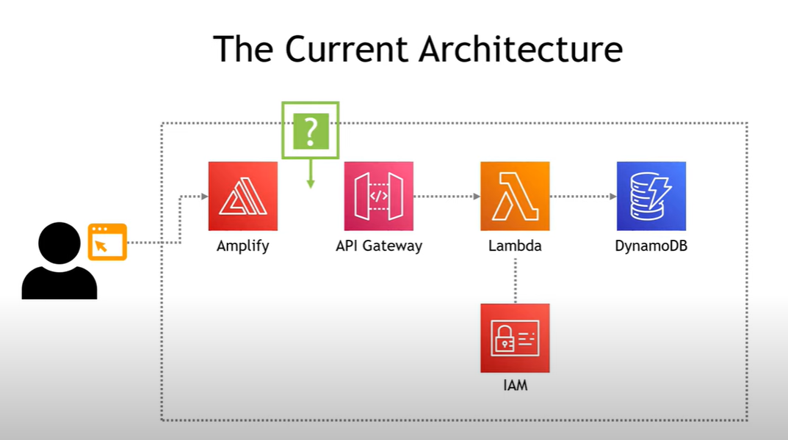

Figure 111: Serverless Infrastructure

The diagram above illustrates the serverless architecture that is proposed to be implemented by the team for Wings Cafe. In the proposed architecture, the flow starts when a user interacts with the graphical interface that is presumably built and hosted with AWS Amplify. Then any interactions that will require the need for backend processing will trigger an API call. The call is then routed via API Gateway, which will then invoke an AWS Lambda function. The Lambda invocation will process the request, which might perform actions such as reading from or writing to the DynamoDB table, the preferred database solution for when creating serverless architecture and then returns a response back via API Gateway to the user. The IAM is utilized across the workflow to ensure security via only letting authorized calls be processed. The serverless element of this proposed architecture is achieved from the fact that there are no EC2 instances or other servers to manage; where AWS provides the service of automatically handling the scaling and infrastructure management of Amplify, API Gateway, Lambda, and DynamoDB.

# 3. Configuration

## 3.1 Step 1: Creating the Amplify Environment

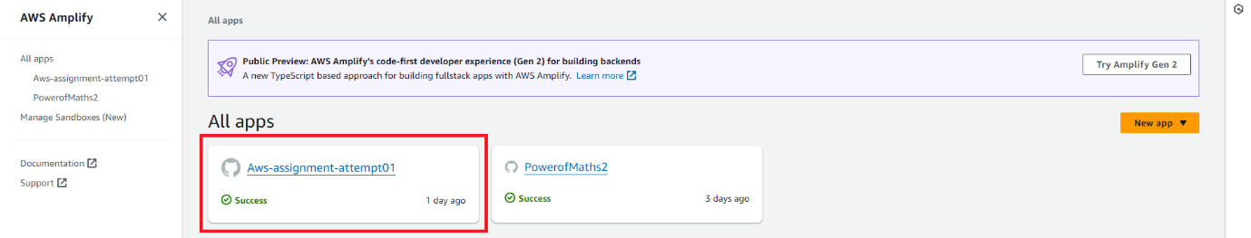

Figure 112: AWS Amplify Console

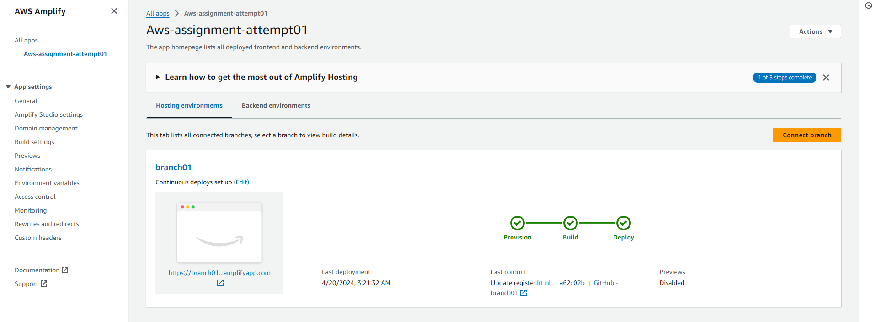

Figure 113: AWS Amplify Environment

Firstly, an Amplify environment that consists of the frontend and backend ecosystems is created. A GitHub repository that stores all relevant application files, such as the application source code, stylesheets, and more, has also been created and linked to Amplify, to create a comprehensive environment for the WingsCafe web application’s development. The name *Aws-assignment-attempt01* was given to uniquely identify the environment, as seen in *Figure 112*. *Figure 113* illustrates the Git branch that was connected to Amplify environment, which contains the source code for the WingsCafe application for deployment.

## 3.2 Step 2: Creating DynamoDB Instance

Initially, a DynamoDB table will be created. DynamoDB, a fully managed NoSQL database service provided by Amazon Web Services (AWS), supports both document and key-value store models, making it highly suitable for web-scale applications (AWS, n.d.). The DynamoDB will store the various pieces of data for WingsCafe such as the information about the food items, members, etc.

An important aspect of configuring AWS resources involves the use of Amazon Resource Names (ARNs). An ARN is a unique identifier that AWS assigns to each piece of resource, which helps in specifying which AWS resources are involved in the operations (AWS, n.d.). For WingsCafe, the ARN will be crucial for setting up Identity and Access Management (IAM) roles, specifically for the integration with AWS Lambda functions. The ARN for the DynamoDB will be embedded within the IAM role, ensuring that the correct permissions are associated with the Lambda functions.

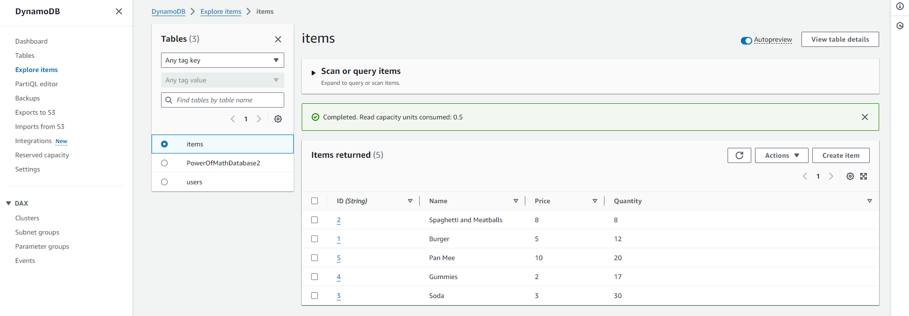

Figure 114: DynamoDB Tables – items

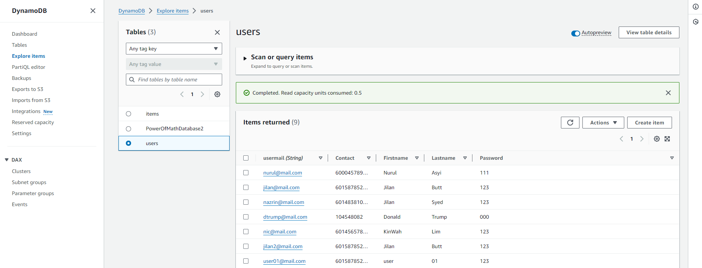

Figure 115: DynamoDB table - users

In this case, the team has configured the DynamoDB tables, *items* and *users*, that stores the café inventory, and the user login credentials respectively, as seen in *Figure 114 – 115*.

## 3.3 Step 3: Giving Lambda Relevant Permissions

AWS Lambda allows users to run code for virtually any type of application without provisioning or managing servers. To enable Lambda to interact with DynamoDB, it is imperative that appropriate permissions are granted. This is managed through the assignment of an execution role and specific permissions within the AWS Lambda console.

Permissions are generally assigned through inline policies. An inline policy is a set of permissions that is directly embedded into a single IAM role or user, defining explicit permissions for the resource in question (AWS, n.d.). For WingsCafe, an inline policy will be created and associated with the Lambda function's execution role. This policy will explicitly permit actions such as Insert, Delete, and Get operations on the DynamoDB table. The ARN of the DynamoDB table will be specified in this policy to ensure these permissions are accurately targeted.

For this task, the team has attached the ready-made role, *LabRole*, which is the default role for the AWS Learner’s Account, to allow permissions to create the Lambda functions in the next step.

## 3.4 Step 4: Creating Lambda Functions

Following the permission setup, the next step involves the creation of the Lambda functions. AWS Lambda supports multiple programming languages, offering flexibility in how functions are developed (AWS, n.d.). Python is recommended for this scenario due to its simplicity and the extensive support available through the AWS SDK (module) for Python, known as Boto3. Boto3 allows for easy integration with AWS services, making it ideal for scripting Lambda functions that interact with DynamoDB (Boto3 documentation, n.d.).

In the Lambda function, the DynamoDB table name will be specified, and data retrieval will be conducted via APIs. The retrieved values may be processed further if required by WingsCafe's business logic, before being inserted into the database. It is crucial to test the Lambda function with sample data to ensure that the implementation meets the operational requirements.

Furthermore, different Lambda functions may be required for various webpages or tables, depending on the structure and needs of the WingsCafe website. Each function will be tailored to handle specific data interactions efficiently.

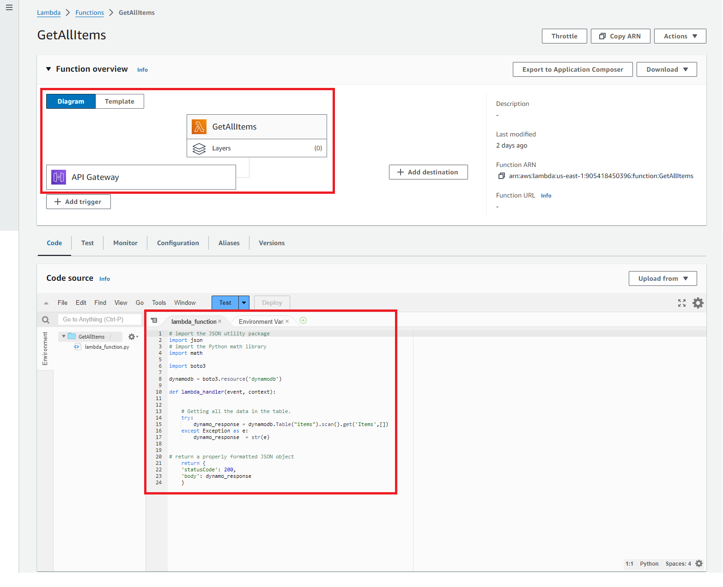

Figure 116: Lambda Function – GetAllItems

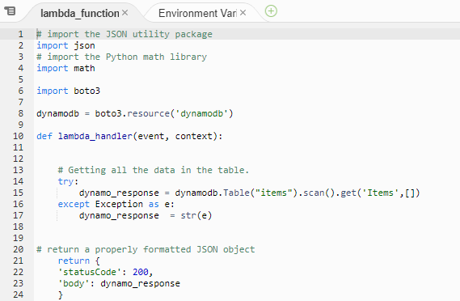

Figure 117: Lambda Function GetAllItems - Code

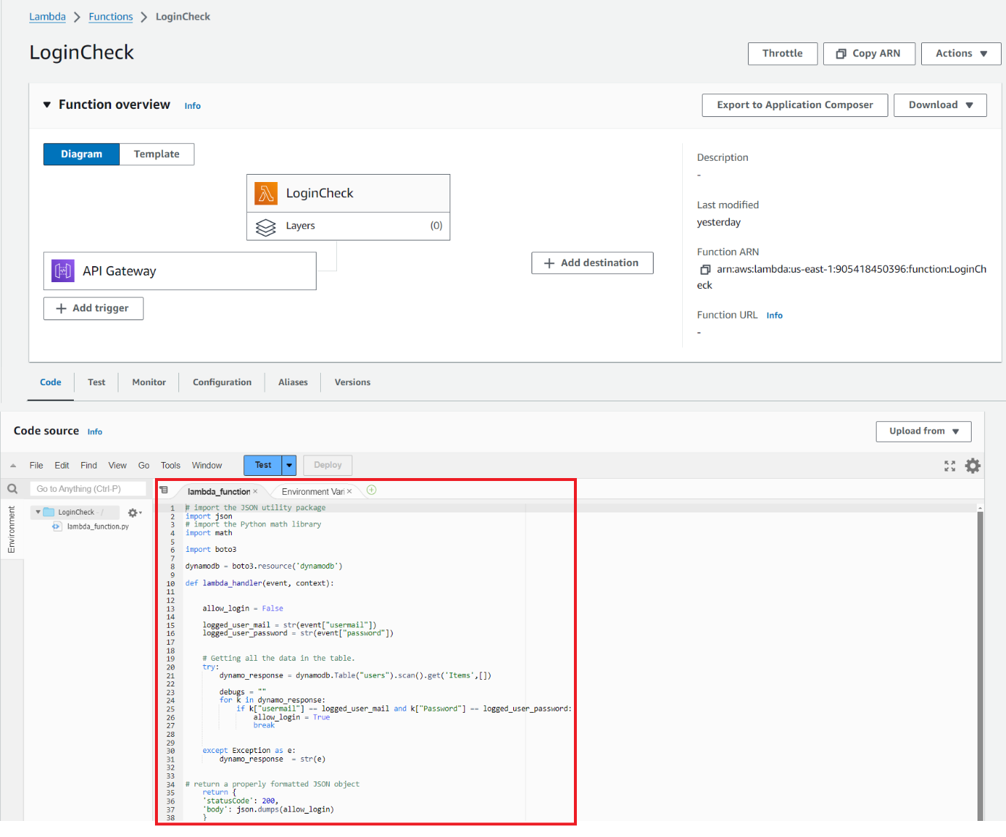

Figure 118: Lambda Function – LoginCheck

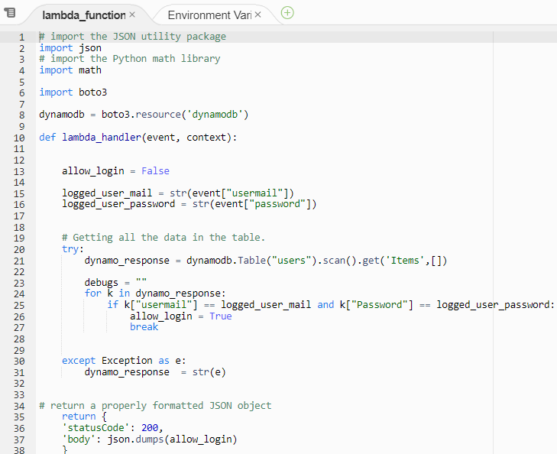

Figure 119: Lambda Function - LoginCheck code

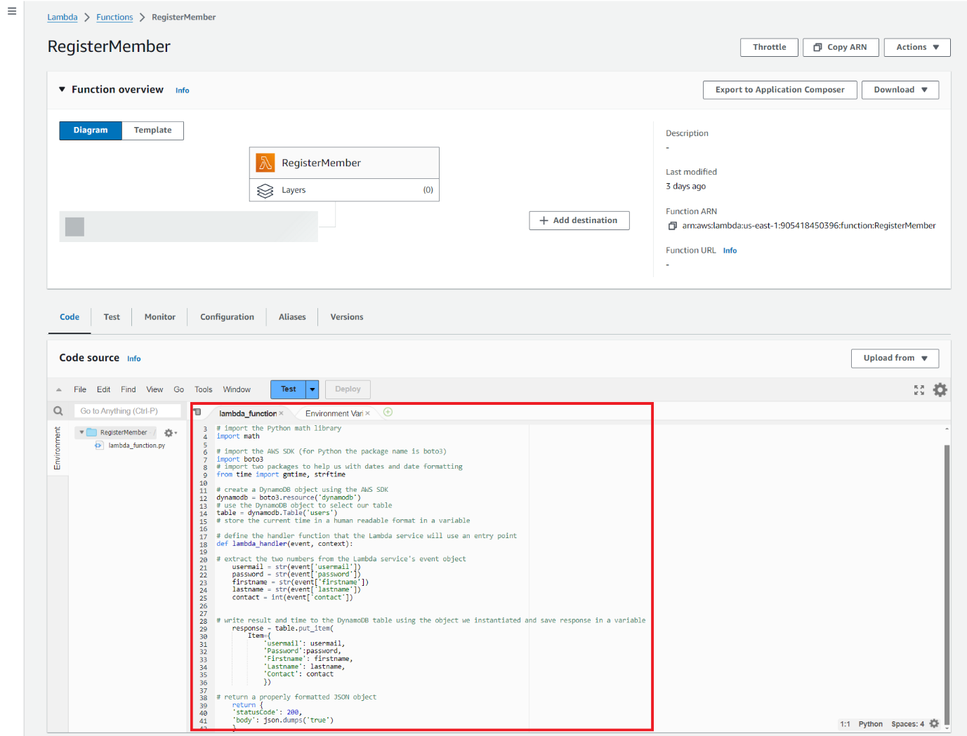

Figure 120: Lambda Function – RegisterMember

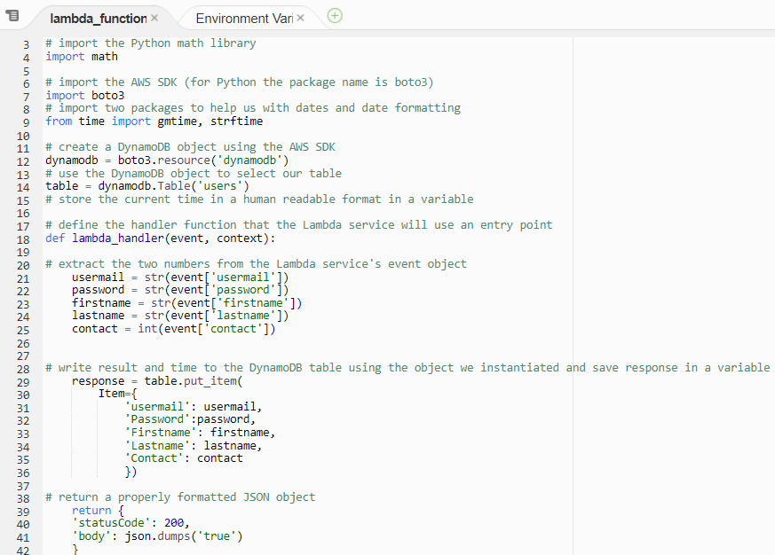

Figure 121: Lambda Function – RegisterMember Code

In this case, the team has created the Lambda function *GetAllItems*, *LoginCheck* and *RegisterMember*.

The *GetAllItems* fetches all information regarding the café’s inventory by scanning through the *items* table in DynamoDB, as seen in *Figure 116*; the *LoginCheck* function validates user input for login credentials by scanning through the *user* table in DynamoDB, as seen in *Figure 118*; the *RegisterMember* function reads and stores the user credentials into the DynamoDB table *users*.

After the functions are done running, their corresponding values will be returned to the API Gateway from which the functions are called. The configuration of the API Gateway is explained in the next step.

## 3.5 Step 5: Creating an API Gateway

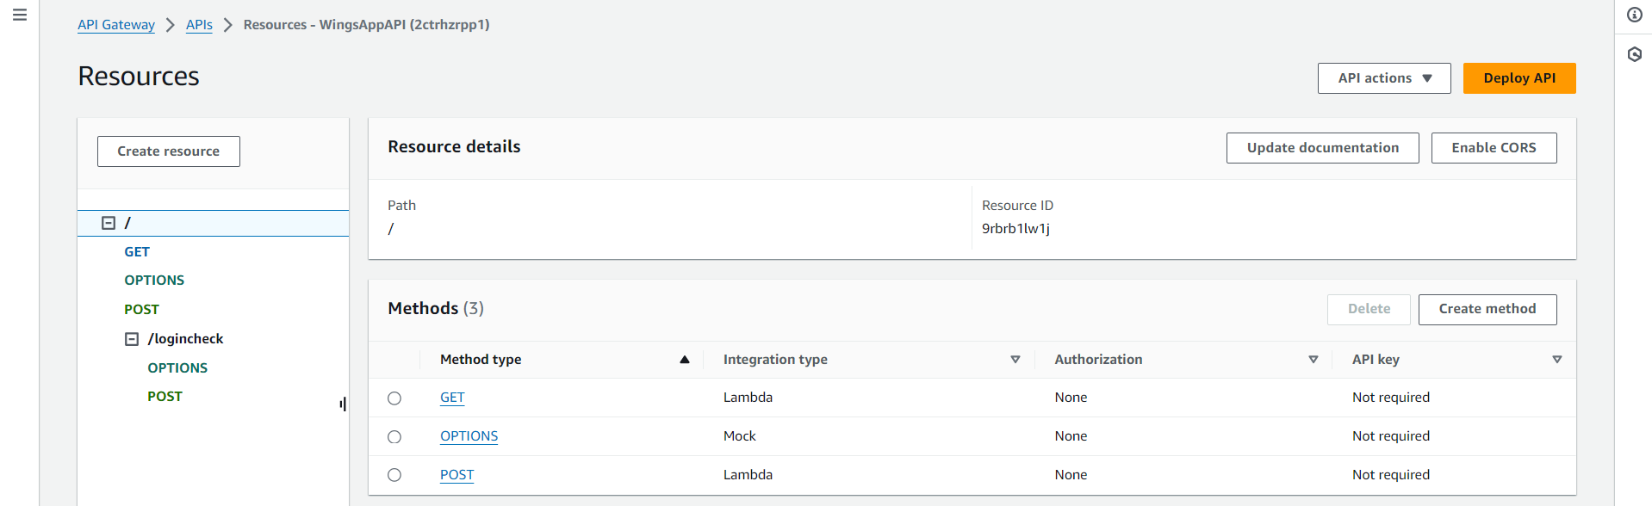

Figure 122: API Gateway - Resources

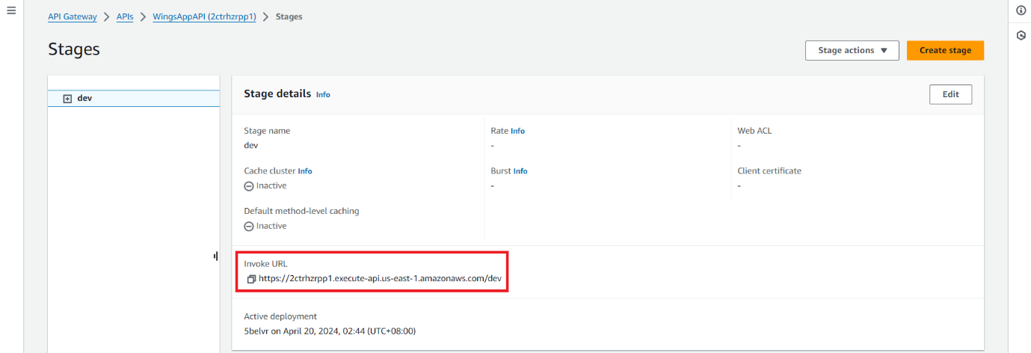

Figure 123: API Gateway - Invoke URL

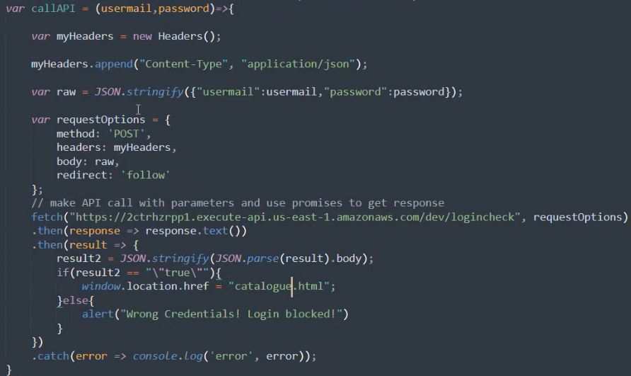

Figure 124: API Gateway – Code for Making API Requests

To enable communication between the front end of the WingsCafe website and the Lambda functions, an API Gateway will be set up. The API Gateway serves as a robust tool to create, publish, maintain, monitor, and secure APIs at any scale.

A REST API will be implemented using AWS API Gateway. REST, or Representational State Transfer, is an architectural style for distributed hypermedia systems and is often used to build scalable web services (Fielding, 2000). In the API Gateway, POST methods will be configured to trigger the relevant Lambda functions when data needs to be inserted into the DynamoDB.

Cross-Origin Resource Sharing (CORS) will also be enabled on the API Gateway. CORS is a security feature that allows or restricts requested resources on a web server depending on where the HTTP request was initiated. This is crucial for securing WingsCafe’s data while allowing legitimate web requests (Mozilla, 2021).

Once configured, the API can be deployed, providing a URL endpoint. This URL is critical as it will be integrated into the WingsCafe website’s code to facilitate communication between the site and the AWS backend.

The team has created the API Gateway named *WingsAppAPI*, that’s associated with the relevant Lambda functions, as mentioned above, for making API requests, which reduces server management and is generally the ideal infrastructure for serverless applications. Each API Gateway consists of a unique URL, as seen in *Figure 123* for making API requests, of which the code is illustrated in *Figure 124*. The code, which is the *callAPI* function, takes the arguments *usermail* and *password* and convert them into strings and initiates a POST request to the API. The request then triggers the *LoginCheck* lambda function, and scans through the *users* DynamoDB table to validate said input. The Boolean value that is returned from said function will be returned to the application via the API Gateway.

## 3.6 Step 6: Testing – Running the Web Application

The existing WingsCafe website, currently utilizing PHP and interacting with a MySQL database, will undergo significant redevelopment. The legacy system’s PHP code will be modified to send data to the REST API endpoint provided by AWS API Gateway instead of directly interacting with a MySQL database. This change requires substantial updates to the existing PHP scripts, ensuring they are configured to handle API calls effectively.

The URL obtained from the API Gateway deployment stage will be crucial, as it will be embedded in the website code, enabling the frontend to pass values directly to the backend Lambda functions through API calls. This modification supports a serverless architecture, aligning with modern development practices and enhancing scalability and management of the web infrastructure.

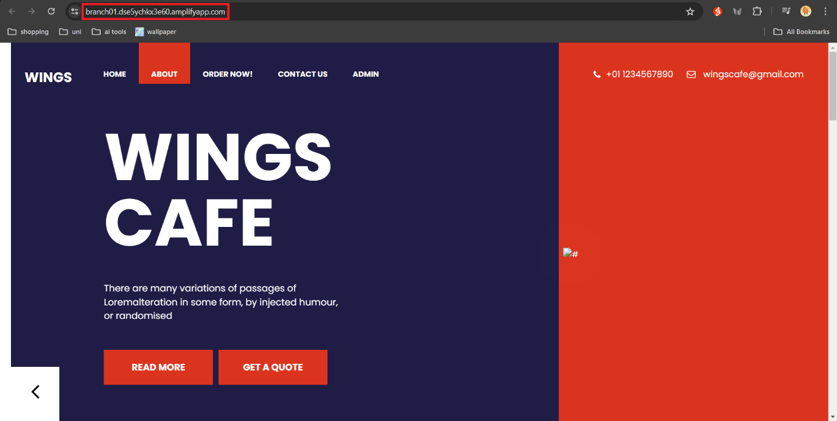

Figure 125: Running the WingsCafe Web Application using the Amplify URL

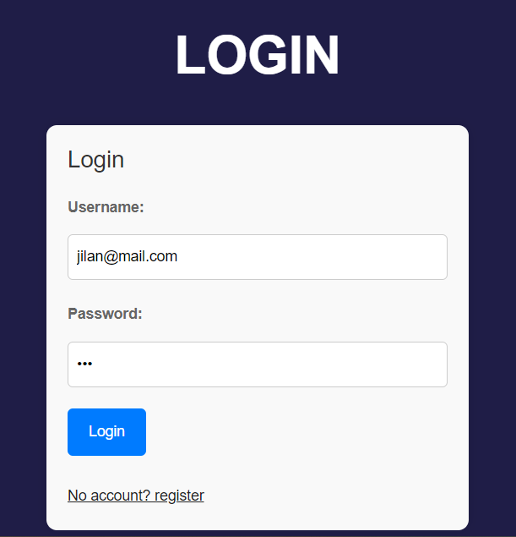

Figure 126: User Login

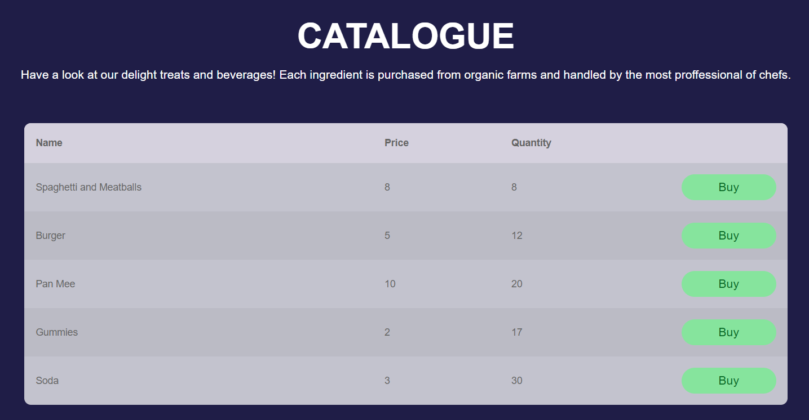

Figure 127: Successful Login

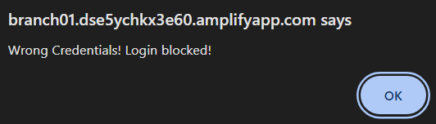

Figure 128: Unsuccessful Login

As shown in *Figure 125*, the WingsCafe web application can run successfully using the AWS Amplify URL, which also signifies the success of the configuration of a serverless architecture and hosting environment. The functions of the website are working as intended as well, as shown in *Figure 126 – 128*, of which the team has logged in as a user with the correct credentials, which leads the user to the catalogue page for ordering. Unsuccessful logins are also prompting the correct responses, which is a pop-up error message that identifies the user that the credentials entered are false. The success of these tests solidifies the function of the the API Gateway, the Lambda functions, and the DynamoDB databases.

This concludes the configurations for the serverless architecture for the hosting of the WingsCafe web application.

# 4. Conclusion

In conclusion, the entire serverless process has been discussed step by step. First of all, all the relevant services were considered and shortlisted to apply serverless architecture for WingsCafe. Then the overall infrastructure was designed to accomplish this and finally, the steps were laid out to implement this. However, the implementation will currently not be carried out due to time constraints. However, if in any future point, it is feasible for WingsCafe to proceed with the implementation of a serverless architecture, the current plan will heavily help and support the network architecture for the network architect team.

# References

Agarwal, P. (2024, March 27). *Demystifying VPC Subnets: Why private subnets in different AZS have separate route tables*. Medium. https://awstip.com/demystifying-vpc-subnets-why-private-subnets-in-different-azs-have-separate-route-tables-451112548bf7

*Amazon Machine Images (AMI) - amazon elastic compute cloud*. AWS. (n.d.-a). https://docs.aws.amazon.com/AWSEC2/latest/UserGuide/AMIs.html

*Amazon RDS Read replicas | cloud relational database | amazon web services*. AWS. (n.d.-b). https://aws.amazon.com/rds/features/read-replicas/

Amazon Web Services. (n.d.). *Amazon Elastic Compute Cloud* (EC2) <https://aws.amazon.com/ec2/>

Amazon.com, Inc. (n.d.). *Amazon Web Services*. https://aws.amazon.com/

Auto Scaling groups - Amazon EC2 Auto Scaling. (n.d.). https://docs.aws.amazon.com/autoscaling/ec2/userguide/auto-scaling-groups.html

*AWS Whitepapers & Guides*. AWS. (n.d.-c). https://aws.amazon.com/whitepapers/

AWS. (2021). AWS Lambda – FAQs. Retrieved from https://aws.amazon.com/lambda/faqs/

AWS. (2024). Amazon EC2 security groups for Linux instances - Amazon Elastic Compute Cloud. AWS Documentation. Retrieved April 12, 2024, from https://docs.aws.amazon.com/AWSEC2/latest/UserGuide/ec2-security-groups.html

AWS. (2024). Connect to the internet using an internet gateway - Amazon Virtual Private Cloud. AWS Documentation. Retrieved April 12, 2024, from https://docs.aws.amazon.com/vpc/latest/userguide/VPC_Internet_Gateway.html

AWS. (2024). IAM - Manage Roles. Amazon AWS. Retrieved April 13, 2024, from https://aws.amazon.com/iam/features/manage-roles/

AWS. (2024). What is Amazon VPC? - Amazon Virtual Private Cloud. AWS Documentation. Retrieved April 7, 2024, from https://docs.aws.amazon.com/vpc/latest/userguide/what-is-amazon-vpc.html

AWS. (n.d.). Amazon DynamoDB. Retrieved from https://aws.amazon.com/dynamodb/.

AWS. (n.d.). AWS Lambda. Retrieved from https://aws.amazon.com/lambda/.

AWS. (n.d.). IAM Policies. Retrieved from https://docs.aws.amazon.com/IAM/latest/UserGuide/access_policies.html.

Book, A. (2023, August 31). Understanding AWS Route Table: A Practical Guide. Tufin. Retrieved April 9, 2024, from https://www.tufin.com/blog/understanding-aws-route-table-practical-guide

Book, A. (2023, September 4). What are AWS Security Groups? Tufin. Retrieved April 12, 2024, from https://www.tufin.com/blog/what-are-aws-security-groups

Boto3 Documentation. (n.d.). Boto3, the AWS SDK for Python. Retrieved from https://boto3.amazonaws.com/v1/documentation/api/latest/index.html

Boto3 Documentation. (n.d.). Boto3, the AWS SDK for Python. Retrieved from https://boto3.amazonaws.com/v1/documentation/api/latest/index.html

Clegg, M., Rowley, A., & Hughes, B. (2023). Web services: A gentle introduction. https://docs.aws.amazon.com/whitepapers/latest/aws-overview/introduction.html

Cloudflare. (2024). How does public key cryptography work? | Public key encryption and SSL. Cloudflare. Retrieved April 13, 2024, from https://www.cloudflare.com/learning/ssl/how-does-public-key-encryption-work/

Cloudflare. (n.d.). What is data migration? Definition and common processes. <https://www.cloudflare.com/migration-services/>

Cloudian. (2023, August 22). S3 Storage: How It Works, Use Cases and Tutorial. <https://cloudian.com/company/>

Davis, N. (2024, March 2). *What is Ami in Aws?*. Medium. https://neal-davis.medium.com/what-is-ami-in-aws-2706fffb51b1

Disaster recovery options in the cloud - Disaster Recovery of Workloads on AWS: Recovery in the Cloud. (n.d.). https://docs.aws.amazon.com/whitepapers/latest/disaster-recovery-workloads-on-aws/disaster-recovery-options-in-the-cloud.html

*Elastic IP addresses - amazon elastic compute cloud*. AWS. (n.d.-a). https://docs.aws.amazon.com/AWSEC2/latest/UserGuide/elastic-ip-addresses-eip.html

*Ensuring AWS AMI compliance with security baselines: Pulumi Ai answers*. Ensuring AWS AMI Compliance with Security Baselines | Pulumi AI Answers. (n.d.). https://www.pulumi.com/ai/answers/myGKV7nUVbTmL7JSsL4VDZ/ensuring-aws-ami-compliance-with-security-baselines

Fielding, R. T. (2000). Architectural Styles and the Design of Network-based Software Architectures. University of California, Irvine.

Get started with. . . DynamoDB - Serverless. (n.d.). https://docs.aws.amazon.com/serverless/latest/devguide/starter-dynamodb.html

*How amazon VPC Works - Amazon Virtual Private Cloud*. AWS. (n.d.-b). https://docs.aws.amazon.com/vpc/latest/userguide/how-it-works.html

Introduction to Amazon S3 (4:31). (n.d.). [Video]. Amazon Web Services, Inc. https://aws.amazon.com/pm/serv-s3/?gclid=Cj0KCQjw2uiwBhCXARIsACMvIU1G3_DKRZKoSMeeYWjCsWGuyxF84BavOsy6k49XqmzKqJLgRPLYOHgaAhtcEALw_wcB&trk=55ffcfa3-95d3-4418-9a79-62a64040b867&sc_channel=ps&ef_id=Cj0KCQjw2uiwBhCXARIsACMvIU1G3_DKRZKoSMeeYWjCsWGuyxF84BavOsy6k49XqmzKqJLgRPLYOHgaAhtcEALw_wcB:G:s&s_kwcid=AL!4422!3!536452732958!e!!g!!aws%20s3!11543056249!112002966709

Iy. (2023, September 3). *Understanding public and private subnets in AWS VPC: Benefits and use cases*. Medium. https://medium.com/@igor_y/understanding-public-and-private-subnets-in-aws-vpc-benefits-and-use-cases-8527c4d95c

Kirimoto, Y. (2022, February 14). Trying out various settings for AWS Amplify Publishing. DEV Community. https://dev.to/aws-builders/trying-out-various-settings-for-aws-amplify-publishing-39i4

*Launch templates - amazon EC2 auto scaling*. AWS. (n.d.-c). https://docs.aws.amazon.com/autoscaling/ec2/userguide/launch-templates.html

Lin, J. (2021, March 17). What is a Database Subnet Group in AWS? <https://docs.aws.amazon.com/AmazonRDS/latest/UserGuide/USER_VPC.WorkingWithRDSInstanceinaVPC.html>

Loshin, P. (2024). What is SSH (Secure Shell) and How Does it Work? Definition from TechTarget. TechTarget. Retrieved April 13, 2024, from https://www.techtarget.com/searchsecurity/definition/Secure-Shell

Mell, P., & Grance, T. (2011). *The NIST definition of cloud computing. National Institute of Standards and Technology*. Special Publication 800-145. <https://nvlpubs.nist.gov/nistpubs/legacy/sp/nistspecialpublication800-145.pdf>

Mozilla. (2021). Cross-Origin Resource Sharing (CORS). Retrieved from https://developer.mozilla.org/en-US/docs/Web/HTTP/CORS

*Nat gateways - amazon virtual private cloud*. AWS. (n.d.-d). https://docs.aws.amazon.com/vpc/latest/userguide/vpc-nat-gateway.html

Oracle. (n.d.). *NAT Gateway*. Oracle Cloud Infrastructure Documentation. https://docs.oracle.com/en-us/iaas/Content/Network/Tasks/NATgateway.htm

Rai, A. (2024, April 12). *AWS RDS Instance Types Pricing + features list*. Economize Cloud. https://blog.economize.cloud/aws-rds-instance-types-pricing/#:~:text=Variable%20Workloads%3A%20With%20burstable%20instances,not%20consistently%20use%20high%20CPU.

REL13-BP01 Define recovery objectives for downtime and data loss - AWS Well-Architected Framework (2023-04-10). (2023, April 10). <https://docs.aws.amazon.com/wellarchitected/2023-04-10/framework/rel_planning_for_recovery_objective_defined_recovery.html>

Risk, E. (2021, December 15). Bastion Host Servers Explained. Twingate. Retrieved April 12, 2024, from https://www.twingate.com/blog/bastion-host

Samuel, J. (2022). Amazon API Gateway The Serverless API service from AWS. Medium. Retrieved April 14, 2024, from https://towardsaws.com/amazon-api-gateway-95b7f711b14a

Serverless architectures. (n.d.). Amazon Web Services, Inc. https://aws.amazon.com/lambda/serverless-architectures-learn-more/

Serverless computing - AWS Lambda features - Amazon Web Services. (n.d.). Amazon Web Services, Inc. https://aws.amazon.com/lambda/features/#:~:text=AWS%20Lambda%20is%20a%20serverless,cart%20on%20an%20ecommerce%20website.

*Shared amis - amazon elastic compute cloud*. AWS. (n.d.-d). https://docs.aws.amazon.com/AWSEC2/latest/UserGuide/sharing-amis.html

*Subnets for your VPC - Amazon Virtual Private Cloud*. AWS. (n.d.-e). https://docs.aws.amazon.com/vpc/latest/userguide/configure-subnets.html

Tagaram, M. B., mahesh babu tagarammahesh babu tagaram                      344 bronze badges, helloVhelloV                      51.3k77 gold badges139139 silver badges148148 bronze badges, & Surya ShuklaSurya Shukla                      11611 silver badge66 bronze badges. (2017, May 1). *How long is an elastic IP valid in AWS? is it terminated after sometime?*. Stack Overflow. https://stackoverflow.com/questions/45518322/how-long-is-an-elastic-ip-valid-in-aws-is-it-terminated-after-sometime

Target groups for your Application Load Balancers - Elastic Load Balancing. (n.d.). https://docs.aws.amazon.com/elasticloadbalancing/latest/application/load-balancer-target-groups.html

Tatham, S. (developer). PuTTY. <https://www.putty.org/>.

Thube, Y. (2023, October 25). *Demystifying amazon EC2 User Data : Practical Guide and troubleshooting tips*. Medium. https://medium.com/@thube09/demystifying-amazon-ec2-user-data-practical-guide-and-troubleshooting-tips-44df3946c2d3

What is AWS Amplify (00:32). (n.d.-b). [Video]. Amazon Web Services, Inc. https://aws.amazon.com/amplify/?gclid=Cj0KCQjw2uiwBhCXARIsACMvIU2oR0nHSy-n6e2wvU7h63WdTyBntDQ_BLevf3XLknTUSLn41GCcaW0aAjncEALw_wcB&trk=27a2247d-3723-4d60-96c5-ac1d66981aa2&sc_channel=ps&ef_id=Cj0KCQjw2uiwBhCXARIsACMvIU2oR0nHSy-n6e2wvU7h63WdTyBntDQ_BLevf3XLknTUSLn41GCcaW0aAjncEALw_wcB:G:s&s_kwcid=AL!4422!3!647301910306!p!!g!!amazon%20amplify!19621316587!146396661100

# Appendices

## Workload Matrix

|  |  |  |  |  |
| --- | --- | --- | --- | --- |
| **Components** | **Angelica Kaylee Wiesi (TP064902)** | **Lim Kin Wah**  **(TP066172)** | **Mohammad Jilan**  **(TP066234)** | **Syed Nazrin**  **(TP066789)** |
| Network architecture planning | 25% | 25% | 25% | 25% |
| VPC (subnets) | 35% | 35% | 15% | 15% |
| S3 | 25% | 25% | 25% | 25% |
| EC2 | 35% | 35% | 15% | 15% |
| RDS | 25% | 25% | 25% | 25% |
| PHP Website | 25% | 25% | 25% | 25% |
| Connection to Server (PuTTY) | 35% | 35% | 15% | 15% |
| Documentation | 35% | 35% | 15% | 15% |
| Individual Component 1 | 100% | 0% | 0% | 0% |
| Individual Component 2 | 0% | 100% | 0% | 0% |
| Individual Component 3 | 0% | 0% | 0% | 100% |
| Individual Component 4 | 0% | 0% | 100% | 0% |

***This page was intentionally left blank.***